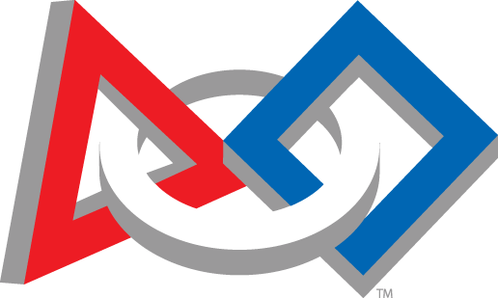
FIRST Robotics Signing Day
May 17, 2017

I have participated in the FIRST robotics program at _____________________ on team(s) __________________________.

I plan to pursue
_______________________________.

Printed Name__________________________________________

Student Signature_______________________________________

