Team 433’s First Annual Post-Build Team Social
¡FIREBIRDS FIESTA!
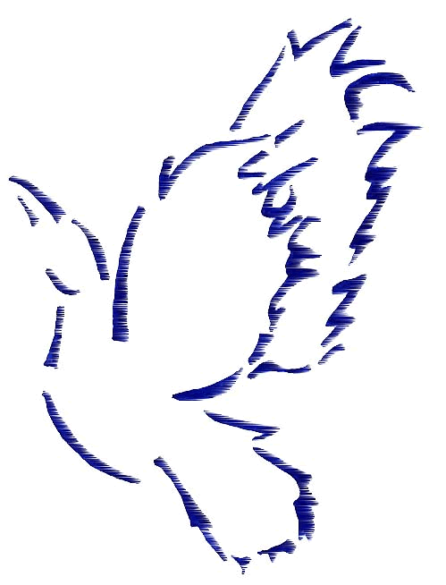

Celebrate the end of the build season with local teams!
Socializing  Music  Dancing  Refreshments

Friday, February 24, 2006
7:00 pm - 10:00 pm

Mount Saint Joseph Academy
120 West Wissahickon Avenue
Flourtown, PA 19031

Cost: $5 per person (at the door)
All proceeds will benefit Team 1874

Note: Students must wear their respective team shirt and long pants
At least one mentor must accompany each team attending
No unbecoming conduct or misbehavior will be permitted
The event will be chaperoned by the MSJA Science Dept. and Administration
There will be a separate “mentors only” area for mentors who would like to socialize in the absence of the music

________________________________
Firebirds Fiesta
Registration Form

Team Name _________________________

Team Number ________

Number of Members Attending ______

Number of Mentors Attending ______

Main Contact E-mail __________________

Please Register By:
Friday, February 17th

The Firebirds
Mount Saint Joseph Academy
120 West Wissahickon Avenue
Flourtown, PA 19031

Bob Foell
Bfoell@msjad.org
Students: Bring form with you for admittance to the event

Firebird’s Fiesta Permission Slip

(I, We) the parent/legal guardian of ________________________________
allow him/her to participate in the Firebird’s Team Social event held at Mount Saint Joseph Academy.

(I, we) release and save harmless Mount Saint Joseph Academy and any and all personnel from any and all claims, demands, damages, and liability for any and all injury arising or resulting from this experience.

_____________________________________________________________

Date___________

Parent/Legal guardian signature___________________________________
or
Member Signature (if 18 or older) ________________________________

Team Name ______________________________________

$5 donation for team 1874 and permission forms will be collected at the door the night of the event; registration can be sent via e-mail, as well

