Match #: ____

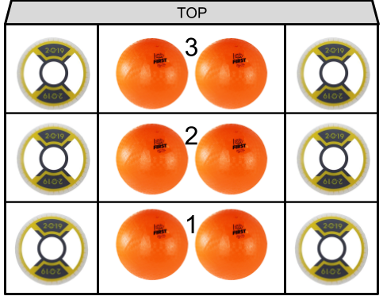

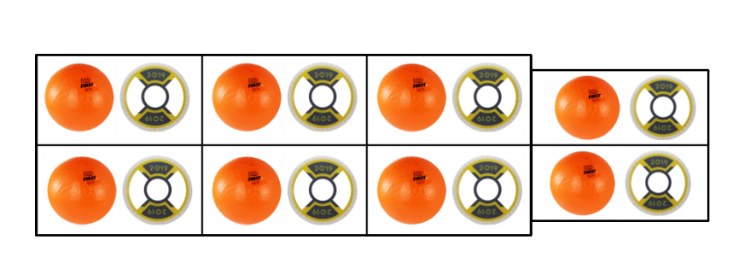

Rocket Rocket

Tally Balls Dropped: ______________

Tally Hatches Dropped: ______________

Level Started on? 1 2

Crossed Line in Sandstorm? Y N

Level Ended on? G 1 2 3

Notes: ______________________________________

___________________________________________

Match #: ____





Rocket Rocket

Tally Balls Dropped: ______________

Tally Hatches Dropped: ______________

Level Started on? 1 2

Crossed Line in Sandstorm? Y N

Level Ended on? G 1 2 3

Notes: ______________________________________

___________________________________________

Match #: ____





Rocket Rocket

Tally Balls Dropped: ______________

Tally Hatches Dropped: ______________

Level Started on? 1 2

Crossed Line in Sandstorm? Y N

Level Ended on? G 1 2 3

Notes: ______________________________________

___________________________________________

Match #: ____





Rocket Rocket

Tally Balls Dropped: ______________

Tally Hatches Dropped: ______________

Level Started on? 1 2

Crossed Line in Sandstorm? Y N

Level Ended on? G 1 2 3

Notes: ______________________________________

___________________________________________