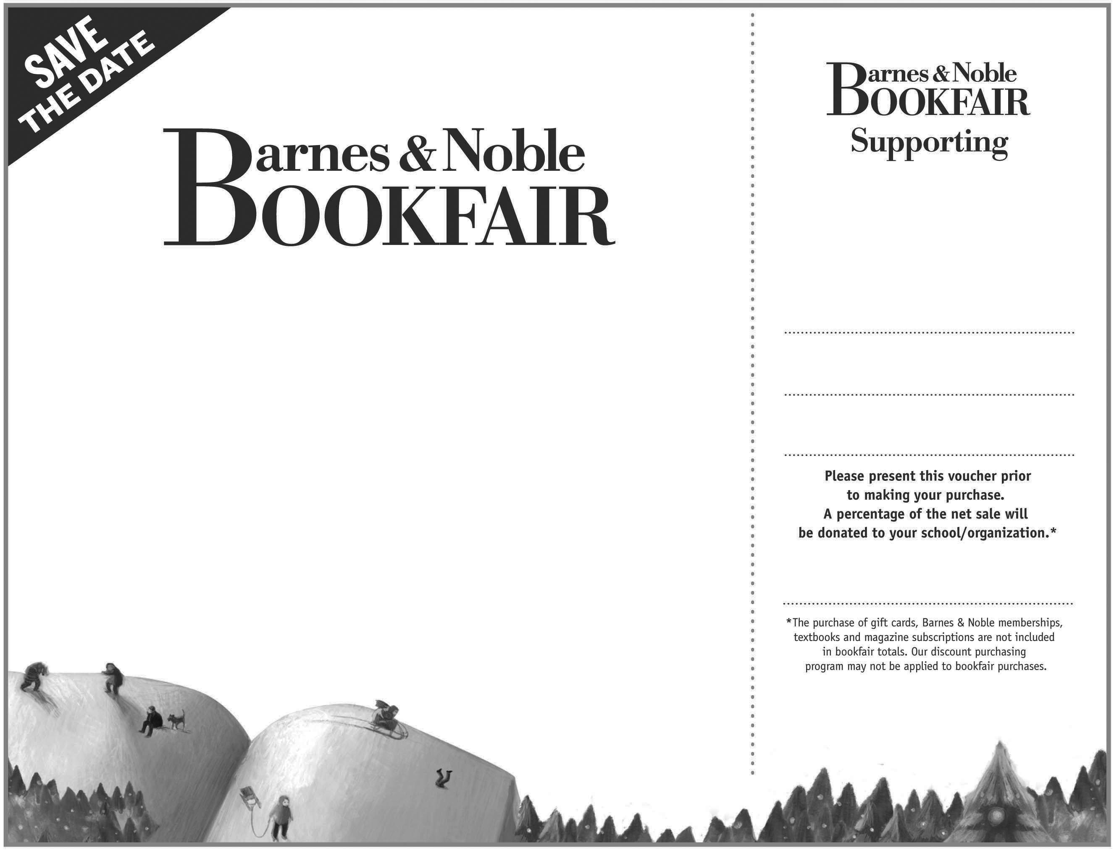
All day Sunday, December 7, 2008
Do your holiday shopping and support the Immaculata Robotics Team at
Barnes & Noble

Vouchers are good at ANY Barnes & Noble in the country and are valid with purchases of DVDs, CDs, Books, Stationary, Gifts and Café items.

(Not valid in college book stores)
Also, Meet the Team!

Where? At the Somerville Circle Store (10am-4pm)
319 Rt 202/206 Bridgewater, NJ

• Children’s story time 11-3, but stop by any time

• Bring your camera and get your picture taken with the robot

• Visit www.coldfusion1279.com for more information!

When? Sunday, December 7, 2008

Where? ANY Barnes & Noble
Nation Wide!
(Not valid in college book stores)

Meet the Team! Where? At the Somerville Circle Store! (10am - 4 pm)
319 Rt 202/206 Bridgewater, NJ

Immaculata Robotics Team
Bookfair I.D. 345843
Immaculata Robotics Team

