Remove the “no-back” rollers from the transmissions ASAP. The pins on carrier that engage the output shaft can easily be broken with the no-back rollers in place.
These pins break
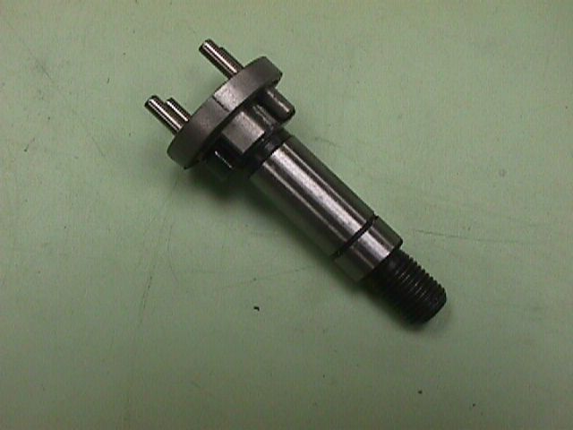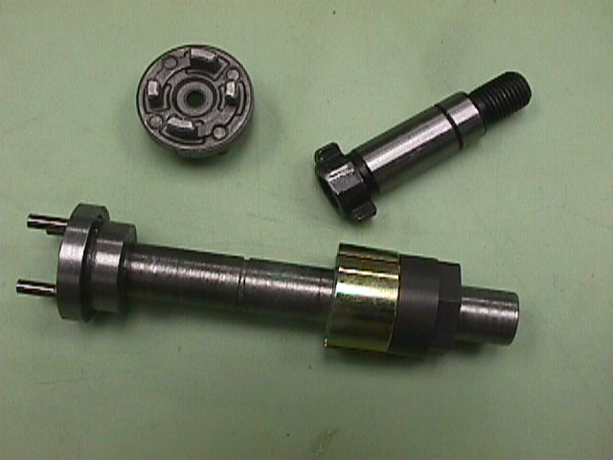

Shifting is trickier than you think -- I recommend against it.

Only 1 team I know does it reliably (Delphi-Kokomo) & it takes time and some fancy programming

Make “rings” to install INSIDE the transmissions to lock them in HI or LOW

Lock out the clutch mechanism

replace spring with length of tube OR

tap the 6 holes with an M-6 Tap and replace the balls with M-6 set screws (My Favorite method)
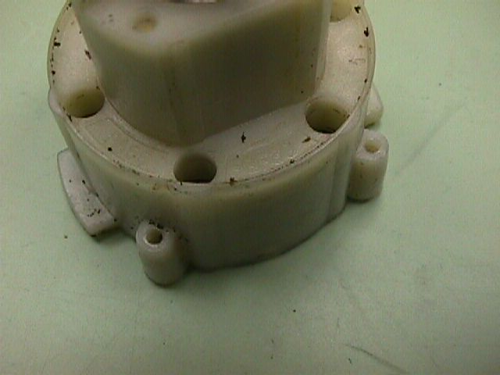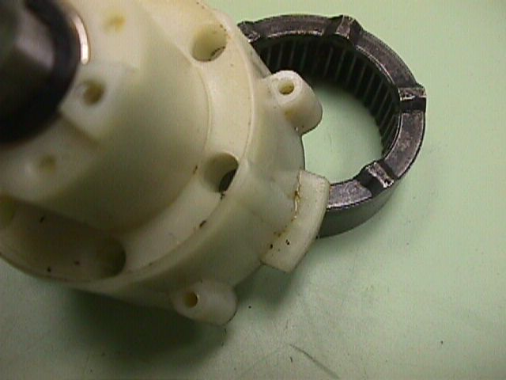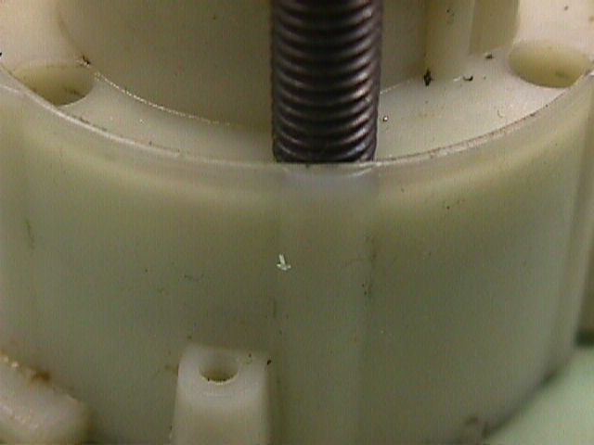

Reverse Engineer the output shaft/final carrier, make smooth long shafted replacement
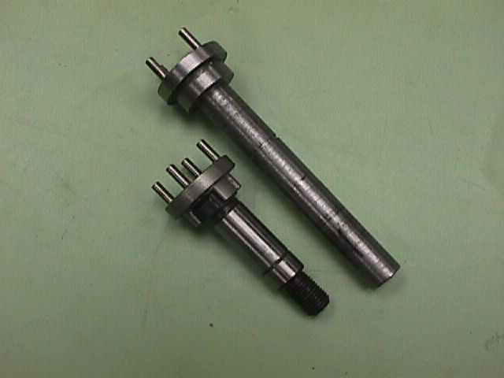

Use a Trantorque™ on the Extended Shaft (NOT on the threaded as FIRST recommends)

Support the drill shaft using two bearings on the Extended Shaft – only use the drill housing to provide TORQUE not as a bearing for the shaft

Alternative to making Extended Shaft: Make a hollow “Chuck-like” Shaft that screw onto the external threads of the drill shaft and allows a left handed screw to screw into the center of the drill shaft.

Mixed results – can be difficult to install tightly. Once installed, difficult to remove without damage.
