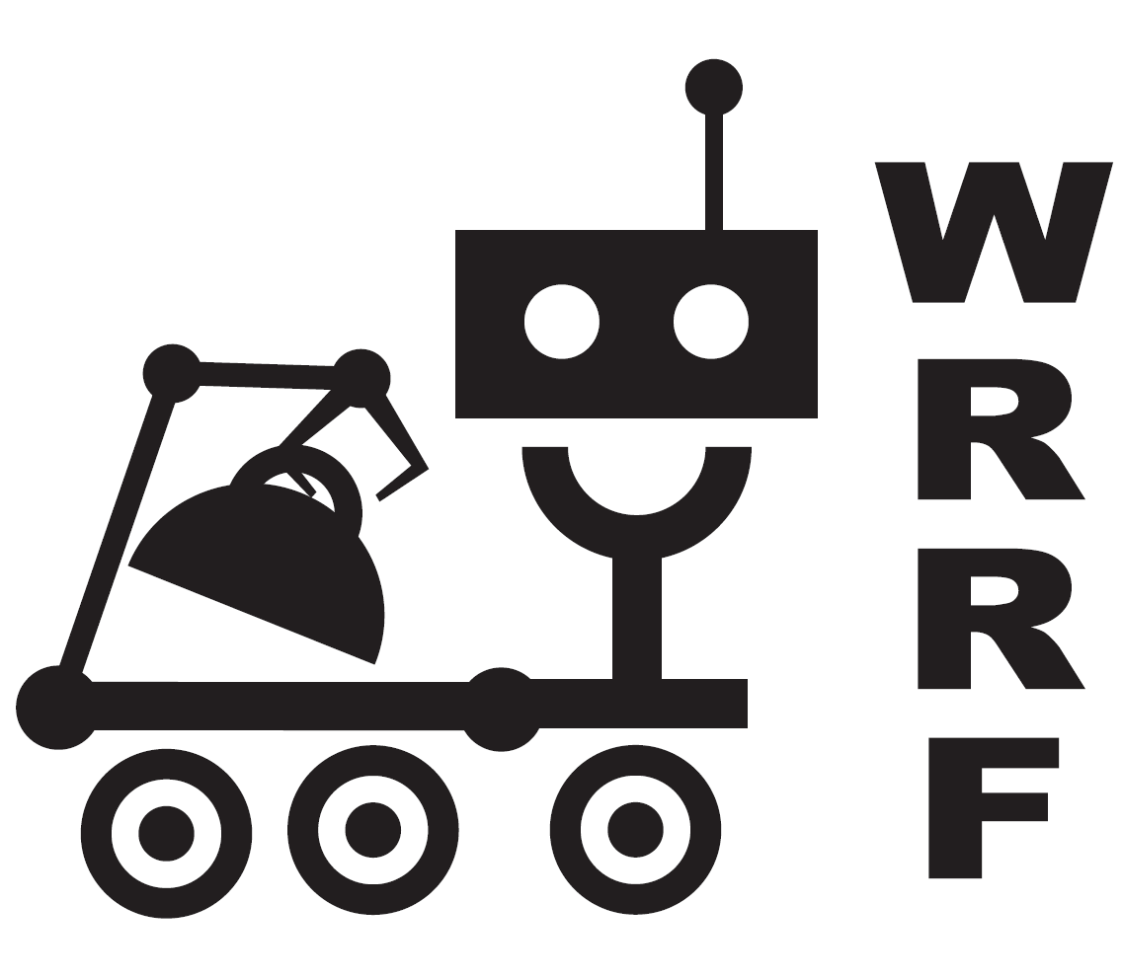
WRRF
Western Region Robotics Forum
PO Box 450 Moffett Field, CA 94035

FOR IMMEDIATE RELEASE: | For more information, contact:
September 21, 2006 | Laura Rhodes
 | (650) 365-3203
 | laura@pyxiseng.com

High School Robotics Teams To Compete in the
2006 California Robot Games

REDWOOD CITY - Students from twenty-four Northern California FIRST Robotics teams will be bringing their robots to compete at the 2006 WRRF California Robot Games to be held at Pioneer High School in San Jose on Saturday, October 28. The Western Region Robotics Forum (WRRF), a not-for-profit organization supporting Bay Area FIRST robotics teams, is organizing the competition. This off-season event will be a replay of the 2006 FIRST Robotics Competition (FRC) “Aim High” game. In this exciting game where 120-pound robots compete in three-versus-three alliances, the action is a combination of autonomous (software control) and remote control. The robots have to accurately shoot 7-inch balls into low corner and high goals, as well as climb a 30° ramp.

continued
Each year teams of high school students work closely with industry mentors to compete in the FIRST Robotics Competition (FRC). The ever-increasing use of technology in our society demands a highly educated, skilled technical workforce. The FIRST Robotics program helps motivate high school students to be prepared for the technical jobs of the future. By combining the excitement of a varsity sport with a fascinating, real-world engineering experience, the FIRST robotics program lets students discover the value of education and careers in science, technology, and math.

The 2006 California Robot Games is free and open to the public. It promises to be as fun and exciting for the spectators as it will be for the student participants.

2006 California Robot Games

Saturday, October 28, 2006
Pioneer High School Main Gym
1290 Blossom Hill Road.
San Jose, CA 95118
Qualifying Matches 9:00 a.m.– 12:00 p.m., Playoffs 1:00 –4:00 p.m.

continued
About WRRF
The Western Region Robotics Forum (WRRF) is a 501(c)(3) not-for-profit organization dedicated to promoting the educational use of robotics and providing support for the Bay Area FIRST robotics teams. WRRF puts on a series of pre-season workshops for FIRST teams covering a wide range of subjects, including: team management, electronics, computer animation, drive train design, and software development. WRRF organizes the California Robot Games off-season competition. For more information on WRRF, contact Ceal Craig, Ceal@WRRF.org, OFC/HM: (408) 259-2836, CELL: (408) 828-2643.

About FIRST Robotics
Founded in 1989 by accomplished inventor Dean Kamen, FIRST (For Inspiration and Recognition of Science and Technology) motivates young people to pursue opportunities in science, technology, engineering, and math. More than 1000 teams of high school students world-wide compete annually in their flagship competition, the FRC – First Robotics Competitions. For more information see the FIRST website at http://www.usfirst.org/.

###

