You Can do CAN: CAN Bus on a Budget
A 2011 (and later) hardware guide on making CAN bus possible for under $50

By Larry Bolan, Former Electronics Captain of FRC 2783, Engineers of Tomorrow

One of the new technologies available to FIRST teams is CAN bus. CAN bus is an alternative to PWM for wiring Jaguar speed controllers. CAN capabilities have been present since 2009 and legal for use since 2010. But since 2011, the bulk of the required hardware comes out of the box. For my former team, 2783, this provided an incentive to give the technology a spin. This document is a collection of what we found works on the hardware end of things.

CAN bus has many advantages over PWM. PWM is a point to point connection, while CAN is a bus. Anybody who has done PWM wiring will tell you how confusing masses of PWM wires can be; CAN only requires one wire to the cRIO and from there, it is a daisy-chain of Jaguars. In addition, with CAN, Jaguars can be wired in any order (with one exception, explained later). CAN strings can also be tested by way of a computer, making troubleshooting even less of a challenge. CAN bus uses 6 and 4 wire oval cable, which is generally more durable than wire used in PWM wiring. In addition, the RJ-12 plugs used by CAN bus have a locking clip, while PWM plugs do not have any lock.

CAN bus currently has two legal implementations (well, you could always make your own adapter, but that is another story). The first one is the Cross the Road Electronics 2CAN adapter. It provides the full, 1 Mbit, connection in an easy to wire format. However, it has a major drawback; it costs nearly $200. For teams on a budget like my former team, this cost reduces the gain by using CAN. Luckily, there is a second option; the Texas Instruments MDL-BDC24, more commonly known as the “black” Jaguar. Since 2011, they have been part of the kit of parts, making CAN bus an even more attractive technology to FIRST teams.

To use the black Jaguar for CAN, there are two options. First, you can buy a lot of the cables and whatnot pre-made by various companies (such as eStop Robotics). The drawback is that often times the pre-made parts are somewhat expensive and for things such as cable length, they can be a bit constraining. However, if you wish to save some money and gain a better level of customization, you can make the serial adapters, cables, and terminators yourself.

To build your own CAN parts, you will first need to buy some things, most of which my former team found at low prices at monoprice.com. You will need: (monoprice.com product codes in Bold)

- Some RJ-12 (6P6C) plugs (7270) and 6 wire cable (943)
- Either more RJ-12 plugs/cable or RJ-11 (6P4C) Plugs and 4 wire cable
- A 6P crimping tool (7035)
- Female DB9 to RJ-12 adapters (1150, or the 2012 KOP adapter) and a pin pusher (2884) OR the serial cable from the 2009 KOP OR any other female DB9 cable with pins 2, 3, and 5 connected
- 100Ω resistors
- A computer (laptop recommended) with Microsoft Windows and a serial port or USB to serial adapter (2276)
- An unbent paperclip (to hit a switch through a tiny hole)
The first thing you need to do is make the serial to RJ-12 adapter and a terminator. For this, refer to the following charts and diagrams:

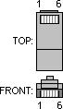
(from pinouts.ru)

For the serial cable, you will want to have at least two, as they are used both to connect to the cRIO and to connect the Jaguars to your computer (not to mention it is good to have spares). There are three ways to make the cables. The first and best way is to use a DB9 to RJ12 adapter. There is one included in the 2012 KOP, which uses the usual RJ-12 pinout. However, the ones from monoprice.com have a backwards from normal pinout, which the chart above reflects. To make the adapter (monoprice.com colors in bold), use the copper end of the pin pusher to insert the white (blue) wire into pin 3 of the DB9 plug, yellow (black) to pin 5, and blue (white) to pin 2 (the pinouts are marked on the adapter). Then, snip the pins off the red and green wires and solder between them a 100Ω resistor. The black (yellow) wire can be snipped and left to hang.

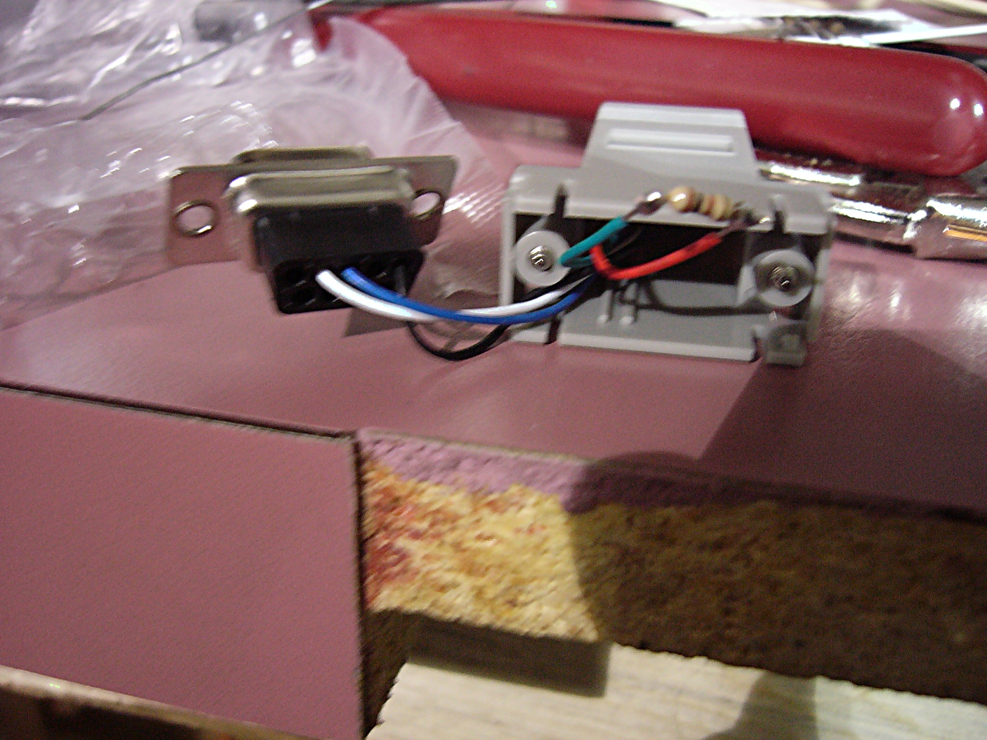
A completed DB9 to RJ-12 adapter (using the monoprice.com adapter)

However, if you are inpatient like I was waiting for the parts to come in and you have the white serial cable from the 2009 KOP, two 100Ω resistors, and a RJ-12 cable, you can make two cables out of that. To do so, cut the serial cable to the desired length. You will only need the orange, green, and red wires. Also, snip the 6 connector cable so about 1”-3” is past the plug. The middle two wires (3 and 4) get the 100Ω resistor, pin 1 goes to the orange wire, pin 5 to green, and pin 6 to red. Be sure to tape or heat shrink all five solder joints to avoid any shorts.
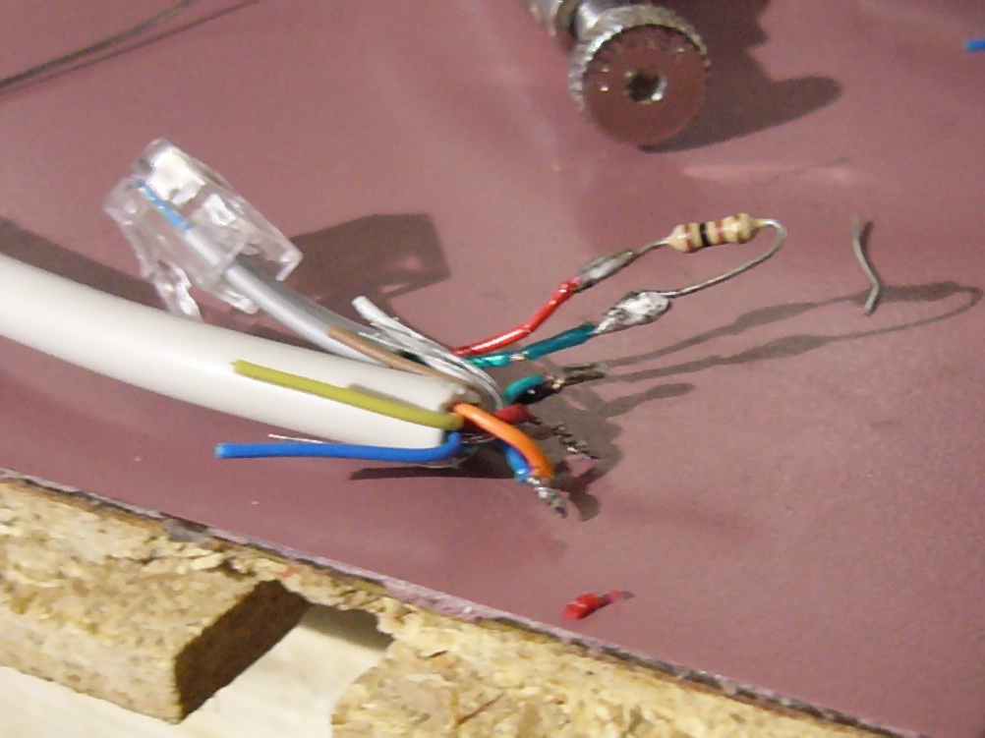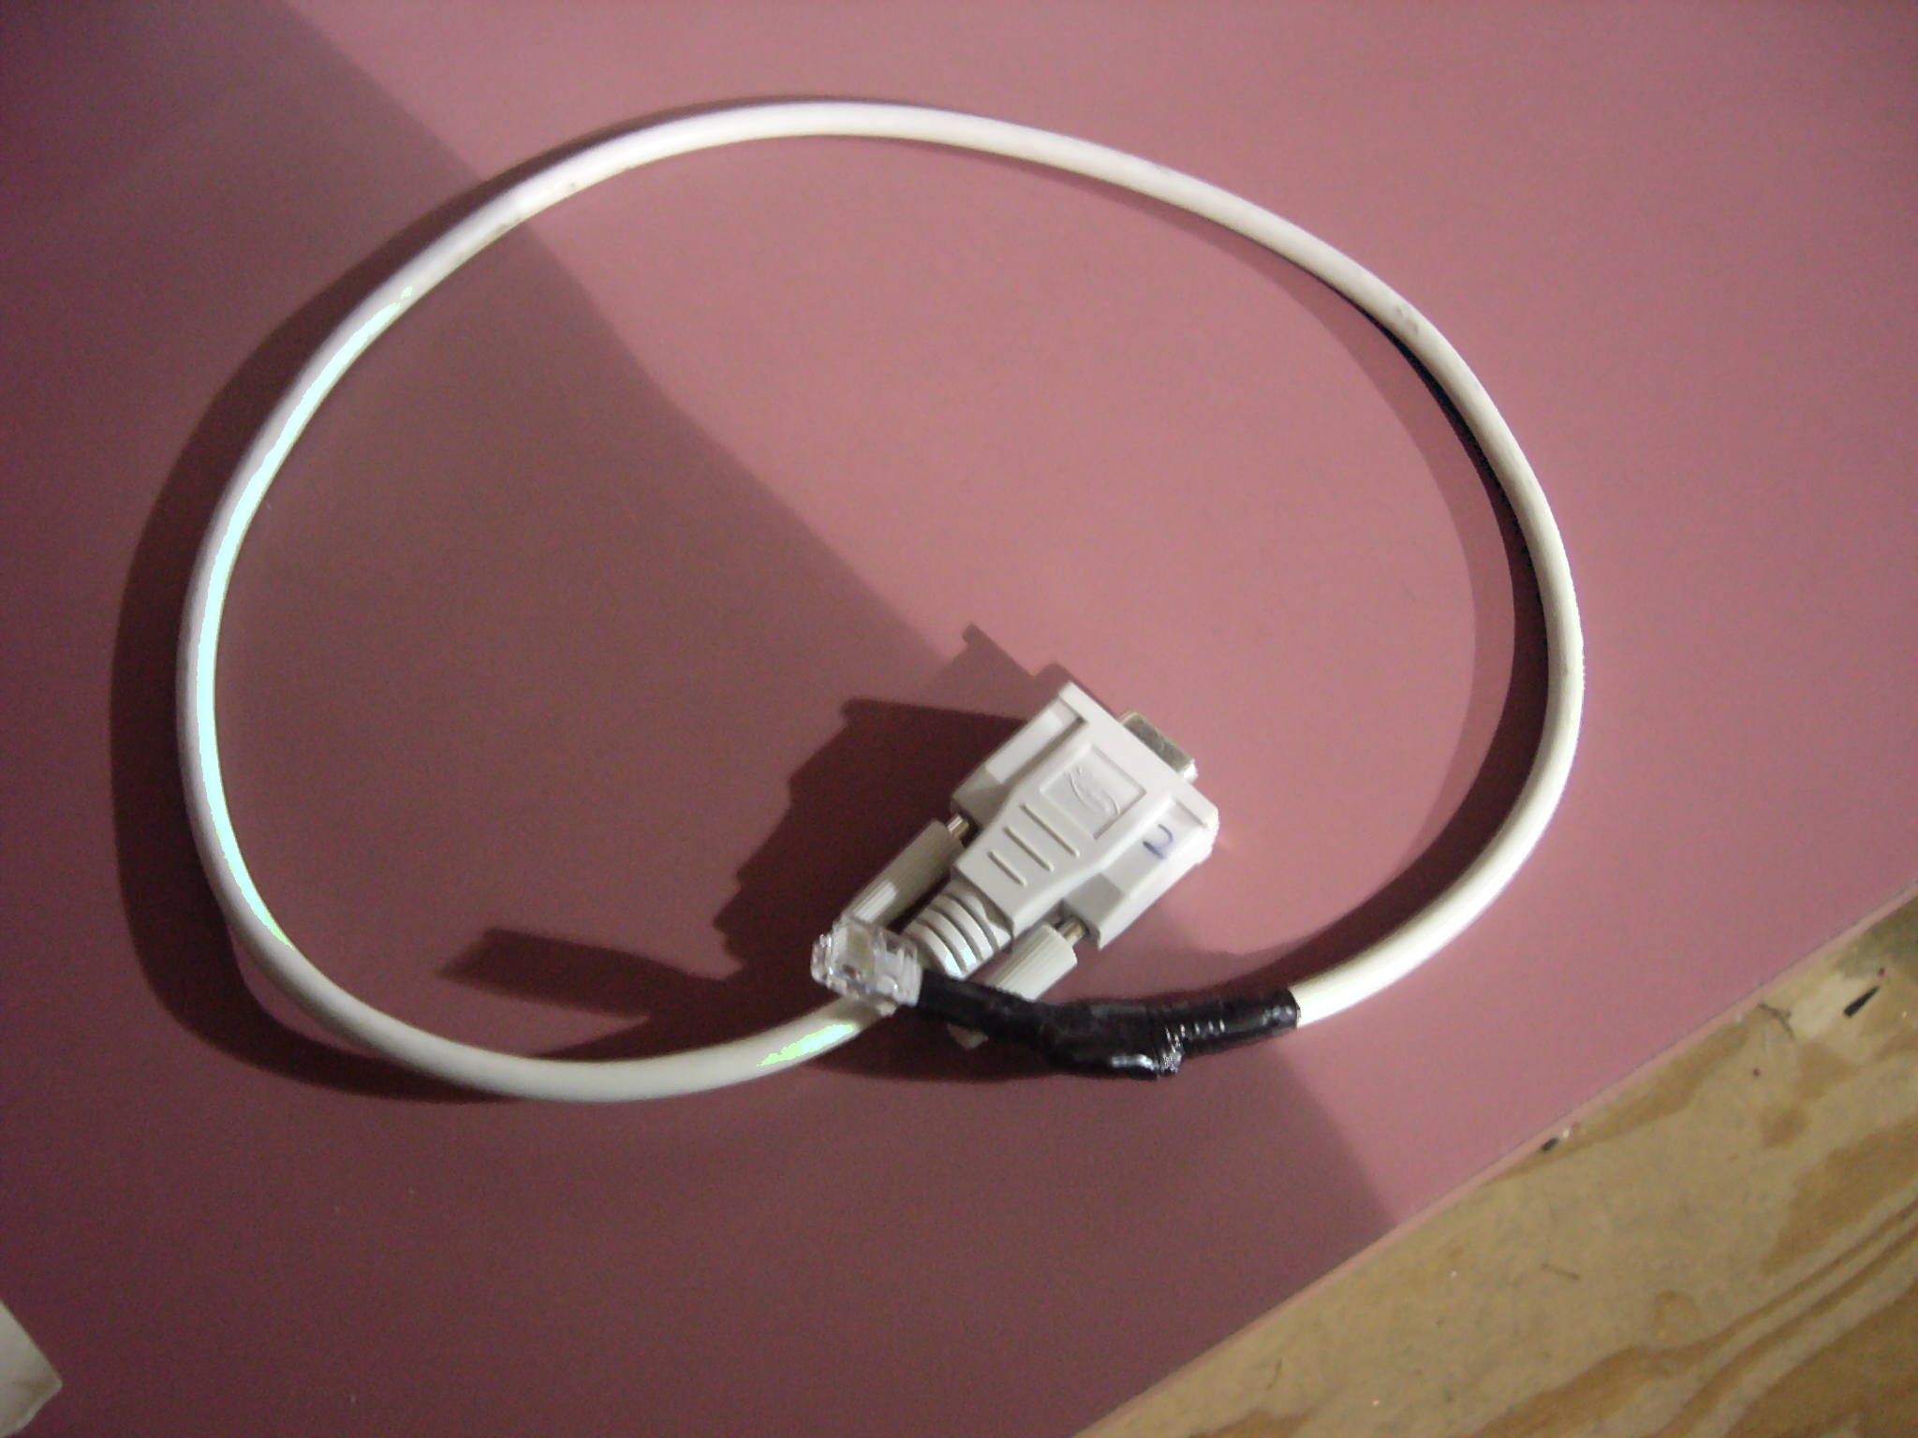
A fully soldered 2009 KOP style serial adapter A finished and taped 200 KOP style adapter

If you are really daring, you can also make the cables out of any other DB9 cable. You will need to make sure that pins 2, 3, and 5 are live; luckily, most cables intended for use with a computer use those pins. You will need to use an unbent paperclip or short bit of solid wire and a multimeter to obtain the pinouts of your cable. It helps to write down these pinouts or put them in a spreadsheet to help you remember what you recorded. Again, cut your RJ-12 cable down to 1”-3” past the plug. You will need to have pins 3 and 4 of the RJ-12 cable connected by a 100Ω resistor and you will need to make pin 1 of the RJ-12 go to pin 3 of the DB-9, pin 5 to pin 5, and pin 6 to pin 2. Once again, be sure to tape or heat shrink all of your solder joints.

You also need to make a terminator, preferably two or more. All it is is an RJ12/11 plug with the middle two pins connected by a 100Ω resistor. The way that TI recommends to make the terminator is to crimp a resistor straight to the plug. However, the way I find works best is to crimp in two wires to the plug (or use a snipped off two wire phone cord) and solder the resistor to those. Again, electrical tape or heat shrink is very important. Be sure to keep your spares in a safe place as they are easily mistaken for trash and are not hard to lose track of.

Last, you need to make your CAN cables. They are four or six wire cables with an RJ-12/11 on each end. It is a “through cable”; pin 1 goes to pin 1, pin 2 to pin 2, and so on. Four wire phone cords are not, so if you recycle a few ones with broken clips as I have been doing, be sure you cut and crimp new plugs on them. You will also find that when properly made, if you hold the cable without twisting it, one plug will be upside down:

(From TI's official black Jaguar manual)
If you do opt to recycle old four wire phone cords, you need to be careful to make sure there are no twists under the insulation. You can usually feel them as a bump/bulge in the cord. They cause issues by causing the pinouts on your cut ends to not be in the same order, resulting in a bad cable. As impossible as it sounds, it does happen and will cause headaches if overlooked.

The next step is to prepare the Jaguars for use. You will need to go to TI's Jaguar page (free registration required) and download the BDC-COMM program and the Jaguar firmware. Then, you will connect the serial adapter to the the left CAN jack on a Black Jaguar. Next, plug a terminator into the right jack. Then, connect power the Jaguar (an old Buss 2008 power board with a battery leads is a good choice), connect the serial cable to the computer, and run BDC-COMM. In the board ID box, you should see a number; if not, then your cable/terminator is bad or your COM port is set wrong.

In the program, go to file and then update firmware. In the dialog box, hit the “...” button and find where you extracted the firmware. Be sure you get the right firmware; there is a black Jaguar file and a gray Jaguar file. Then select update.

In the program, you also need to reset the ID of the Jaguar. All Jaguars come with an ID of 1, so to make a chain work, you need to change the ID. To do so, take an unbent paperclip and insert it into the “user switch” on the Jaguar, located on the right side, below the right mounting hole. In the program, go to the system tab and in the “new board ID” box, enter the new ID (2-63) and select assign. Within 5 seconds, push the user button with the paperclip.
in
You need to do this with all Jaguars. The black ones use the same process as above; the gray ones use the same but with a black Jaguar connected to power and the computer, a CAN cable connecting the black Jaguar to the gray Jaguar, and a terminator on the unused port of the gray Jaguar (be sure to use the gray Jaguar firmware!).

You also should somehow mark the ID on the Jaguar; I suggest numbered stickers since you may want to change the IDs and relabel your Jaguars in the future. Another option that works well is labels made using an electronic label maker; they cost more but look even better than pre-printed numbered stickers. Either way will work, as long as one can easily tell which Jaguar has which ID, there should not be any issues. In a pinch, you could even use a pencil and masking tape.

You can also test your string with the program as well. This is what the “mode” tab is for. You can use the slider to change the voltage being sent by the Jaguar to the motor output. You can even test more than one Jaguar at once. All of the limit switch, potentiometer, and encoder inputs and the voltage and temperature levels on the Jaguar can be monitored from this tab as well.

Before you can wire all of your Jaguars on the robot, you need to do a couple things to the cRIO. First, you need to update the firmware on the cRIO and when doing so, select the black Jaguar option (this installs the necessary driver on the cRIO). You may then load your code. After doing that, If you are using the older 8-slot cRio (2009-2011), the “CONSOLE OUPUT” DIP switch on the cRIO needs to be switched to off. The switch is set this way by default from the factory. Be careful of how the switches are set; they have a tendency to be confusing. If you are using the newer 4-slot cRIO (2012 and later), instead of physical DIP switches, there are virtual switches in the cRIO firmware utility; with these, follow the same rule, “CONSOLE OUT” set to OFF.

Finally, the wiring on you robot can be done. You can be very flexible on your wiring order as long as the first Jaguar is a black one and you connect the serial adapter from the cRIO to the first black Jaguar's left port. From there, either port is fair game for in/out, and your order can be whatever you want. Be sure to put a terminator in the last Jaguar's unused port.

One thing often overlooked is the layout and order of your Jaguars. If you have two or more banks of Jaguars (like some on one side of the robot and some on another side), be sure that you put a black Jaguar on the left side of each bank. That way, if you need to update firmware, a black Jaguar is always within reach of any gray Jaguars; if you put the black Jaguar on the right instead of the left, there is a good chance you will accidentally plug the serial adapter into the right port instead of the correct left port. Trust me, you do not want to spend an hour playing “Jaguar swap” thinking your Jaguar is bad only to find it was a case of using the wrong port.

Also, be sure to have spares of all of your cables. The parts are cheap; you do not want to be put out of commission by a part less than a dollar. As durable as CAN cables can be, they can and do fail.

A last note to the programmers: Whatever language you are using, you need to modify your code to use CAN. The things you will need are at the FIRST forge. In fact, LabVIEW has all of the code for using all of CAN's features already in the WPI libraries.

Good luck to all who are reading this document with you decision to use CAN bus on your robot. You will probably find that CAN bus is a far superior method for wiring Jaguars as opposed to the classic PWM method.

Last revised 1/25/12

