3D Printed Parts
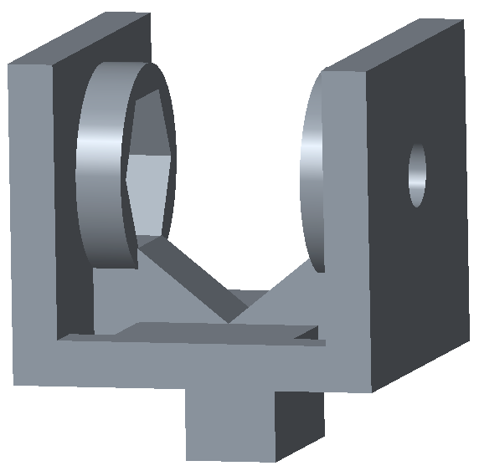
This mount is used for putting our Talon on 80/20. It allows us to mount two Talons, one across from the other.
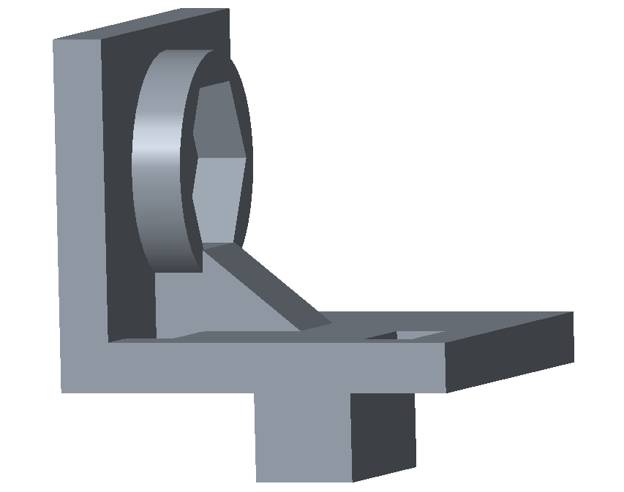

This mount is designed for holding a single Talon.

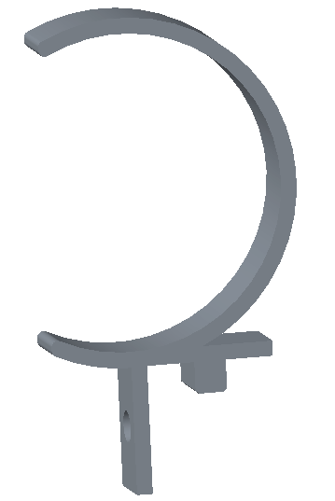

This is designed for the air tank used on our robot, and it is mounted to the 80/20 as we have limited space elsewhere.

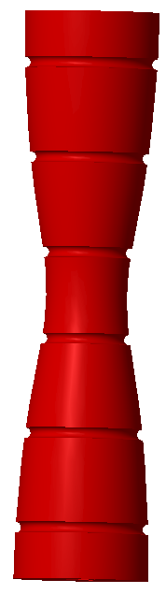

We have multiple rollers that can intake balls using polychord; we can maneuver the ball into our shooter or shoot it into the low goal.

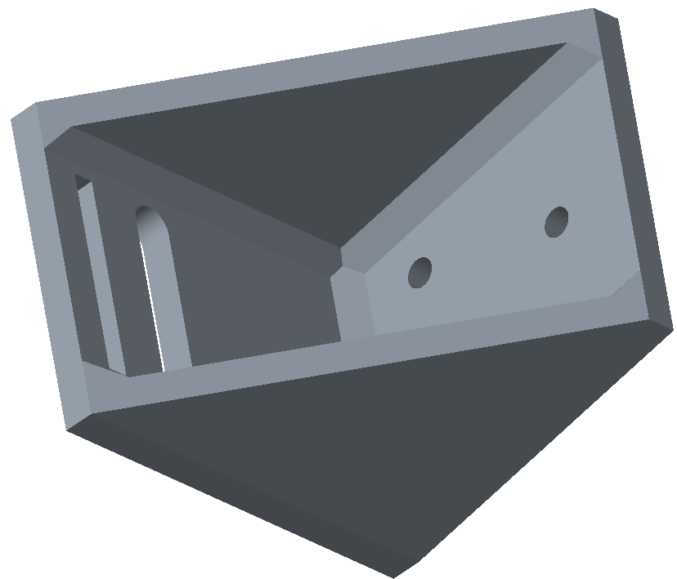

This piece is used to hold a small metal connector which attaches to a pneumatic cylinder. It then moves the intake to ensure the ball stays in the robot.

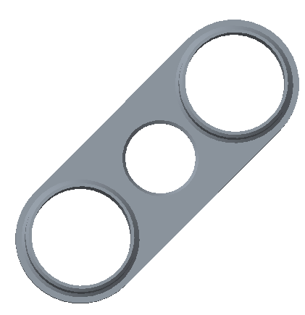

This piece, which is used to hold our regulators in place, is attached to our side plate.

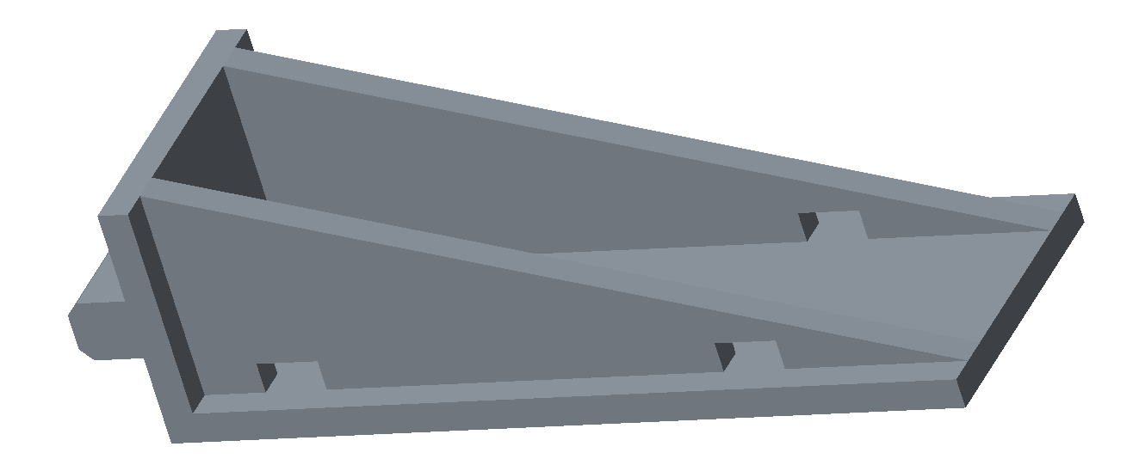
This mounting platform is used to support the high-flow solenoid that powers our firing piston.

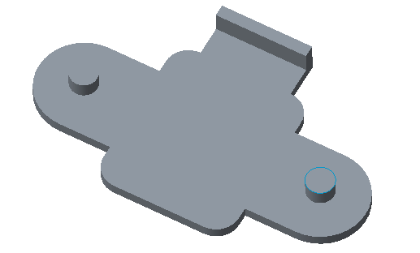
This piece is used to mount and secure our radio on the side of the robot, so we don’t lose communication during a match.

