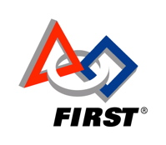

Below is the entry Team 499 submitted for the 2008 Chairman's Award.
Event: Lone Star Regional
Submitted: 02/21/2008
 | Images:  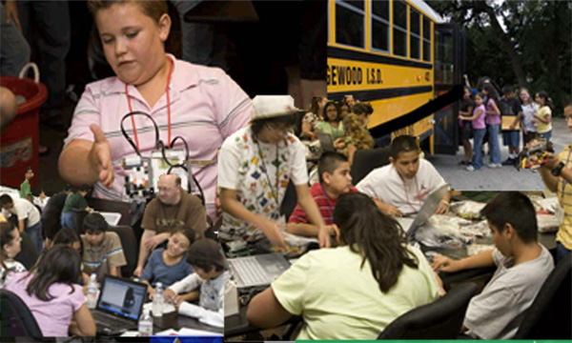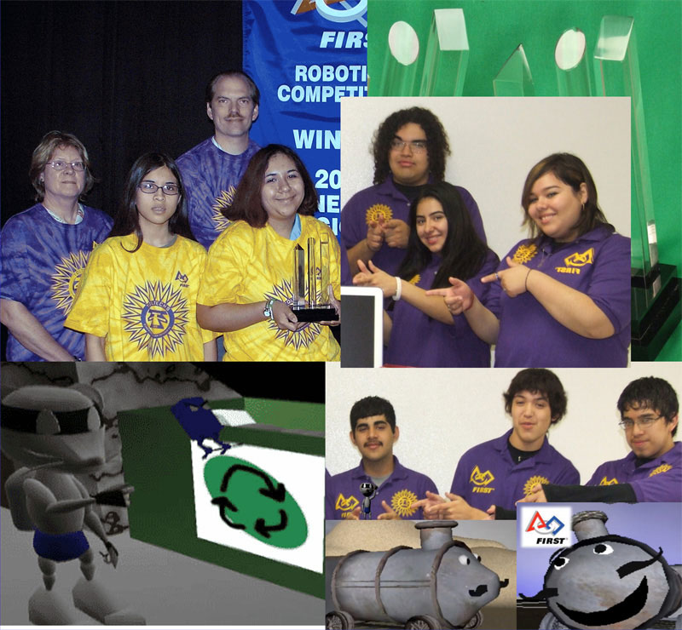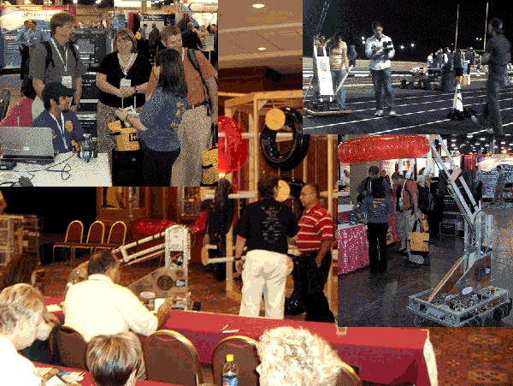
  Your Team Number: | 499
  Team Name, Corporate / University Sponsors: | ITT Tech/Kelly Aviation Lockheed Martin/ASME - International Petroleum Technology Institute/MTC Technologies/Home Depot & Edgewood ISD
  Briefly describe the impact of the FIRST program on team participants with special emphasis on this year and the preceding two years. | Provides unified program for students interested in Engineering Growth rate has exceeded 6X original members, and 10X in mentors Students enter vocational college prep programs Alumni continue studies at UT, ITT, RIT, MIT, and return to mentor each season Expels cultural boundaries, introduces engineering to the Hispanic culture Provides access to Industry professionals that operate as leaders within their discipline Preparation encourages critical thinking, analyzing, and problem solving
  Examples of role model characteristics for other teams to emulate. | Hosted tournaments for GEAR, BotBall, & EARLY Mentored elementary and middle robotics teams Building a foundation for two new teams Organized local Kick-Off for two years Served as ambassadors to Brazilian teams Traveled nationally to spread the message of FIRST Rebuilt robot to promote FIRST at school events Center of National Engineering Week Event at Witte Museum SpaceTEAMS employed members to orchestrate summer program Served Habitat for Humanity as volunteers and as recruiters
  Describe the impact of the FIRST program on your team and community with special emphasis on this year and the preceding two years. | Developed robotic programs in schools across district Provided constructive, educational activities for minority students Community shares a sense of pride & accomplishment Organized biennial _Robo-Expo_ at state capitol, Sponsored by State Senator Leticia Van de Putte Promoted FLL, FRC, BEST, GEAR, BotBall Community service activities Promoted and recruited at district parade & football games Spread FIRST at in & out-of-town conferences
  Teams innovative methods to spread the FIRST message. | Local News coverage on students and engineering Newspapers highlighting Toltechs as success story Internet Podcasts geared at helping other teams Presentations to educational conferences Visits with government officials and educational leaders Classes in engineering and technology Hosted elementary students for one day assembly at Lone Star Regional
  Describe the strength of your partnership with special emphasis on this year and the preceding two years. | Seven years with Lockheed Martin, founding & supporting sponsor Four years with ITT Tech Partnered with other FIRST teams Consistent interaction with elementary and middle schools Expanding contacts at state capitol to support FIRST programs Members bond with mentors
  Teams communication methods and results. | Internet Podcasts expanding robotics to the world wide community Presentations at educational conferences resulting in new interest and teams Trips to state capitol resulting in legislative awarness of robotics and engineering programs across Texas Appearances at district events building community relations and local support Newspaper articles & spots on local TV news programs creating a _limelight_ for Toltechs in Edgewood and across the city
  Other matters of interest to the FIRST judges, if any. | Developed an elementary & middle school program(SpaceTEAMS) for Northwest Vista College to demonstrate engineering and technology and its use in education, and promote the inclusion of robotics programs at schools associated with that program during the school year. 2005 Lone Star Regional Winner 2005 Website Excellence Award 2005 and 2006 Autodesk Visualization Award Winner 2006 Safety Recognition

Edgewood Independent School District (EISD), in west San Antonio, has a population that is greater than 95% Hispanic, with 90% of district budget funded by state and federal programs and other grants. The families living in the district are hard working and most have two or three jobs to make ends meet. The Toltech robotics team is the only place that gives the students hope for something more than a minimum wage job. In 2001, Andrew Schuetze, team founder, first proposed the idea of robotics to the Edgewood district. Immediately, the team formed relationships with Lockheed Martin, ITT Tech, MTC Technologies, and ASME-IPTI. The collaboration made it possible to open students_ eyes to a world of engineering and technology. Students from grades 9-12 were given the opportunity to engage in _hands-on_ applications of the math and science concepts they learned. The team members were also introduced to computer science and computer programming, which was something completely new for Edgewood students. Thus, the Toltechs were born.
The team began with a few students and one mentor, throughout the years the team evolved into six times the original members and ten times the mentors. The team has won the 2005 Lone Star Regional, (with alliance teams #118 Robonauts and #231 High Voltage), the 2005 Lone Star Regional Website Excellence Award, the 2005 and 2006 AutoDesk Visualization Award, and Safety Recognition in 2006.
The Toltechs partnered with the district_s Gifted and Talented (GT) program to implement EARLY robotics (Engineering and Robotics Learned Young). Team 499 saw this as an opportunity to introduce the excitement of robotics to elementary students and develop future recruits. A competition was held on December 5, 2005, in which the upper classmen organized practice times and ran the mock challenge while other Toltechs acted as mentors for the elementary school teams. Each competing team designed and built a robot for the _Moon Challenge_ game. Additionally, during the 2007 Lone Star Regional in Houston, the Toltechs team sponsored a group to travel with the team and learn about the FIRST competition. A group of about fifty students from the EARLY League were bussed to Houston, and spent the day experiencing FIRST. The visiting students witnessed the many teams generously cooperating and cheering on each other and the uniqueness of FIRST with respect to its high level of comradery and healthy competition. In doing so the elementary students became motivated to keep on the robotics path. The focus and gracious professionalism of FIRST was prevalent throughout the day.
Maintaining the team_s contact with elementary students, in the fall of 2007, the Toltechs organized an invitational GEAR (Getting Excited About Robotics) tournament that was held at the Edgewood Fine Arts Academy. In the weeks preceding the tournament, Toltech members mentored students after school attending various campuses helping each elementary team perfect their robot for the competition. The days were filled with hard work, fun, and most importantly, quality mentoring.
The efforts to share robotics, historically, included junior high BotBall teams, but most recently SpaceTEAMS, which is a robotics competition for elementary and middle school students held at Northwest Vista College. This summer program is heavily influenced by the team and is designed to increase knowledge of high tech industries, as well as to provide aide for students in _low income families, and to create career paths for them._ During the summers of 2006 and 2007, the Toltechs served as interns for this program _targeted to generate interest among the city_s youth in science, technology, engineering, and mathematics education._ Team 499 captain, Johnathon Martinez, expressed his joy in helping the young engineers, _It was a lot of fun to help the kids learn about how to build a robot and even do a little programming._
In addition to working with younger students, Team 499, mentors and collaborates with other FIRST teams. In 2005, the Toltechs served as ambassadors to four Brazilian rookie teams at the Lone Star Regionals. The teams were given Texas flags and escorted throughout the tournament. The similarity in culture and language (Spanish and Portuguese) was advantageous in forming a bond between the teams. The Toltechs also have extensive collaboration and friendship with a dozen other area teams where technology and teamwork skills are shared, consequently laying the foundation for two new teams in the 2008-2009 season. These relationships in conjunction with developed Toltech leadership skills made it ideal for Team 499 to host Kick-Off. In January 2007, FRC teams from all around Central and South Texas gathered at Port San Antonio (formerly KellyUSA) to see the competition details via satellite. January 2008 brought about the second annual San Antonio FIRST Robotics Competition Kick-Off. The event was successful and rewarding. The visiting teams appreciated the opportunity to stay closer to home, and the rookie team from Westwood High School, Austin, Texas, took advantage of seeing Toltech operations, facilitating the development of their program.
Team 499 has invested time and resources in educational conferences to represent FIRST across the nation. The team organized a mock scrimmage in San Antonio at the annual Career and Technology Education (CATE) summer conference for educators and administrators. Teams participating in the scrimmage were The Grease Monkeys, 457, Purple Haze, 418, and FRC 2007 rookie team AusTinCans 2158. In mid October 2007, the Toltechs engaged in spreading the excitement of engineering on a trip to attend a convention of the National School Board Association in Nashville, Tennessee. School board members and school district administrators went to this event to learn about ideas and technology that would positively impact the students in their schools. Team 499_s goal of attending the conference was to encourage these educators to begin an engineering program in their school system.
The benefits of engineering and technology programs are substantial, but funding is not. Since 2005, the team took extensive strides towards lobbying for robotics programs in legislation. The Toltech_s biggest breakthrough was consecrated in April of 2007 when State Senator, Leticia Van de Putte, sponsored the team's efforts to conduct a week long Educational Robotics Exposition at the Capitol Building in Austin, Texas. Team 499 arranged to have teams from across the state representing EARLY, GEAR, Botball, BEST, FLL, & FIRST. The week long demonstrations were established to highlight the spirit of healthy competition and the career building benefits of engineering and technology in education. For their efforts, the Toltechs were recognized on the Senate Floor by the Senator. Van de Putte visited the team on February 6, 2008 to witness the team in action and experience robotics first hand. The Toltechs are already organizing the 2009 Educational Robotics Exposition during the legislative session. Team 499 remains in contact with Senator Van de Putte, keeping her up to date with development of the team.
Despite the far reaching arm of the Toltechs, Team 499 has not forgotten its place of origin. The team gives back by attending various district events including football games. At halftime they drive a modified FRC competition robot onto the field and shoot out t-shirts for the fans in attendance. The team also uses this function as an oppurtunity to promote FIRST and to encourage more students to join. They are also starting a tradition of participating in the construction of houses with Habitat for Humanity.
The media has become engaged in the team_s efforts to endorse FIRST. In fact, the team has been visited by several local news stations consisting of KENS 5, KSAT 12, and UNIVISION 41. With the achievements and accolades earned by Team 499, a brighter image is now being associated with city_s lowest performing district in local newspapers. Along with external media coverage, the team has provided its own source for world-wide exposure by producing podcast videos. These podcasts are designed to aid rookie teams in their first year of building and increase awareness of the need for safety in all areas. With all media coverage, the Toltechs stick to the phrase that there is no news like FIRST news.
FIRST has created new hope and pride with the development of educational and career possibilities for the students who have joined Team 499 over the years. Members cherish the Toltech program so much, they want to carry the advantages of robotics to their younger siblings in hopes of a better future for them as well. The Toltech vision is for engineering and robotics to be the norm, not the exception, on campuses across the district. Through the inspiration of FIRST each year the team strives to transform this vision into reality.

By entering my name below, I agree that I have read my teams Regional Chairman's Award submission and have personal knowledge that the statements and claims made are complete and accurate.
Team Captain / Student Representative : | Evelyn Delgado
Team Mentor : | Edith Kouri

Copyright ©2008 FIRST

