How to Watch the 2019 FIRST Deep Space Robotics Game

By Gary Hedge, Mentor, Team 3476,   
Code Orange March 20, 2019

This guide explains the basic flow of the FIRST “Destination: Deep Space” Robotics Game to a VIP, family member or visitor who is new to the program. It suggests what to watch on the field and tells why robots are doing what they are doing. Scoring is explained with examples and predictions.

It is best to read this while you watch a Match, either live or on video. Live matches can be seen at <https://www.twitch.tv/team/first> . Video of past Events can be watched at <https://www.thebluealliance.com/events> . (Pick a past event and choose the page for the “Results”. Click the little circle with a triangle arrow inside next to the Match you want to watch. Click the “Play” arrow in the middle of the video picture.) This year, the game is fairly simple with speed and accuracy being the main ingredients for victory. Defense will play a major role since even a simple, short robot can prevent a great, tall robot from scoring.

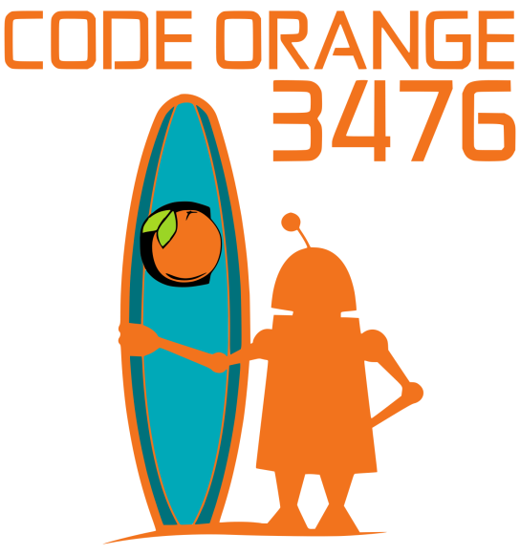The theme of the game is that two competing Alliances (Red & Blue) are in Deep Space collecting samples on “Planet Primus”. Unpredictable terrain and weather patterns on the planet make remote robot operation essential to their mission. With only 2 ½ minutes until liftoff, the 2 Alliances must each use their 3 robots to secure their Cargo Bays with Hatch Panels (plastic disks with hook and loop fasteners) and load as many Cargo units (orange rubber balls) as possible into their spaceships. Then as time runs out, the robots rush to return to their Habitat Platform (Hab Platform) and climb as high as they can. Nearly all robots will be able to handle the Hatch Panels and/or Cargo (Game Pieces): it is just a question of how many each robot can deliver in the limited time.

Six randomly selected robots are scheduled for each Match. They are randomly assigned to either a “Red” temporary Alliance or a “Blue” temporary Alliance. Scoring is for the Alliance as a whole, scores are not tracked for each robot. Since the 3-Team Alliances are randomly assigned there can be a great deal of luck involved in having either strong or weak partners and opponents.

The game starts with a 15-second “Sandstorm” where the student drivers’ are unable to see the field. This is simulated with a black curtain which is rolled down at the start of the Match. However, each Team can still move their robot using video cameras attached to the robot to see where they are going or using pre-programmed “Autonomous” movements or driving blindly. The first task during the Sandstorm is for each Team to have their robot leave the Hab Platform scoring Sandstorm Bonus points. Each Team can choose whether their robot starts at the lowest height (Level 1) which is barely above the carpet or on top of a 6” step (Level 2). They score 3 points by leaving from Level 1 or 6 points for starting on the more difficult Level 2 of the Hab Platform. Of course, there is some risk of tipping over, damaging the robot or getting stuck. During this period, the more advanced Teams will have their robots place Hatch Panels on Cargo Bays and load Cargo into those bays.

The field is dominated by 6 large structures: each Alliance has a “Cargo Ship” in the center and 2 “Rockets”, one on either side. Each Alliance basically plays on their own side with only 1 robot at a time allowed to go on the opponent’s side to interfere with their movements. Each Cargo Ship has 8 Cargo Bays, all at the same height. Each Rocket Ship has 6 Cargo Bays arranged vertically so there is one pair of high Cargo Bays, one pair of medium Cargo Bays and one pair of low Cargo Bays. Most of the Match is spent picking up Hatch Panels and Cargo from the Loading Stations in the corners and taking them to the Cargo Ship and Rockets. There is also a Depot with Cargo on the floor next to the Hab Platforms that can be picked up. Each Hatch Panel secured with the hook and loop fasteners on a Cargo Bay is worth 2 points. The Cargo Bays are designed so that if Cargo is loaded before a Hatch Panel is attached, it will roll out and not score. Also, only 1 Cargo per Cargo Bay counts in the scoring. The first Cargo loaded behind a Hatch Panel is worth 3 points.

Near the end of the Match, robots will return to the Hab Platform right in front of the Drivers’ Stations to score Hab Climb Bonus points. Getting completely onto Level 1 scores 3 points. Climbing up the 6” step to Level 2 scores 6 points. And, the most difficult and exciting, climbing up the 12” step to Level 3 earns 12 points. (However, if a robot never left the Hab Platform, then they are not eligible for these points.) When time expires, the Rockets “liftoff” and the Alliance with the highest score wins. Expect typical scores of about 40-50 points.

The goal during the 70 to 90 Qualifying Matches is to achieve top Ranking by earning Ranking Points (RP). These will be used to determine which Teams get to choose their 2 partners for an Elimination Tournament on the afternoon of the last day of the competition. Winning a Match earns every Team on that Alliance 2 RPs. All 6 Teams get 1 RP in the unlikely case of a tie score. There are 2 additional RPs available to each Alliance. The first is called the Hab Docking RP. If the sum of the points earned by the 3 robots for the Hab Climb Bonus in the End Game is 15 or more, each Team on that Alliance earns 1 (RP). That could be 6 + 6 + 3 = 15 points, but it is more typically 12 points scored by an advanced robot plus either of the other 2 robots scoring 3 or 6 points. About 30% of the Alliances will earn this RP making it highly desirable and fairly easy. The other RP (harder) is earned if either one of the 2 Rockets is completed with all 6 Hatch Panels and all 6 Cargo. Two half-filled Rockets does not qualify for this RP. And if both are filled, it is still just 1 RP. Less than 2% of all Matches will complete a Rocket. So the maximum number of RPs in a Match is 4 for one Alliance and 2 for the other (or 3 RPs each if there is a tie) for a total of 6 RP.

Before the Match starts, each of the 3 Teams can pre-load 2 of the Cargo Bays on the side of the Cargo Ship with either a single Cargo or a single Hatch Panel. This Hatch Panel is called a “Null Hatch Panel” because it does not count in the scoring. There are white tape markers on the Null Hatch Panel so the Referees know not to score it. If a Team chooses to put on 2 Null Hatch Panels on their 2 Cargo Bays, any of the robots on that Alliance can later load Cargo behind it that will score 3 points each. But they can never earn 2 points for a Hatch Panel on that Cargo Bay. Typically you will see all 6 of the Cargo Bays on both sides covered with Null Hatch Panels before a Match. If they pre-load a Cargo Bay with a Cargo, but fail to secure it with a Hatch Panel during the Sandstorm, it will automatically be rolled out at the end of the 15 second period. You might see this where the robots are good at handling Cargo and can later pick them up from the floor faster than going back to the Loading Station. Also, in addition, the 2 Cargo Bays in the front of the Cargo Ship that face the Driver’s Stations are pre-loaded with 1 Cargo each. They will score 3 points each if, during the Sandstorm, Hatch Panels can be attached to secure them. Although there is no bonus for doing this during the Sandstorm, watch many robots try this to get a “free” 3 points from the pre-loaded Cargo.

At the start of each Match, watch how many of the robots move forward to completely leave the Hab Platform. About 85% will do this. The more advanced robots will have a Hatch Panel or a Cargo (only 1 Game Piece is allowed to be controlled at a time) and will attempt to place it. Sometimes will you see a robot then pick up another Game Piece and go score it also. Typically an Alliance will score 3 + 3 + 6 = 15 points for the Sandstorm Bonus, plus, a handful of points for a couple Game Pieces. Then at the end of the 15-second Sandstorm, you will hear 3 bells and the black curtains will roll up so the student drivers can see the field.

Robots will move around the field, getting Game Pieces and scoring them. Some robots will only be able to handle Hatch Panels. Some of those will be able to pick them up off the floor. Other robots will only be able to handle the Cargo which will prove to be difficult to control since they are very bouncy. By accident, robots will drive up on top of a Cargo and be stranded until a partner pushes them off. Since the Cargo Bays on the side of the Cargo Ship face sideways, the student drivers cannot see if there is already a Cargo in the bay. If the robot does not have a camera transmitting video to a monitor at the Driver Station, the Team will have to keep track of where Cargo has already been placed. The more advanced robots will be able to handle both Hatch Panels and Cargo. So there needs to be a high level of planned strategy and coordination to get things placed in the correct sequence. If a robot is not good at handling either of the Game Pieces, they will typically be assigned the duty of “playing defense” where they go to the other side of the field, after the Sandstorm, to inhibit the opponent robots from scoring. When on the other side of the field, a robot cannot let any of its “arms” stick out beyond its bumpers. Robots are not allowed to damage other robots.

The Hatch Panels are stuck on with “hook and loop” material on the edges. If the robot does not push it on straight and only one side attaches, it might fall off or it will be knocked off when a Cargo is placed behind it. It is critical, when attempting to attach a Hatch Panel to align it both vertically and horizontally as well as parallel to the Cargo Bay wall. There are white lines on the carpet that robots can see, if they have optical sensors, to line up in the correct position.

When 30 seconds are left, you will hear a warning sound. When 20 seconds are left, you will hear a train whistle sound. (You have to imagine trains on Planet Primus.) In this End Game period, all robots must be on their own side of the field.

During the Match, you can follow the real-time scores on the Audience Display:

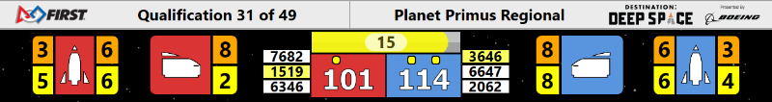

The number of the current Qualification Match is shown at the top with the number of the final Match. The numbers in the orange boxes tell the quantity of attached Cargo in the corresponding Rockets and Cargo Ship. The yellow boxes tell the number of attached Hatch Panels. The 3 Team numbers in each Alliance are shown next to the scores. The number of seconds left in the Match is shown in a progress bar above the scores. The color of the progress bar changes to indicate the different periods of the Match. The little yellow dots above the scores mean 1 or 2 additional RPs have been earned. The real-time scoring shown during the Match is not official. It does not include the End Game Hab Climb Bonus points. Sometimes penalties are not added into the displayed scores until after the Match is over. The display changes after the Match to list all the points for each category and other details.

A team can be on the Winning Alliance and still go down in rank. This is because a win only earns a Team 2 RP which are averaged into the existing total RP of all of a Team’s Matches. Teams that were previously ranked lower might have gotten 3 or 4 RP in more Matches giving them a higher average RP (Ranking Score).

A few General rules: During the Sandstorm, the robots from one Alliance cannot go on the opponent’s side of the field. A robot can’t pin an opponent for more than 5 seconds. Referees will point to the offending robot and wave their other arm counting the 5 seconds and then either wave it off, if the pin is released, or wave their flag for a penalty. Each robot can only control 1 Game Piece at a time. You can’t “de-score” the opponent’s Game Pieces. There are several “safe” zones where robots can’t be hit: like while on their colored Hab Platform for the climb. Breaking the rules results in 3-point fouls being called by the referees who wave the red or blue ends of their flags. More serious fouls, called Technical, result in a 10-point penalty.

After all the randomly assigned Qualification Matches have been played, the 8 highest ranked Teams get priority to pick partners for the best 2 out of 3 Matches Elimination Tournament. In case of a tie in Ranking between 2 or more Teams with the same average RPs, the Tiebreaker is the sum of all the Cargo points scored in all the Matches by each Team. If there is still a tie, then the sum of points for the Hatch Panels, Hab Climbs and Sandstorm Bonuses are compared in that order. The #1 Ranked Team gets to pick their 1st partner, then #2 picks and so on down to #8. Then #8 gets to immediately pick a 2nd partner, then #7 and so on back up to #1. This is called the “Alliance Selection”. Note that #1 gets to pick both 1st and 16th. This serves to even the playing field and give all Teams a chance of winning. The only rule is that if a Team “declines” to be picked they cannot be picked by another Team. If they are one of the top 8 Teams, they could still pick other Teams as partners to form their own Alliance.