Team No. Team Name Match

Hybrid

top ________ middle ________ bottom ________

Teleop

◻ Shot from key ◻ Shot accurately ◻ On offense side ◻ On defense side

◻ Played defense ◻ Crossed bump ◻ Balanced on bridge… ◻ with another robot

Penalties

Shot record
Draw a circle at the location on the field of every shot or pass. Write a T in the circle for shots scored on the top basket, M for shots scored in a middle basket and B for the bottom basket.

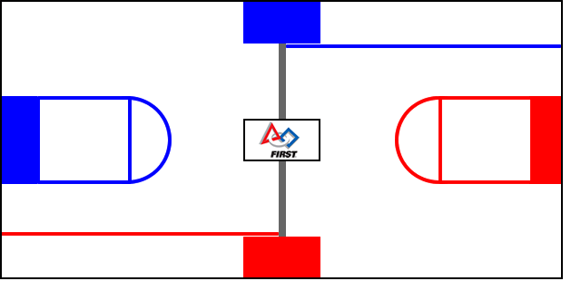

Completed shots

top ________ middle ________ bottom ________

Rating

Overall 1 2 3 4 5 6 7 8 9 10

