Swerve drive-mechanical
Concept initially came from team Neutrino, we heard about it through a mentor of Neutrino who used to mentor Winnovation. Their design was revised and improved by our team, but named “Midwest swerve” after the general area that both our teams are from. There is, however, only one interchangeable part between our swerve and theirs after our modifications, the CIM motor. 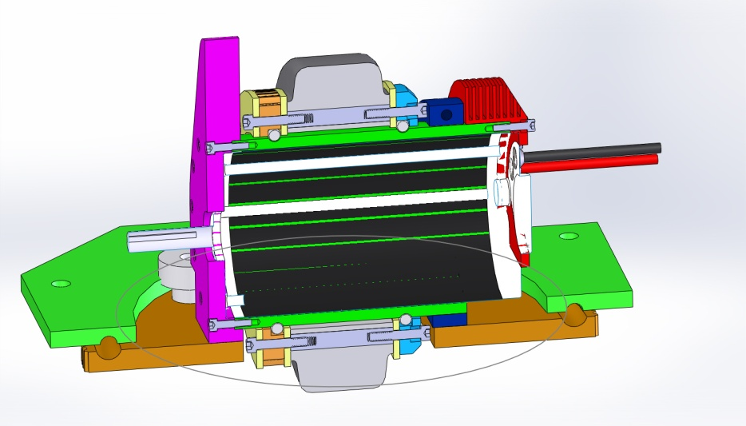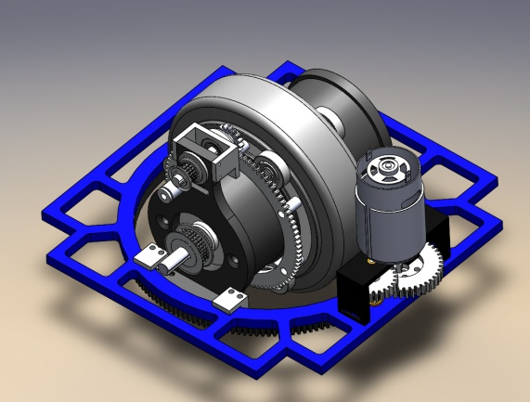
Some revisions of the original design
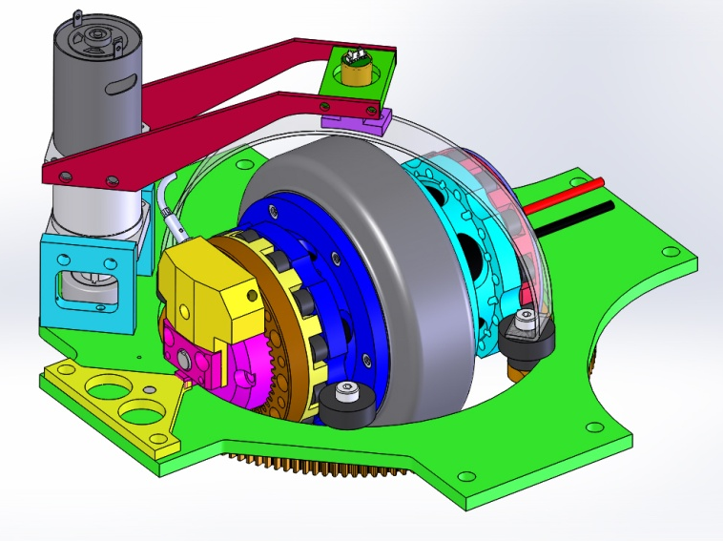
Early design lasted for approximately 2.5 years, during which we improved, redesigned, and tested the new swerve drive. These changes included using internal, shielded gear and no belts, as well as rollers outside the motor and the addition of steering encoders.
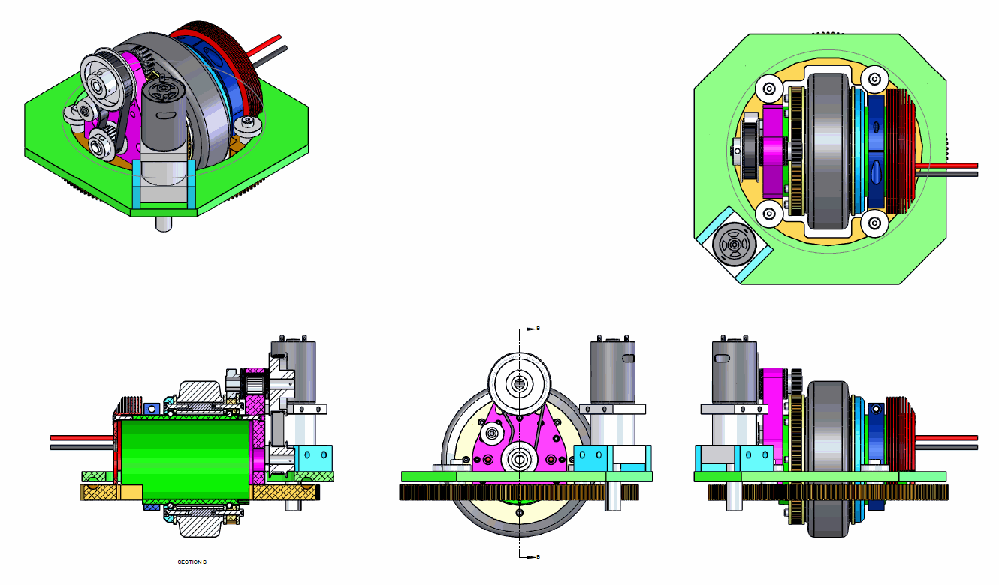
Original design
Current design
Made four “final” prototypes just before this season started to test, speed and maneuverability, as well as allow significantly extended driving practice and software development. These modules have had over 20 hours of run time, and are still working as well as when they started. They were disassembled after 10 hours of use, but showed no signs of damage, stress, and very minimal wear.
Analysis was done initially on a test chassis with the four prototype modules, which allowed for early determination of its capability, and resulted in the decision to finish and use it this year.
It was picked because of the significant maneuverability required this year, as there are no safe zones, and thus the robot will have to avoid defense and defend well. Torque and traction are important, to stand up to pushing, and push for ourselves. Omnis, mechanum and west coast, all are low torque, traction, or not as maneuverable. Swerve is the best of all three worlds, at the cost of complexity and weight.
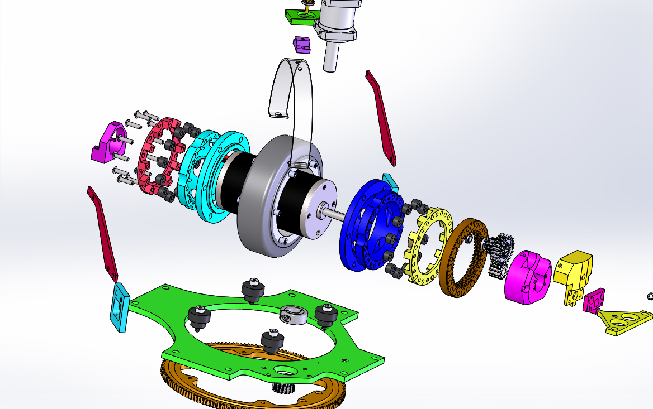
This design of swerve was picked for the low weight, low center of gravity, high speed, and durability. The novelty, though less so than the others, was also a factor.
The unusually low ground clearance (1.7” from the center of the bearing to the floor) and large bearing size (7” diameter) gives this swerve drive an extremely low moment of torque when hit, unlike tall, traditional swerve modules which may be damaged when pushed, or will torque and deform the chassis under high horizontal loads. These swerves push almost entirely horizontally, with very little rotary torque.
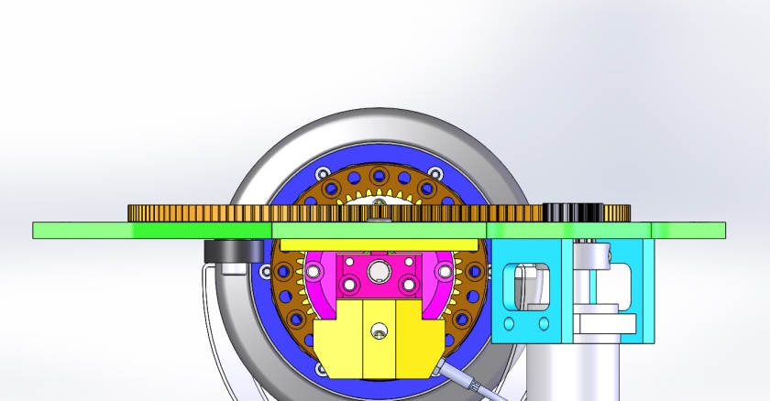
All modules steer totally independently (crab drive), the code computes the desired angles and speed for each motor. This allows the robot to move in any direction and turn on any axis, inside or outside of the robot.
Numerous redesigned elements and upgrades during the season included revised dead stops, cooling vents that force airflow over the motor, altered mounting plates, absolute encoders and encoder mounts for turning, new gear-end plate to cover the shaft and gears, added encoders to the CIMs themselves, magnetic tooth counters on the gear.
It uses banebot 550s, 20:1 Andymark planetary gear boxes, and has a 9.375:1 gear ratio to the module’s turning gear. The CIMs have a custom 8:1 internal, two-stage planetary gearbox (2:1 and 4:1 reduction), and modified 5” colson wheels, with the hub removed and replaced with some aluminum adapters that connect to the two radial bearings which support the wheel itself.
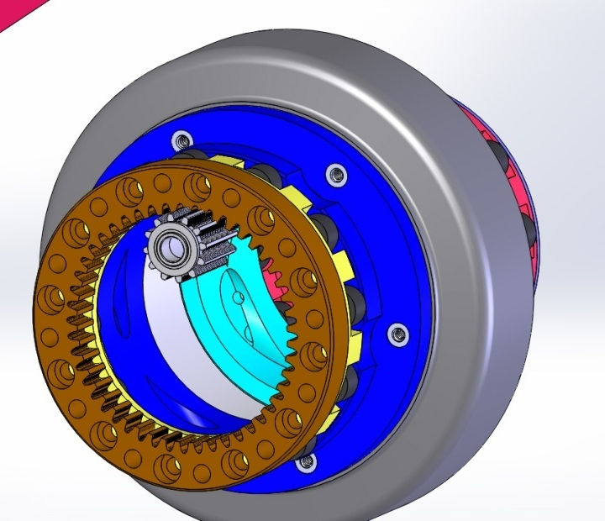
Steel gears are used internally, but the inward-facing gear (dark orange in the image below) that attaches to the hub is made of 7075 aluminum, as it needs to move fast, to save weight, and will rub on the internal steel gears without wearing. 7075 was chosen because it’s stronger than the 6061 that the rest of the drive is made of. The original prototypes used ceramic coated 7075, but during build season we didn’t have time to coat the new gears between machining and assembly. Even so, there is little wear even after several hours of driving and a regional.

To counter side loads, there is a delrin retainer directly on the CIM end cap. During normal operation, there is just 0.0018N of friction, and therefore virtually no performance degradation. It takes approximately a 60N side load to reduce speed just 1%, and will wear only 4/1000 inch per kilometer of driving under normal conditions. There is almost no damage from substantial side loads, as the large surface area distributes the force even more efficiently than the wheel and turning bearings.
14.5ft/sec theoretical, 11ft/sec actual, so it’s fast, even for a normal drive, and especially for a swerve drive. The original neutrino design moved at a maximum theoretical speed of 13.9ft/sec, and bomb squads swerve moved at a maximum of 12.98ft/sec. We verified our calculations using pictures of their swerves and by counting teeth on their gears/pulleys.
At 5300RPM, 5” wheels, and an 8:1 reduction, it would move 14.45ft/sec. (5300(rpm)*5(in)*pi)/(12(in/ft)*8(gears)*60(sec/min))=14.453ft/sec
At half speed, or 2655RPM, which was the original estimated speed, it will run 7.227ft/sec, however, in tests we reached an actual speed of approximately 11ft/sec, or 76.1% of theoretical.
The corner-cut chassis was very useful for a swerve drive, as it increases the length and width, beyond what’s possible with a rectangular robot, given the new rules on maximum robot size. The low center of gravity amplifies this effect and gives us an unshakable drive train.
Rollers on the motor and balls within the thrust bearing are delrin, and nylon, respectively, and therefore self-lubricating, and shock absorbent. They also will not damage the CIM or ball race if there’s an impact, radial or thrust. This avoids brinnel (dents from the balls) on the bearing track and motor casing. The delrin rollers roll on the cast endcaps of the CIM to give extra strength and accuracy. The normal motor casing was pretty low-tolerance and thin walled, so the original design used large, standard bearings and a steel sleeve. The new design is extremely strong, durable, and accurate, without the weight of steel parts.

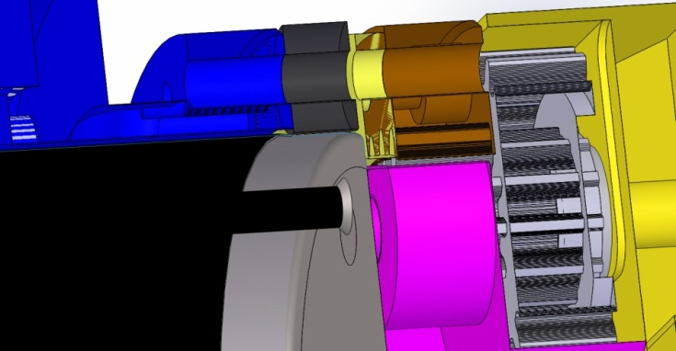
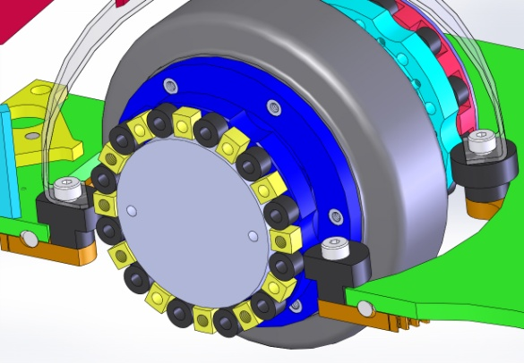
It was machined almost entirely by our team members: Emil, Jose, and Jackie, who milled and assembled most of the components by hand in just a few weeks during build season.

