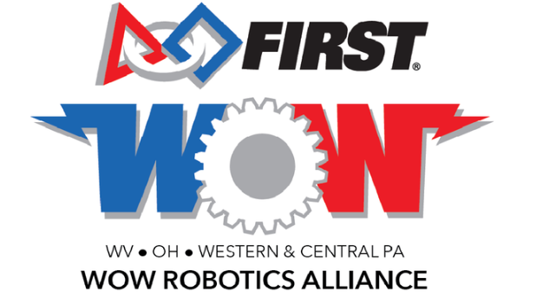

**2018 WOW Alliance District Championship - Mentor of the Year Nomination Form**

Submit by May 4th to Andy Bruening at [wowalliance@pastfoundation.org](mailto:wowalliance@pastfoundation.org), or bring to the team sign-in table by 9:00 am the morning of the event.

**Mentor’s Name:**

**Nominee’s Name:**

**Team Number:**

**Team Name:**

**Description of mentor’s activities that have helped their team grow within itself and to help the *FIRST* community:** (one page typed or two pages hand written)