


World’s First Online Interactive Contest for Industrial Application

- Get Involved with your Team
- Experience a brand new contest
medium
- Have Fun!

Contest Theme: Material Handling
Win: Prizes! Prizes! Prizes!
*Win up to $1500 in Prizes

[Internet Community-based
Interactive Technology Environment]

Innovate, Invent, Interact using a unique contest environment  Use VizSeek, a Breakthrough visual search technology and its VizSpace environment to create and collaborate with your team  Use VizSpace widgets to create your ideas | Create a design using the    Internet based Design Tool  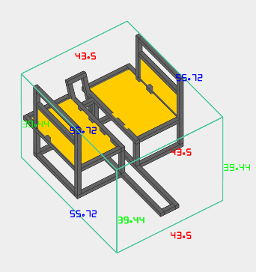  Example | Contest is open to all the US FRC teams  1st 50 teams registered are eligible to participate  Registration Opens  September 8, 2009  For more information check out  www.vizseek.com



Supported by:
Look for a Chief Delphi Thread with more information
and a link for the Contest INCITE soon!
The National Science Foundation

