Week 3 & 4 Vex Game: Robo-Rumble
Designed by: Kwami Williams, Alex Cormier, & Clarence Ankrah

Competition Rules:

Each match will be 2:45 minutes long. First 15 seconds of the match will be autonomous where each robot will be moving on its own. The next two minutes and thirty seconds of the match will be operator control where humans will control the robot. This period is divided into a two minute Operator Mode and a thirty second End Game. The object of the game is to score as many tennis balls in your alliance high goal and the human goal as possible. There will be 28 total tennis balls on the field and each robot will be allowed to start with 1 ball at the beginning of the game. The scoring opportunities are as follows:

Mission: | Point Value:
High Goal Scoring | 5
Human Player Goal in Alliance Zone Scoring | # of pts in goal
Human Player Outer Ring Scoring | 2
Human Player Inner Ring Scoring | 3

Robot Rules:

At the start of every match the robot can not be any larger then 15" x 15" x 24".

Any official Vex material can be used in any quantity except for the following:
- Only 1 Vex microcontroller
- Up to 10 motors/servos, any combination
- Only one battery pack

Robots built with the intention to destroy the field elements or opposing robots will not be allowed.

The Game:

The game is played on a 120" by 95" carpeted playing field. Teams will play in alliances comprised of two robots for a total of 4 robots on the field at once. The object is to have your robot score the tennis balls by shooting them into your alliance high goal. The balls scored in the high goal will come out of an opening at the base of the goal, and ONLY then will the designated human player be allowed to touch the balls. The HP objective is to shoot, at their own discretion, shoot the balls into the human player goal located in the center of the field. The balls scored in either ring of the human player goal will not count for any team until the conclusion of the End Game. During the End Game, and ONLY during this time, robots will be allowed to move the mobile human player goal (mounted on casters). The object here is to have the ENTIRE human player goal in your alliance goal. Accomplishing this task will give your team ALL the points scored in the human player goal during match play. The inner ring of the human player goal will be 12" in diameter, the outer ring 24" in diameter, and the entire structure 18" tall. The high goal will be 12" tall and 8" in diameter.

Penalties:

If a robot enters the high goal at any point the alliance will receive a 5 point penalty. If any robot tries to move the mobile goal before the end game has started, that alliance will be penalized 10 points. If anyone other then the HP for a team throws a ball, that specific team will have automatic disqualification and have their robot turned off. If the referees see there was intent of throwing a ball to destroy a robot, the alliance we be penalized 10 points. Any robot that scores into the HP mobile goal will be assessed a 10 point penalty towards their alliance.

Tournament Rules:

Teams will have the opportunity to play in as many matches as possible. The tournament will be run Round Robin style, the total amount of matches will be totaled and the team with the most wins will be the winner. If there are multiple teams with the same record, the tie breaker will be the determined by the total amount of points scored throughout the matches. All teams will be given the same amount of matches. There will be 6 matches, after match 3 there will be a 10 minute break to cool down the robots. Each team will be play 5 matches.
Start
Start
Black Zone
Red Zone
Black High
Goal
Red
High
Goal
Mobile Human Player Goal
Start

Designed by:
Kwami Williams
Balls
Alex Cormier
Clarence Ankrah

Start

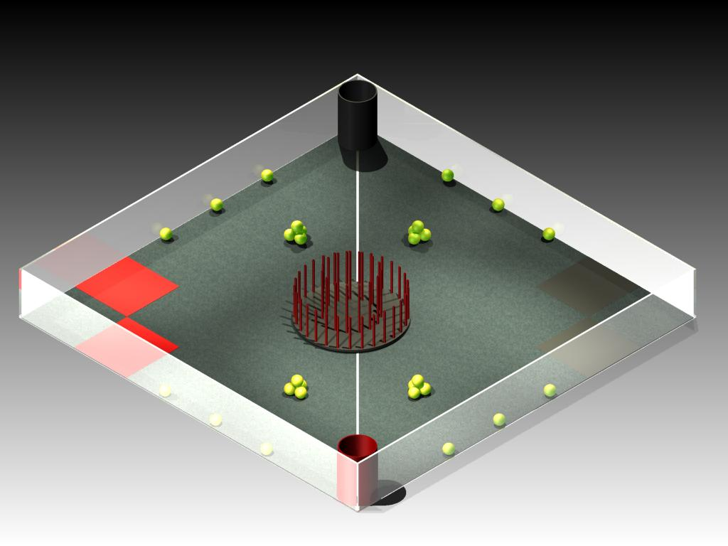

Field Materials:
8"dia, 24" tube
28 Tennis Balls
3 small casters
24"x 24" x ½" plywood – Mobile goal
½" doll rod/pvc 20' – 30'
Red/Black paint for mobile goal
32' 2x4 (8' each)

