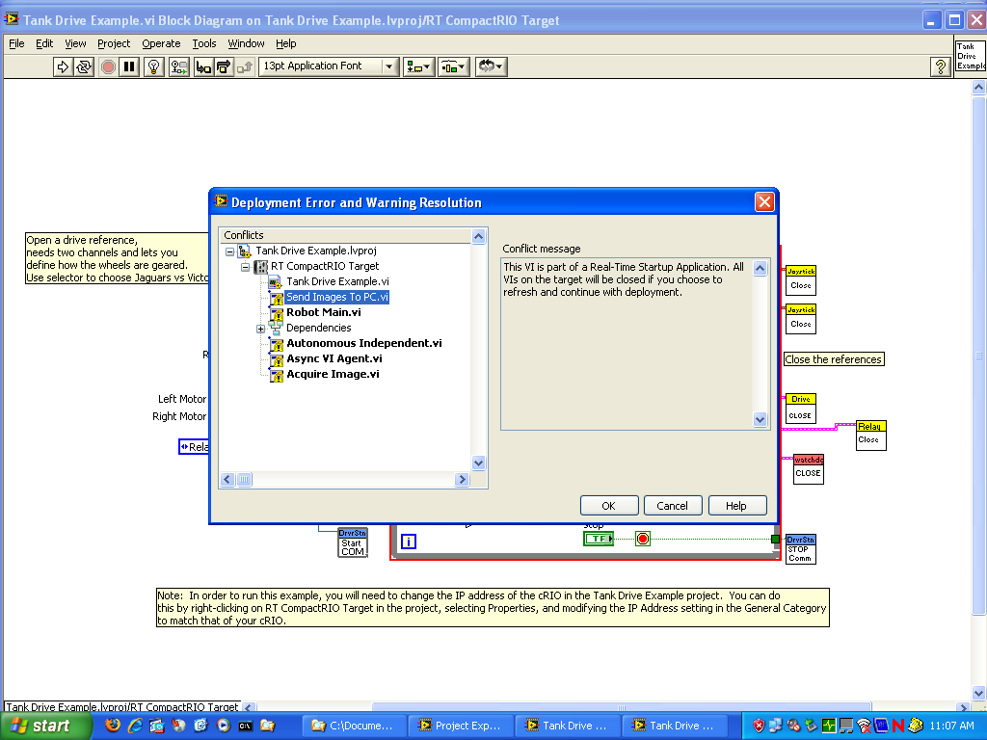

We get this and then it goes through and it loads 100’s of vi’s.
We press okay and then it appears to have deployed but then the robot is not responsive.

This is just joystick tank drive only.

All we are doing is trying to a program onto the cRIO.

We have followed the directions step by step

We have reimaged the cRIO also and it did not change the behavior.

