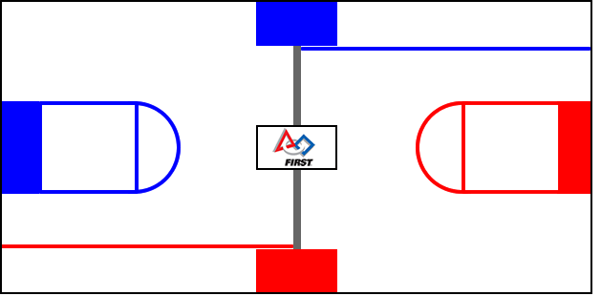
Team No. Team Name

 | Hybrid |  |  |  | Teleoperated |  |  |  |  | Endgame | Penalties
Match No. | Missed Shots | Top Shots Made | Middle Shots Made | Bottom Shots Made | Missed Shots | Top Shots Made | Middle Shots Made | Bottom Shots Made | Defense | Balanced on Bridge | Fouls | Technical Fouls | Yellow Card | Red  Card

