Robot output – actual view on left, after HSV transform on right.

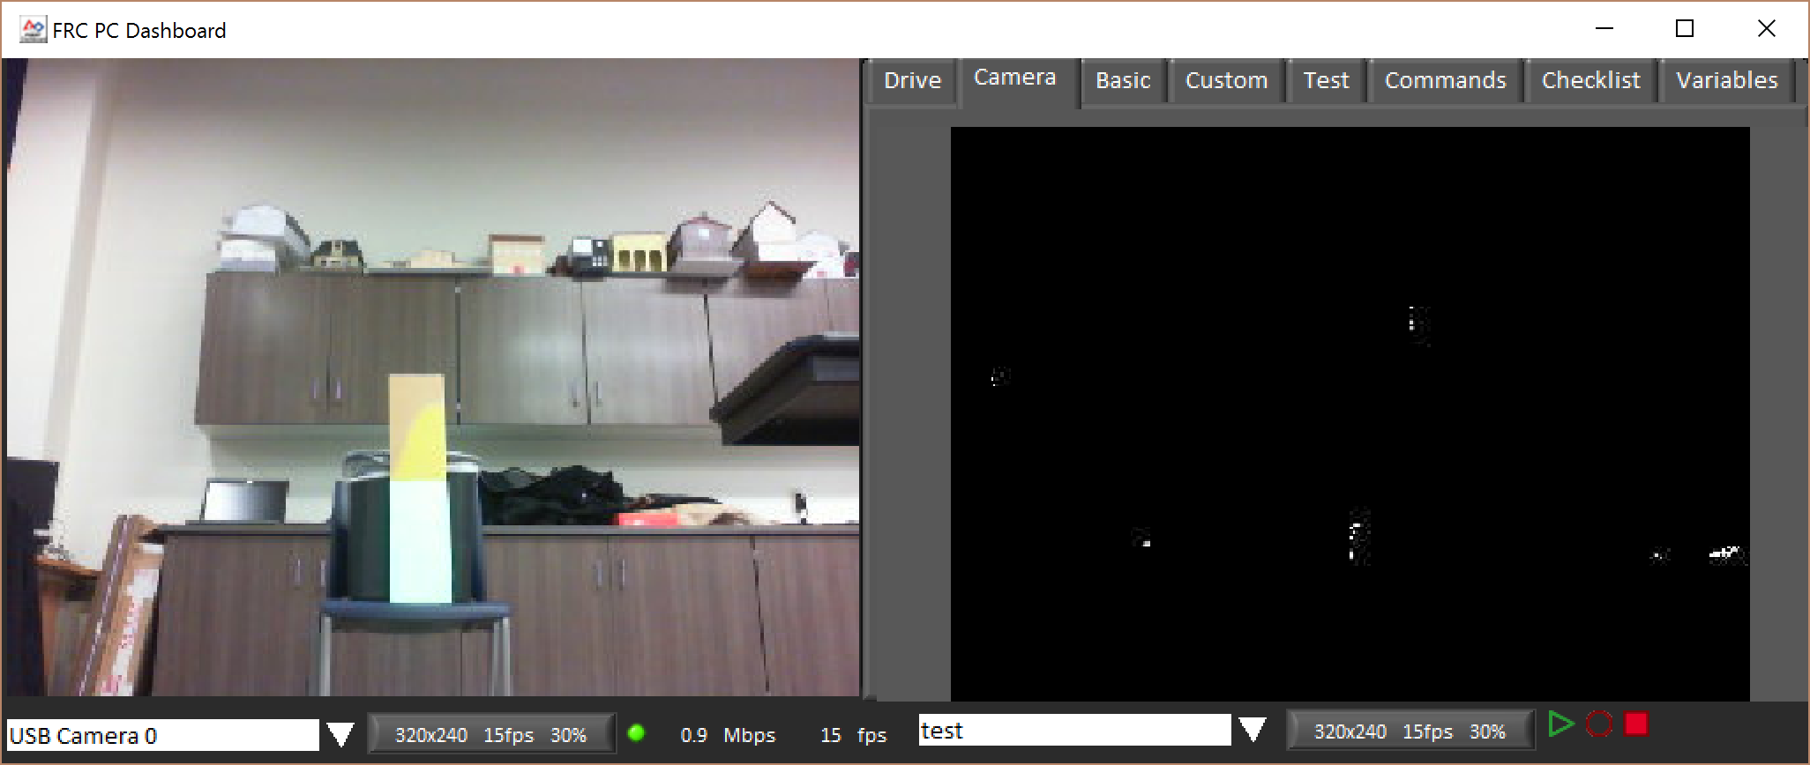

Grip output – actual view on left, after HSV transform on right

