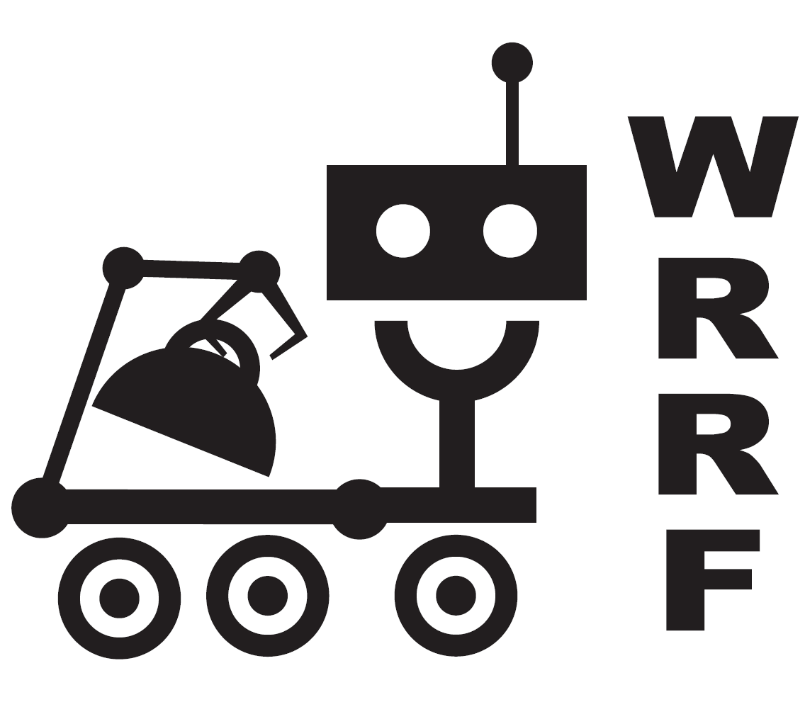
WRRF
Western Region Robotics Forum
PO Box 450 Moffett Field, CA 94035

September 20, 2006

Dear High School Administrator,

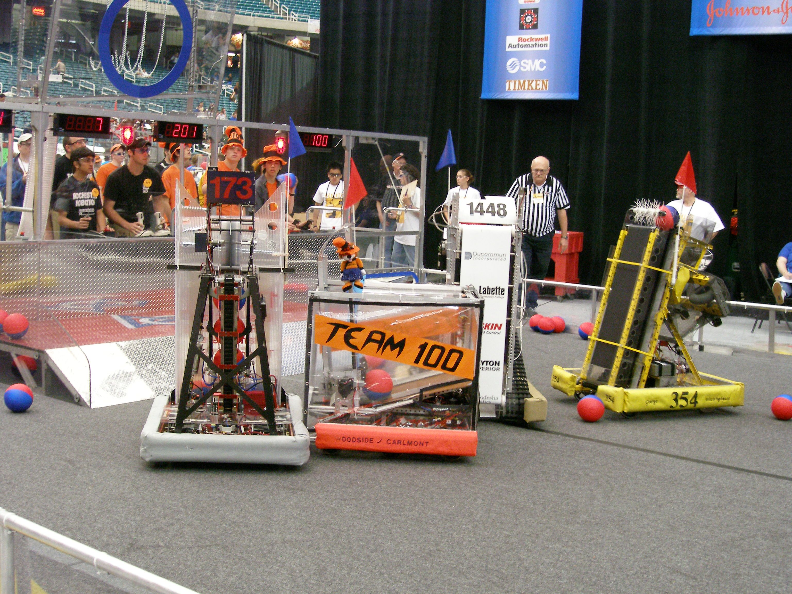
High school students and robotics – what’s right with this picture? At the 2006 WRRF California Robot Games you will see students excited about their future in technology. Combining the excitement of a varsity sport with a fascinating, real-world engineering experience, the FIRST robotics program lets students discover the value of education and careers in science, technology, and math. Each year teams of high school students work closely with industry mentors to compete in the FIRST Robotics Competition (FRC). This is a life-changing experience for many of the students involved – they gain an appreciation of technology, teamwork, and hard work, and, for many, the program has an influence on their chosen career path.
Photograph Courtesy Of Bob Kahn

On Saturday, October 28, you will have the opportunity to observe this innovative, educational program in action at the 2006 WRRF California Robot Games to be held at Pioneer High School in San Jose. This off-season replay of the 2006 FRC “Aim High” game is being organized by the Western Region Robotics Forum (WRRF), a not-for-profit organization supporting Bay Area FIRST robotics teams. In this exciting game where 120-pound robots compete in three-versus-three alliances, the action is a combination of autonomous (software control) and remote control. The robots have to accurately shoot 7-inch balls into low corner and high goals, as well as climb a 30° ramp. Approximately 24 teams from Northern California will be competing. This event will be as exciting for the spectators as it will be for the student participants and is free and open to the public.

2006 California Robot Games
Saturday, October 28, 2006

Pioneer High School Main Gym
1290 Blossom Hill Road.

San Jose, CA 95118
Qualifying Matches 9:00 a.m.– 12:00 p.m.

Playoffs 1:00 –4:00 p.m.

Please plan on attending. If you currently have a robotics program, there is no better way to see the impact it has on your students. If you are contemplating starting a robotics program in your school district, this is a great opportunity to see the robots in action, talk to the advisors, industry mentors, corporate sponsors, and, of course, the students themselves.

Please post the attached flyer for the 2006 WRRF California Robot Games and pass on this information to your science and technology staff. I hope you can join us and see for yourself the educational impact of a robotics program.

Sincerely,

Laura Rhodes
2006 California Robot Games
Planning Committee
About WRRF: The Western Region Robotics Forum (WRRF) is a 501(c)(3) not-for-profit organization dedicated to promoting the educational use of robotics and providing support for the Bay Area FIRST robotics teams. WRRF puts on a series of pre-season workshops for FIRST teams covering a wide range of subjects, including: team management, electronics, computer animation, drive train design, and software development. WRRF organizes the California Robot Games off-season competition. For more information on WRRF, contact Ceal Craig, Ceal@WRRF.org, OFC/HM: (408) 259-2836, CELL: (408) 828-2643.

About FIRST Robotics: Founded in 1989 by accomplished inventor Dean Kamen, FIRST (For Inspiration and Recognition of Science and Technology) motivates young people to pursue opportunities in science, technology, engineering, and math. More than 1000 teams of high school students world-wide compete annually in their flagship competition, the FRC – First Robotics Competitions. For more information see the FIRST website at http://www.usfirst.org/.

