# Executive Summary

## Sponsors

* J C Penney
* America’s 091 Huey Foundation
* Time Warner Cable
* The Elmendorf Family Foundation
* Texas Workforce Commission

## Impact on Team Members

* 100% of Team 3999 members plan to attend college
* All current members are interested in exploring majors in a STEM related field.
* 8 of 10 team members went on to study STEM related curriculum after High School.
* Team members come from different schools and locations and have to work together to be successful.

## Role Model Characteristics

* Formed when students, mentors, and teachers wanted to provide access to FIRST without regard to campus or district affiliation.
* Students come from 5 different high schools and home school.
* The team has been invited to participate in the Snowball Express event for the last two years.
* Involved with the local fire department, Boys and Girls Club, and the local youth centers on Fort Hood.
* Mentored 3 local FLL teams and is the main sponsor for the T3 FLL team.

## Impact on Community

After winning the Rookie All Star Award at the Alamo Regional and a trip to the Championships in St. Louis, mentors from Shadetree provided workshops on Fundraising and Rookie Preparation to multiple teams in the Central Texas and San Antonio areas. At the 2012 Roundup the team was able to help other teams by sharing our knowledge and experiences. To support other FIRST competitions, the team provided referees, scorekeepers, and judges for the FLL Regional in Killeen, TX.

## Innovative Methods to Spread FIRST

* Shadetree conducted a series of five workshops for the community to introduce the robot building process. Harvest Technologies of Belton, TX presented a workshop on Commercial 3D printing during one of the workshops.
* Hands-on presentations are given throughout the year to local Boys and Girls clubs, Boy Scout troops, and local schools.
* Shadetree was the only FIRST team to attend the Snowball Express event for family members of fallen military heroes.

## Strength of Partnership

Team 3999 was formed so that all students, mentors, parents, and teachers would have access to FRC without the constraints of a school or district affiliation. Team members attend different high schools or home school and live in different cities. Shadetree partners with various community organizations to raise funds during the year to offset costs. Local restaurants and civic organizations often donate time and assist the team in an effort to sustain the program.

## Communication Methods

* Multiple articles published about Shadetree in the Killeen Daily Herald.
* Appearances on YNN Cable news.
* Team webpage and a group page on Facebook.
* All material is shared with the America’s 091 Huey Facebook page.
* Monthly meetings held at the Community Center open to the public.
* Flyers and promotional materials available at all demonstrations and fund-raising events.

## Other Considerations

Team 3999 is not affiliated with a school district or civic organization. All robot building takes place in a mentor’s garage and meetings are conducted at the Community Center. The team is funded by grants and community fund-raising. Our proximity to Fort Hood allows us to share FIRST with members of the military at the largest post in North America. Although we are only in our second year, the team conducts itself in a manner that reflects a much more seasoned team.

## Photos

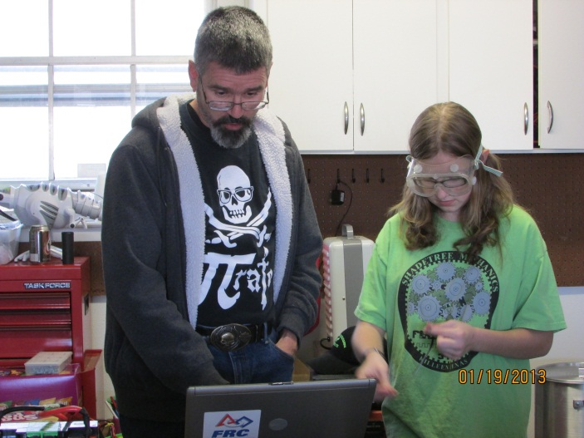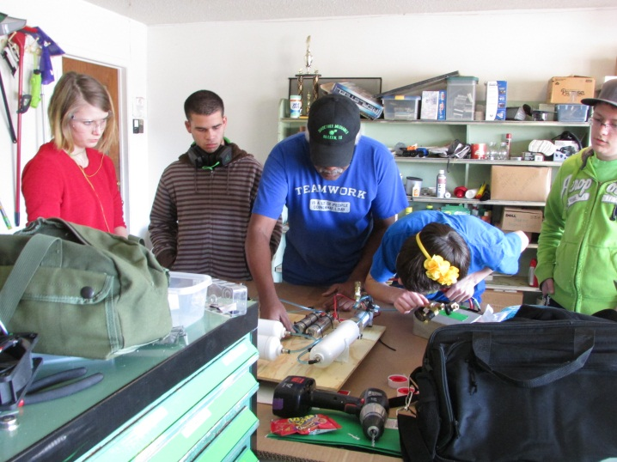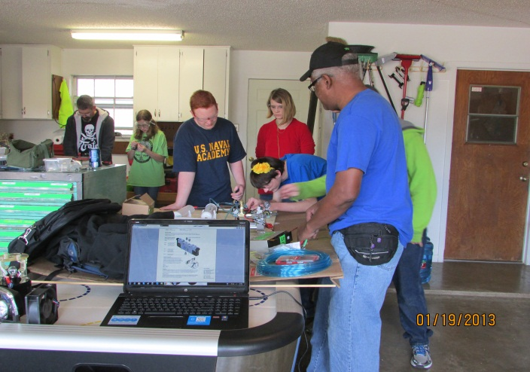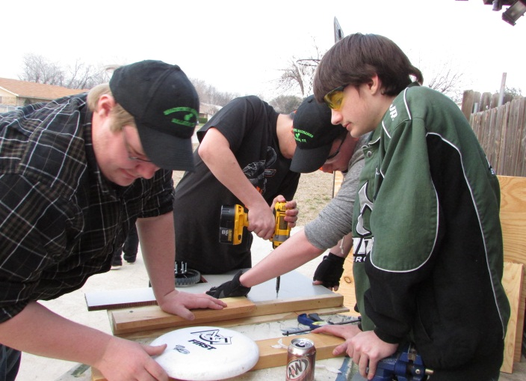

## Essay

On a cloudy night in May 2011, Fort Hood, TX, had one of the worst thunderstorms in Texas’ history. A group of people gathered during this thunderstorm and discussed the need to make STEM education available to all students without regard to assigned school district or location. It was during that monstrous downpour that the Shadetree Mechanics Robotics Team was born.

As we move into our second FRC season, FIRST Team 3999 has truly shown that, with hard work and dedication, anything is possible. Through the combined efforts of our remarkable mentors and students, we have been successful in introducing our surrounding community to the ideals and principles of FIRST. We have remained committed to providing quality extracurricular programs designed to foster interest and promote education in science, technology, engineering, and mathematics to students of all ages. We have encouraged and welcomed new students and mentors from across the Central Texas area. Our open-door policy has allowed students from diverse backgrounds, such as students from different school districts and from homeschool environments, to participate in a program not otherwise available to them.

Throughout the past year our students have learned and embraced the ideals of FIRST. Students and mentors from FIRST Team 3999 understand that FIRST extends beyond simply building robots. Whether creating a design or testing a feature, our students realize that frustration and failure are merely part of the process. They have learned to step back, regroup and then move ahead. Although the finished product is something to be admired, the journey is something to be remembered.

There is a close relationship between our mentors and students. Our veteran team mentors are accustomed to teaching and sharing information with students of varying ages, helping younger members integrate with more experienced team members. Former students have also returned as new mentors providing valuable knowledge and experience. This cycle ensures that the team will always have a wealth of knowledge to draw on.

In addition to maintaining sustainability in team membership, FIRST Team 3999 understands the importance of maintaining financial stability. As a non-school-affiliated team it is vitally important for us to actively reach out to potential sponsors and maintain mutually healthy relationships with those who support us. As members of the FIRST community, it is imperative that we strive to maintain integrity within our team and promote the ideal of gracious professionalism not only with fellow FIRST teams but with our sponsors as well. FIRST Team 3999 takes great pride in our ability to raise enough funds to cover the 2014 season in addition to the current year. Thanks to our wonderful sponsors and the fundraising efforts of our members, we have been able to secure FIRST Team 3999’s return next year for a third season. While grants provide a large chunk of the funds that the team uses to operate, fund raising is essential so the team will be self-sustaining. The team had the robot outside of Outback Steakhouse on multiple weekends to raise funds for the upcoming season. Prize drawings and spirit nights at local restaurants were also on the fundraising agenda.

From the team’s inception, being an active member in the community has been an integral part of our team. Starting in September 2012, FIRST Team 3999 provided five classes at the local community center, highlighting the key components of designing and building a successful FRC robot. Both mentors and students from the team participated in teaching these classes, while students from multiple schools and community organizations attended them. By providing these classes, members of FIRST Team 3999 had the opportunity to reach out to members of the community and share not only their knowledge but also their experiences with US FIRST as well. The workshops quickly inspired many of those who attended to pick up a wrench and start building a robot with us, yearning for the same passion of FIRST that we possess.

Throughout the year, FIRST Team 3999 had the privilege to host numerous demonstrations for local groups such as Boy Scouts, the Boys and Girls Club, local youth centers, and the public library in an effort to bring the ideals of FIRST to the community. At these demonstrations, our students brought an FRC robot as well as an FTC robot and any other current projects. After team members demonstrate the robots, attendees have the opportunity to ask questions about how the robot works and how they can get involved. There are always opportunities for hands-on learning, usually involving driving the robot. These demonstrations are just another way we grow our team and continue our outreach to the community.

After partnering with the America’s 091 Huey Foundation last year, FIRST Team 3999 was invited to participate in the community’s 2011 Veterans Day parade. With the help of the FRC robot, the team made their presence known again by participating in the 2012 parade and passing out flags and brochures with information about the team and how to join. In an effort to support the mission of FIRST Robotics and honor the memory of Dr. Bart Kamen, the 091 Huey Foundation has introduced a new scholarship for the 2013 competition season. The unique relationship FRC Team 3999 shares with the 091 Huey Foundation was an essential factor in being chosen to receive the inaugural Dr. Bart Kamen Memorial Scholarship Award.

One of our favorite examples of our team’s outreach is FIRST Team 3999’s participation in Snowball Express. Snowball Express is an event dedicated to providing a weeks’ worth of fun and relaxation for children and surviving spouses of military heroes who have died protecting our country while on active duty since 9/11. Through our partnership with the 091 Huey Foundation, Team 3999 was invited again in 2012 to support the event by providing demonstrations and assisting the children in operating the robots. First Team 3999 is proud to be a part of giving back to the families of those who made the ultimate sacrifice. Because a large portion of the members on our team are associated with the military, our attendance at this event has a special significance for all members of the team.

In summary, Team 3999 has become a destination for any student, teacher or mentor with a desire to learn or teach robotics. The team boasts a geographical footprint that spans 4 cities. Students come from 5 different high schools and 2 different school districts. As the word spreads about Team 3999 local companies and organizations are taking notice and helping the team expand. After a great rookie year in 2012 Team 3999 expects to be a force in 2013, and looks forward to a bright future.