Real Time Multi-Square Detection and Tracking

____________

An Engineering Paper
Presented to
Junior Science, Engineering and Humanities Symposium
Maryville University

____________

By
Hunter Park
Junior
600 Campus Drive of
Wentzville, Missouri
63385

February 2012-April 2012
Jennifer Berendzen
Sponsoring Teacher
600 Campus Dr.
Wentzville, MO 63385

Acknowledgements
David White
Jason Buxton
Vince Redman
Jennifer Berendzen
Wentzville School District

Abstract
Real Time Multi-Square Detection and Tracking
Hunter Michael Park, 4015 Key Harbour Drive, Lake St. Louis, Missouri 63367
Wentzville Holt High School, Wentzville, Missouri
Teacher: Ms. Jennifer Berendzen

This paper presents a method to track, organize, and view reflective squares in real time using the Microsoft Kinect sensor. Before the possibility of tracking could occur, image processing was required. The images were captured from the Kinect IR camera as grayscale and then went through numerous filters such as erosion, dilation and thresholds. After the image was processed, calculations could be made to show how far away in Cartesian coordinates and the degree of turn in respect to the X, Y, and Z planes the squares were in relation to a fixed position. In order to do this, image and object point pairs are created, making the center of the top target the origin. The image feed to the Kinect defines the image’s image points and uses vector calculus to tell the change in the vector’s characteristics in relation to the standard image. The object pose of a given set of object points is estimated, the translation and rotation vectors are found between the two images, and then converts the eigenvalues to eigenvectors, and the final result are the eigenvectors that tells how far away the squares are in relation to the Kinect, as well as the pitch, roll, and yaw.

Background
Recently, many research teams have used the Microsoft Kinect and other similar tools to conduct research. One particular group, Microsoft research, used the Microsoft Kinect to scan and recreate objects it circled using the depth map readings, while others simply used it as another camera. Another Microsoft research team also used the Kinect to track pose recognition [1], and they also used OpenCV (Open source Computer Vision) to assist them in tracking people with a single depth map camera. The implemented a data tree to reduce computation time.
Introduction
The purpose of tracking multiple squares was for a FIRST (For Inspiration and Recognition in Science and Technology) Robotics Competition (FRC). The object of the game was to play basketball with robots, but with four hoops instead of just one (Fig. 1). The backboard was a typical one found in a gym, but the tape on it was retro-reflective, meaning it redirects light aimed at it directly back at the source, so it made tracking it easier. Around the tape was an inch of black electrical tape, which ensured the edges of the reflective square would not blend in with the backboard. The backboard itself was made of Lexan, a clear plastic that can bend well past 90 degrees and allows light to pass easily through. This ensured that the infrared (IR) light would not reflect off of the backboard and interfere with the tracking of the squares. The target range for this program to run at is between 5 and 30 feet, and also be able to track the targets at 45 degrees of rotation in 3 dimensions, pitch, roll, and yaw. The vision solution was used to automatically aim and shoot the game pieces into the baskets without human control.

Fig 1. FIRST – Rebound Rumble competition playing field
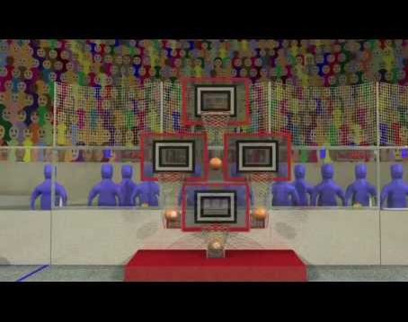

Apparatus
1) The Kinect Sensor
The Kinect is an up and coming sensor platform that has recently been widely-available in stores, mostly for gaming applications. It incorporates a structured light based depth sensor, a coloured camera, an IR camera, and an IR light to accompany the IR camera. Because the depth map has a range of 50cm to 5m (16.4 feet), which is too short of a distance required for this program to be useful for competition, the IR camera was used to ensure that adequate vision of the squares was possible at all times, regardless of distance. The maximum distance this system was able to handle was found to be approximately 10.4m (35 ft.). This distance could have been much greater if the thresholds were changed to be more sensitive, but this was not needed because the robot that used this program only had the capability of making baskets from only 30 feet away.
The Kinect sensor platform has been used in many recent research projects involving computer vision and tracking, most involving the depth map. Issues many people have run into are the numerous holes in the depth image, meaning that it depth camera outputs places where it cannot find how far away it is, and motion blur, which leads to missing data. It is becoming more apparent that the complexity in computer tracking is parallel to the advancement of the cameras themselves.
2) Software
This project was performed on a Lenovo ThinkPad T43 running Ubuntu 9.04 64-bit OS. A software development tool suite called Qt (pronounced cute) was used. The reason this OS was selected was because it is essentially the king of all operating systems when it comes to programming and has a quick compile time compared to Windows and OS X, and is also free and easy to acquire. Qt is a cross platform C++ integrated development environment. Qt was used to enable easy communication between the computer mounted on the robot and the cRIO, an industrial control system that runs the software controlling the robot and is also on the robot.
3) OpenCV
OpenCV is a cross platform, widely used open source library used for real time computer vision developed by Intel. OpenCV runs on Windows, Android, Maemo FreeBSD, OpenBSD, iOS, Linux and Mac OS. OpenCV has been used to automate cars in long distance courses to in labs at MIT, Harvey Mudd, and Canterbury. OpenCV was designed for computational efficiency and with a strong focus on real-time applications [2]. It was written in optimized C and C++ to reduce execution time. The library can take advantage of multi-core processing and has been adopted all around the world. OpenCV is widely known; there are more than 47,000 people active in contributing to the OpenCV library and it has an estimated number of downloads exceeding 5.5 million. OpenCV’s usage ranges from interactive art, mine inspection, stitching maps on the web and advanced robotics.
Basic Structures
Some fundamental aspects of programming are the same universally, meaning every language has them. CvPoint is an example. It is a 2D point with x and y coordinates. It marks a particular spot on an image, whether it is blank or loaded from a file. To be more precise in where to mark the image, CvPoint2D32f is used. This is a 2D point presented by two 32-bit floating point numbers, meaning it does not have to be an integer, which enables it to mark in-between pixels. Similarly, CvPoint3D32f is a 3D point with floating-point coordinates x, y, and z. With this comes CvSize, a pixel accurate size of a given rectangle (width, height) where width and height are integers. One step beyond CvSize is CvSize2D32f, which does the same thing, but adds sub-pixel accurate sizes of the rectangle given where width and height are floats. A very similar function, CvRect, also gives a rectangle that is given x and y in integer values.
When getting into data manipulation or storage of data, CvScalar is ideal. It is a container for 1-4 tuples of doubles. Another data storage function is CvArr, which is an arbitrary array, or matrix. Derived from CvArr is CvMat, a multichannel (as in multiple layers) 2D matrix, where the amount of channels, rows and columns can be decided by integer values. Derived from CvMat is IplImage, which contains n channels, and also has image width, height and depth, in bits. Some possible depths are: IPL_DEPTH_8U, IPL_DEPTH_8S, IPL_DEPTH_16U, IPL_DEPTH_16S, IPL_DEPTH_32S, IPL_DEPTH_32F, IPL_DEPTH_64F, where U means unsigned, S is signed, and F is floating. Since IplImage originated from version on of OpenCv it is not compatible with all V2 OpenCV functions., one may input a CvArr when a function asks for a CvArr, CvMat or IplImage, and CvMat when a function asks for a CvMat, or an IplImage, but one can only use an IplImage when the function allows it, and it cannot be used in place of CvArr or CvMat.
CvMemStorage is a low-level structure that creates growable memory storage which can be used to store dynamically growing data structures, such as sequences and graphs. Another very useful but complex data structure is CvSeq. CvSeq is a growable sequence of elements. There are two types, dense and sparse. A dense CvSeq is used to represent a 1D array, such as vectors. It does not have gaps in between, meaning if an element is inserted or removed from the middle; the elements from the closer end are shifted. A sparse CvSeq has a CvSet (a collection of nodes) as a base class. This type of CvSeq is used for unordered data structures, such as graphs or sets of elements.
With these basic structures of data, or arrays, manipulations may occur to produce uses for them. CreateMat creates a matrix header and allocates the matrix data, or says how many rows, columns and channels there will be in it and also if it is sign, unsigned or float. CreateImage creates an image header and allocates the image data with CvSize, and also bit depth and amount of channel. CreateSeq creates a sequence that returns a pointer to it. Since computers have limited memory storage, every memory storage and window created is required to be destroyed at the end of code to prevent data from leaking when programming.
All of these data structures and manipulations of data structures were used in this program. Each function requires a specific type of input, whether it is a CvArr, CvMat, or IplImage that can then either populate it with data, do calculations on it, copy it, or erase what has populated it.
Construction of Code
In order to be able to do calculations with an image, the program needs to have characteristics able to detect on the image. The first step in any computer vision program is to acquire an image. Since the squares were made from reflective tape, using the IR camera was possible. IR was useful for this task was because it would eliminate problems with tracking other non-reflective squares in the background.
Fig 2. Unprocessed Kinect IR image
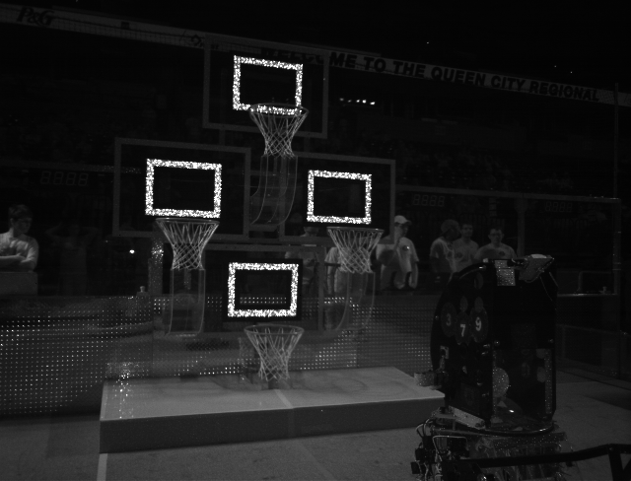
Fig 2 right before a match began at a FRC competition in Cincinnati.
The first step in image processing is converting it from gray scale, to a binary image which is all black or white, which makes the pixel values 0 or 1. A regular RGB (red blue green) image can have the same bit depth as a gray scale image, but it has three 2D channels of matrices, one for each colour, while a gray scale image only has one 2D array. This process is required to threshold the image. Thresholding an image means that if the pixel value is greater than the two threshold values chosen, it turns white, and every pixel below the threshold stated turns black.
After the image is converted to gray scale and put through the threshold, the image is eroded using
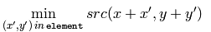 where x and y are pixel coordinates, and x’ y’ are the pixels in a structuring element. Src stands for the source image, the image it applies the function to, and returns another image dst(x,y), the destination image. The source image and destination image can be the same, meaning the function would repopulate the source IplImage with the changes this function made to it. Eroding an image means taking away pixels wherever the image changes colour, giving the illusion that the image is shrinking, or eroding. The image that is given using the specified structuring element then determines the shape of a pixel neighborhood. It can be applied as many times as desired.
The next step is called dilation. An image is dilated using the equation
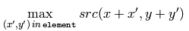. The variables are the same as stated in erosion. This equation dilates the image it is given using the specified structuring element that determines the shape of a pixel neighborhood over which the maximum is taken. The function adds pixels to the contours, which gives the illusion that the image was dilated. An image may be dilated as many times as desired. The purpose of eroding an image then dilating it is to reduce noise in the image. These steps have values for which how many pixels the user wants to take away or add in. This gives the user freedom to either apply small changes per erosion or dilation and apply it many times, or use the functions once and make them add or subtract many pixels.
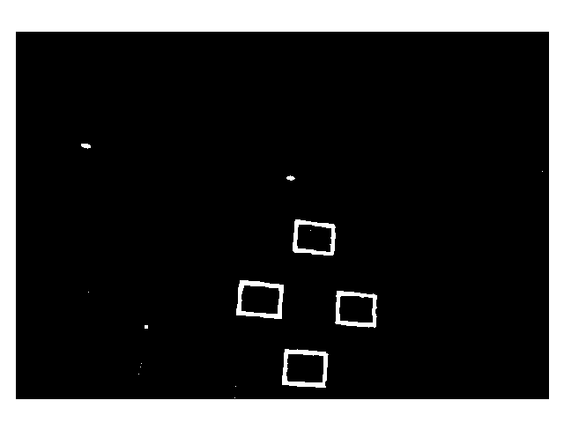
Fig. 3 Processed Image

Fig 3 was during a match while the robot was in motion. After the image has been processed, the squares are much more defined, and noise is virtually eliminated. The white specks above and to the left of the targets are from the stadium lights, which also emit IR light.
Now that the image has been processed, the act of targeting the squares is now possible. The first step is to find the contours of the image, or where the image turns from white to black or vice versa. This is done with the function cvFindContours, which draws them on the image. Then these contours are run through the function cvApproxPoly, which approximates the contour of a polygon. Before this data can be used, it must be organized to return squares and their corner coordinates. This was done first by eliminating everything but polygons with four contours, and then eliminates everything that did not have angles near 90 degrees. With both of these parameters in place, the image is saved in a sequence of squares. Then to accompany these squares, the 4 corners of the contours were found. These corners would help in deciphering whether the square was an inside or outside square, and also to find the centers, which is needed to assist in aiming the shot in the competition.
The next step is to orient the centers. To do this, the centers for every square were found by a simple averaging of the corners, and then compared the pixel coordinates of the squares to orient them. After this step has been executed, the corners of the squares are matched in image coordinates with the same corners in 3D coordinates. Finally, the determination of whether the square was an inside or outside square was needed because in some solutions, the centers did not match up. This was done by calculating the slope of opposite corners, bottom left and top right, then checking the pixel value outside of square that is on the slope. If that pixel is white, the square is an inside square, if not then it is an outside square.
Once the image point and object point pairs have been determined they are passed to the OpenCV function cvFindExtrinsicCameraParams2. This function estimates the object pose given a set of object points, their corresponding image points, along with the camera matrix and distortion coefficients (stored in an intrinsic parameters matrix) when it is compared to the image points. A very crucial step to ensure optimal results was to calibrate the camera. To do this, the function CalibrateCamera2 was called. This finds the camera’s (in this case Kinect’s) intrinsic parameters such as the field of view. 3D object points must be know beforehand and specified.
Lastly, the rotation and translation matrices are converted to three Euler angles along each axis (X, Y, and Z) as well as the X, Y, and Z distances relative to the top target.
The end result has the distance to the target basket, distance to the basket center, how many feet away it is from the target in the x, y and x dimensions as well as the pitch roll and yaw drawn on the gray scaled image, and not the processed one to give it a more applicable feeling. All the output data, such as distance in the x, y and z plane as well as rotation vectors are printed on the screen. Another aspect that was used for the FRC game was an estimate of accuracy. The method used to gauge accuracy gave 20% for every outer square and 5 percent for every inner square. This allowed the driver of the robot to see an estimation accuracy of the reading.

Fig. 4 Output Image
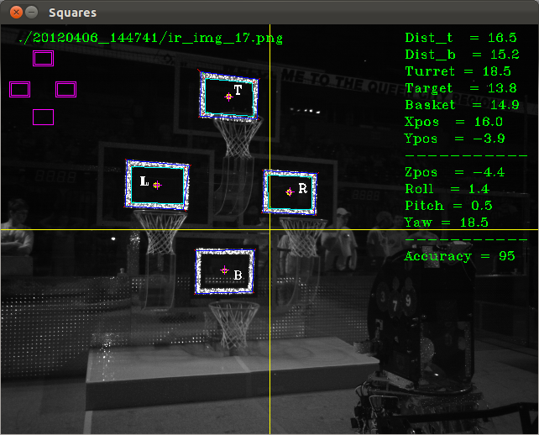
Where Dist_t is the target distance, Dist_b is the distance to the center of target. Turret is the angle of the turret, Basket is angle to target center, and Basket is angle to basket.
Fig. 4 is a processed image taken from the Kinect in the first few moments of the match right before the robot shot. The robot was about 16 feet out and made baskets regularly from this distance and much greater ones.
Results
The results showed that the program is very reliable for solving the task it was designed to solve. It enabled the robot to be very precise during the match. A very interesting and useful aspect of the code is that because the centers of the squares are ordered, when the camera is unable to detect the top target, but able to detect any of the other 3, the program is able to calculate the center of the untracked target based off of the centers it calculated for the other 3. This works even when only one square is found. A crosshair is placed where the calculated center is based off of the data given, although the predictions for the other 3 squares are a rough estimate.
Fig. 5 X Distance in a Static Scenario
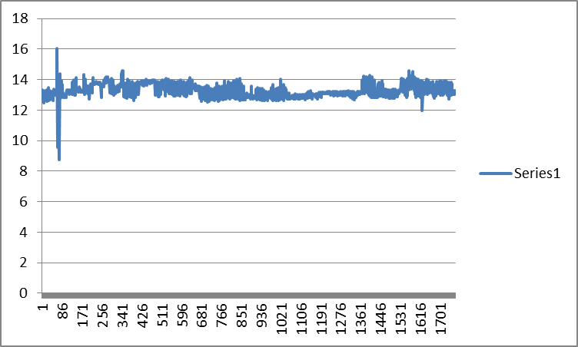
Fig. 5 displays the results of the program when calculating the distance in the X dimension, or from the camera directly horizontal to the ground to the wall, in a stationary scenario. It has a very small uncertainty, with a standard deviation of 0.65, and over time, the results begin to be more precise.
Fig 6. Distance to Target in a Static Scenario (in feet)
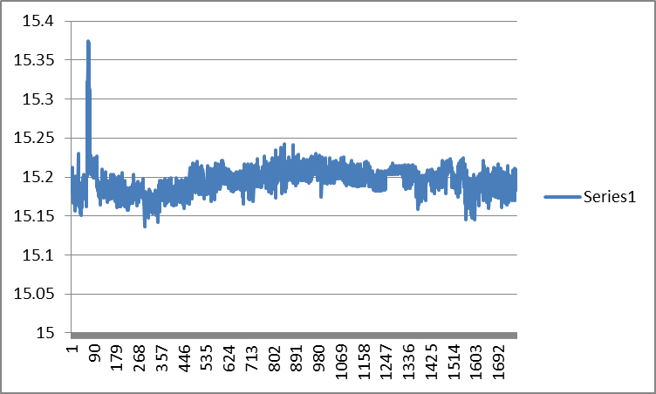

Fig. 6 represents the data the program outputted at a constant distance; it has an uncertainty of ±0.05 feet, or .6 inches. The standard deviation of this data is .62, which was about the same for other trials. The data has a slight variance because the camera used is not perfect, and did not consistently emit IR light evenly onto the targets, which would cause the contours the programs finds of the squares to change slightly which would then alter the calculations. It enabled the robot to make baskets 35 feet out, two times in a row, which was later discovered to be the limit to the program distance wise.

Fig. 7 Angle to Basket in a Static Scenario
Fig. 7 shows how the output in degrees varies when the target and camera are static. It has an uncertainty of ±0.7 degrees. After several trials, the standard deviation turned out to be 0.819471. This is from 15 feet away, which is a typical distance for the program to run at. The angle to basket turned out to be the eigenvector that had the most variance, by a significant amount.
Discussion
This method to target and track squares is a common method used in computer vision tracking anything. The results show how reliable the program’s output is. One error in this program is that sometimes, the program is unable to track the squares for a frame or two every 50 or so frames, but since the program runs at 20 fps this error is negligible, but still raises the question as to how to prevent it. Plausible causes to this error is motion blur, it is found that with the Kinect, motion blur is a problem. While some cameras are designed to limit motion blur, the Kinect was intended for game applications and not to be used for computer vision, which is a problem that could possibly be eliminated by using a different camera.
Another thing that needs to be addressed is the sudden jumps in output when the scenario is not moving. The program does the steps for every frame, or picture, it takes. It is noticed that between frames that are suppose to be the same scenario, slightly different contours are drawn, which cause a difference in calculated corners and in turn image points. The reason for the drawing of slightly different contours is due to the fact that the camera is not perfect, and the output image still contains noise regardless of the attempt to eliminate it, therefore it causes the calculations to be slightly different, as shown in the graph.
A method to eliminate this uncertainty is to average to solutions when the camera and target is not moving, which would cause the program to become more accurate the longer it ran.
A step beyond this program is to implement this method and apply it to track personnel for military purposes. This would be useful because satellite images may be purposely jammed and it would eliminate the dependence on them. Another application this could be used for is tracking windows of a building, also for military applications. The 2013 FIRST Robotics Competition involves 5 sets of reflective tape targets. This will be interesting in discovering if the addition of more targets will increase the accuracy and effectiveness of the solution, and how it will influence the frames per second of the program. With the 5 targets, will the program become more accurate in prediction the targets that it does not track and must predict? If so, what is the limit to the amount of targets that the program and do calculations for until the math becomes too large and reduces the fps to a level that is less than ideal?
The centers of the contours were calculated by averaging its 4 corner pixel coordinates. This method proved to add to the variance of the output. Another method exists which eliminates nearly all of this variance. It uses binary centroids inside the contours to find the center of the contour. It applies the math of image moments. To do this, it is assumed that the picture is continuous, which allows for the area of the binary image to be calculated. Then it sums the pixels coordinates and divides by the area producing a center virtually unaffected by noise.
This may not be the best method to solve this problem, but it does it well with minimal error. As bigger and hard tasks arise, a different method may be required to solve it, or this approach may suffice. As technological tasks advance, the program begins to be a combination of previous works and some unique programming, as this program is.

References
[1] Shotton, Jamie, Andrew Fitzgibbon, Mat Cook, Toby Sharp, Mark Finocchio, Richard Moore, Alex Kipman, and Andrew Blake. "Real Time Human Pose Recognition in Parts from Single Depth Images." Computer Vision and Pattern Recognition 3 (2011): 1-8. Print.
[2] Thorne, Brian, and Raphael Grasset. "Python for Prototyping Computer Vision Applications." http://academia.edu/ 1 (2010): 1-6. Print.
[3] Newcobe, Richard, Izadi, Shahram, Hilliges, Otmar, Molyneaux, David, Kim, David, Davidson, Andrew, Kohil, Pushment, Shotton, Jamie, Hodges, Steve, Fitzgibbon, Andrew. “Kinect Fusion: Real-Time Dense Surface Mapping and Tracking.” IEEE ISMAR (2011): 1-9. Print.
[4] You, Wonsang, Sabirin, Houari, Kin, Munchuri.”Moving Object tracking in H,264/AVC Bitstream.” http://academia.edu/ (2007): 1-10. Print.
[5] Waqar Shahid Qureshi, Abu-Baqar Nisar Alvi. “Object Tracking using MACH filter and Optical Flow in Cluttered Scenes and Variable Lighting Conditions.” World Academy of Science, Engineering & Technology (2009) Vol. 60, p709. Print.

