Section 1. Business Plan Overview

1.1 Mission Statement
To inspire socially conscious leaders in STEM and related fields.

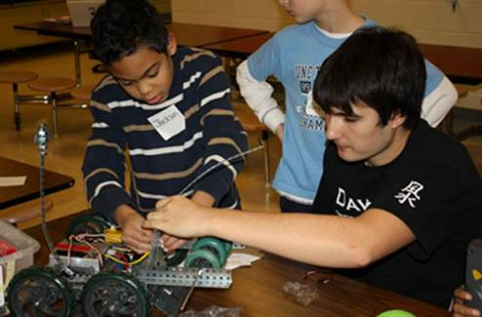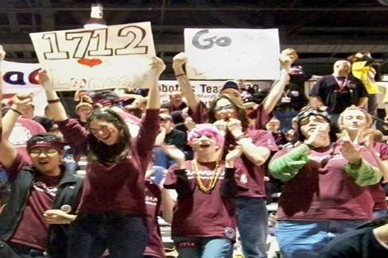

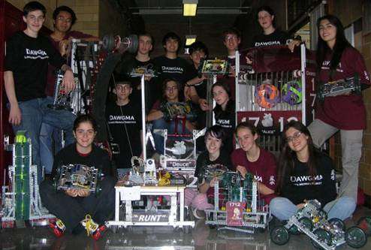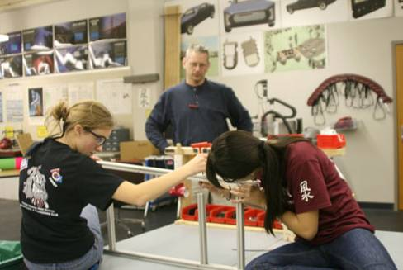

1.2 Executive Summary

- Created in 2005
- Founded by Rich Kressly: Chief Mentor; Winner of Regional Woodie Flowers Award
- 29 members
- Located in Lower Merion High School, Ardmore, PA. Sponsored by Lockheed Martin, Lower Merion School District, Lower Merion Interschool Council and VEXrobotics.com
- Services
  - Production of an FRC robot each winter.
  - Off-season we devote our time to training and outreach.

- Sponsors
  - Receive most of our financial support from our school district
  - Receive additional monetary support from local donors
  - Fundraisers include
    - Bake sales
    - Hexbug sales
    - Raffles
    - Special events and performances
  - Lockheed Martin provides two engineers whose expertise has been fundamental to our success.
- Team Growth
  - Totaled eleven awards across three robotics programs, winning at least one award at every regional event we have attended.
  - Created and developed extensive outreach program focused on exposing children to accessible and fun robotics
    - Helped create a Science Club at local elementary school, ran a three day robotics event with 36 4th and 5th graders
    - Organized and ran 4 JrFLL expos in two years, 52 new teams a total of approximately 200 students participating
    - Paired up with team 365 for the Ulster project, brings together Protestant and Catholic students from Ireland with team building activities
  - Strong commitment to helping other teams at competition and during build season: CheifDelphi papers have been downloaded over 5,400 times
  - Traveled to Nation and State capitals to demonstrate effectiveness of robotics to legislators
  - 92% of alumni pursue STEM, 42% study engineering
- Future plans:
  - Continue to focus on and expand all outreach efforts
  - Encourage and foster passion and interest in STEM among students
  - Continue to take every opportunity to spread FIRST’s message
  - Planning has begun on next year’s JrFLL expos

Section 2. Market Analysis and Marketing Strategy

2.1 Industry Analysis
FIRST robotics is a massive organization. There are 1,800 projected teams for 2010. The total operating expenses for FRC in 2008 was $20,558,122. According to the official FRC handbook, a team can compete for as little as $10,000. While our team budget exceeds the samples, they are still very useful tools in our planning. The two sample budgets below, also from the official FRC handbook, show the potential costs of an average team.

Sample Budget: Teams attending one Local Regional Event
Cost Items
$6000 Registration for a regional competition, includes kit of parts and FIRST team support
$1500 Additional parts and shop materials
$500 Practice field components:
$200 Shipping crate (consider asking school construction class for materials)
$100 Robot cart (could be flat dolly constructed from leftover wood)
$1000 Travel costs: bus transport to Regional for 3 days
$100 Publicity and sponsorship materials:
$500 T-shirts & marketing materials
0 Robot shipment – Used FedEx donated shipments
(Refer to “Robot Transportation” section of the Manual)
$500 Post-season/Pre-Season events. Set aside money for participation. Besides being fun, they provide more experience for your team and possible press coverage.
Total: $10,400

Sample Budget: Teams attending Two Events
Local Regional ($8,300)
First event registration $6,000
Lodging for 3 nights $2,100 7 rooms: 14 students - $100/room/night
Team buttons/trinkets 200
Robot ship – dropped off at drayage facility 0
Second Regional ($8,920)
Second event registration $4.000
Travel 2,200 8 students at $275 each
Lodging $1,200 4 rooms, 3 nights - $100/room/night
Rental vehicle $1,320
Team buttons/trinkets $200
Robot – free FedEx 0 FedEx free between events and home

Sample Budget: Teams attending Two Events (continued)
Materials ($1,190)
Electronics $595
Speed controllers $345
Sensors $200
Controls $50 Operator interface controls and connections
Construction ($1,615)
Metal, etc. $250
Sprockets, chains, bearings, etc. $500
Wheels $140
Polycarbonate $50
Hardware $250
Signs $50
Playing field $300
Shipping crate $75
Miscellaneous ($1,239)
FIRST LEGO League $264 Sponsorship of a middle school team.
Tools $300
Web site $175
Off-season events $500
TOTAL EXPENSES $21,264

2.2 Target Market for Sponsorship
The majority of financial sponsorship is targeted towards local businesses. Our school district provides most of our budget, but we also seek help from engineering companies in our area. Last year we sent out letters to approximately 20 engineering based companies asking for support.
We’ve also targeted larger engineering corporations in our area, specifically we’ve established a relationship with Lockheed Martin.

2.3 Target Market for Members
Dawgma 1712 recruits members from the student body of Lower Merion High School. We try to target students who have already shown an interest in technology by either joining the school TSA (technology student association) chapter or by taking a Technology Education elective. Underclassmen are preferred recruits, but all grades are desired.

2.4 Funding
2.4.1 Fundraising
Dawgma participates in fundraising as part of the schools Technology and Engineering Club in conjunction with TSA. Most fundraisers consist of club members directly selling a product such as candy, magnets or Hexbugs. In addition to sales for profit we also put on multiple bake sales each year to contribute to a charity of our choice, this year it is Engineers Without Borders.

2.4.2. Donors
Each year every member of Dawgma is expected to hand out at least two Donor Forms to local businesses. Local donors have also become aware of our team through our many appearances in our community and media.

2.4.3. Sponsors
The majority of our finances are given generously by our district, and district policy does not allow us to have official sponsors. We consider Lockheed Martin to be a sponsor. Two of their engineers donate huge amounts of time and energy to assist the team. We listed NASA as a sponsor last year because we won a grant that allowed us to travel to the DC regional. We also list VEXrobotics.com as a sponsor because they have donated materials and VEX equipment is integral to robotic education in our school district.

2.5 Advertisement/Promotion
2.5.1 Website
Our primary promotion tool is our website. It includes a comprehensive history of our team, pictures, and even twitter updates of our progress. We also use a Youtube Channel to share video of build, competitive events, and promotional materials/spots.

2.5.2 Marketing/PR
We use the excitement generated by our success in outreach and competition to appear in local and national media, including newspaper, TV news and websites. We also use demos such as the Philadelphia Video Game Expo and the Franklin Institute Family Fun Day to not only showcase our robots, but also hand out information and promote our team.

Section 3.Services and Products

3.1 Services

3.1.1. VRC Team
In addition to FRC team 1712, Dawgma also includes a competitive VRC team. VRC (VEX robotics competition) teams are made up of 10 students or less, and use the VEX platform to play a game that changes annually. With a smaller and simpler team structure and robot, the VRC team provides Dawgma with a fantastic tool to train rookie members.

3.1.2. Community Efforts
3.1.2.1 Outreach
Dawgma is extremely proud of its extensive community outreach efforts. Most efforts are centered around Dawgma’s outreach package: Portable Inspiration. Portable Inspiration (PI) utilizes the financially accessible and mechanically manageable VEX robotics platform. Eight ‘tumbler” robots make up the PI fleet, along with stations designed to educate younger students on the basics of simple machines, team work and robots in our world. PI has been implemented at a variety of events such as workshops with elementary school and autistic students and demonstrations at the Franklin Institute and the Philadelphia Video Game Expo.
November 2009 was the second year that team members and mentors organized and ran two Jr. FLL Expos at regional elementary schools. In two years 52 teams and nearly 200 students ages 6-9 have become inspired FIRST participants, at least one FLL team and one high school robotics club has grown from it, and our team members learn leadership skills while giving back to the community in the process.
For the past two summers we have paired up with 365 to participate in contributing a daylong event to the Ulster project. The Ulster project is a summer teen program with the goal of improving relations between Irish Protestant and Catholic youth. Using VEX we spent a day providing 40 students with a taste of robotics and collaborative problem solving.

3.1.2.2 Service
In addition to community outreach work with PI, Dawgma has also participated in multiple charitable food and book drives over the years. For the 2008 Duel on the Delaware event, we collaborated with our school's service club to raise 2200 lbs of

books for team 365's annual book drive. Dawgma has also helped raise money for Engineers Without Borders.
Dawgma has also put forth efforts to help support other robotics teams. Both at competitive events and during build season, we have been a resource for both materials and information for other teams remembering how helpful others have been to us, Dawgma continues to share expertise via many avenues. Since our rookie year we have offered FIRST and STEM knowledge and assistance to fellow teams and others at workshops, events, through published articles and the ChiefDelphi message boards, where our papers authored by students, alum, engineers, and teachers have been collectively downloaded over 5400 times. Papers include running JrFLL Expos, CADD tips, robotics curriculum, design, outreach, award entries, grant tips, and more.

3.2 Products

3.2.1. Robots
Every year Dawgma has six weeks to manufacture a single, 120-pound robot for the FIRST Robotics Competition. Dawgma has consistently found success using a chassis made of 80x20 aluminum extrusion. We normally use AndyMark tough boxes, CIM motors and chain and sprocket to power our drive trains.

2006 Game: “Aim High”
Robot Name: Dawgma 1
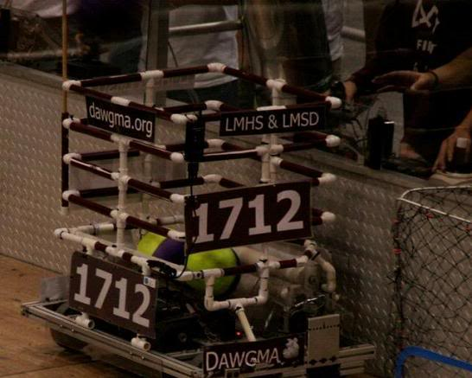
-Accumulator scores in the corner goal
-Three rollers run from one large CIM, two rollers for intake and one to prevent balls from getting stuck in the hopper.
-PVC hopper could hold up to 15 balls.
-Robot Length: 27 inches.
-Robot Width: 37 inches.
-Robot Height: 40 inches.
-Inspection Weight: 118 lbs.
-6 wheel drive powered by 2006 kit gearboxes.

2007 Game: “Rack n’ Roll”
Robot Name: Deuce

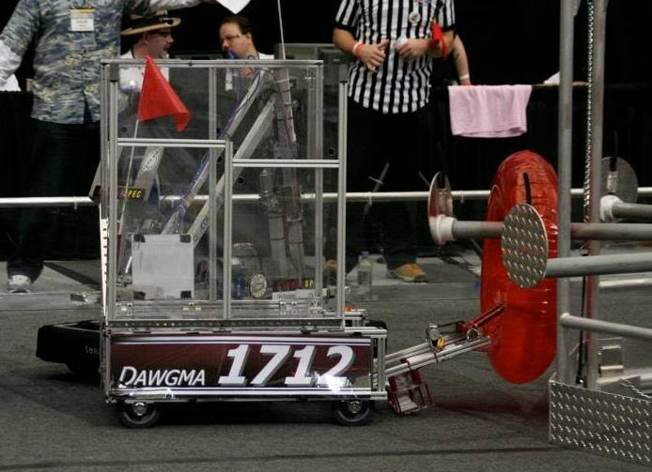
-Scores on low row
-Capable of holding one robot
-Inspection Weight: 120 lbs
-Platform Height: 13″
-Total Platform Length: 58.5″
-Total Width: 31″
-Ramp Angle = 21 degrees
-4 wheel drive powered by 2007 kit gearboxes

2008 Game: “Overdrive”
Robot Name: Galactus

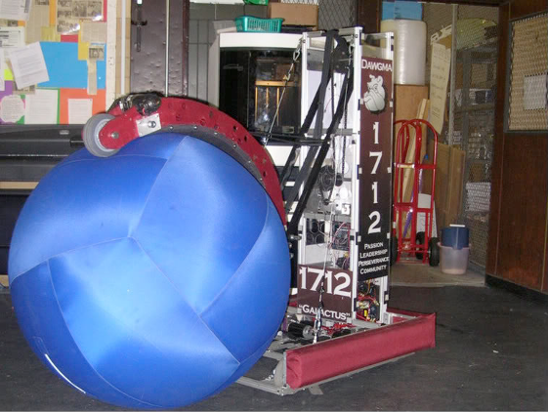
-Scores by placing, hurdling, and lapping.
-Autonomous mode: crosses 1-2 lines.
-Inspection Weight: 120 lbs.
-Weight battery and bumpers: 144 lbs.
-6 Wheel Drive, center wheels dropped 1/8 inch. Powered by 2008 kit gearboxes.
-Total Robot Length: 37 inches.
-Total Robot Width: 27 inches.
-Total Robot Height: 59 inches.
-Claw can reach up to approximately 81 inches.

2009 Game: “Lunacy”
Robot Name: Alice

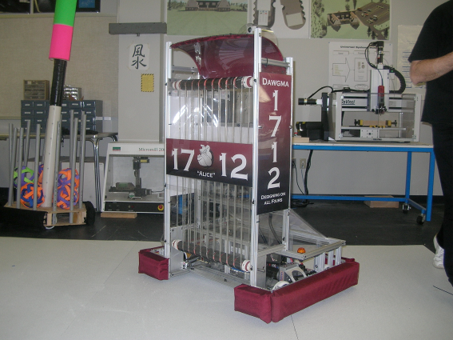
-Size: 27 x 37.25 x 59 inches
-Inspection Weight: 120 lbs
-Orientation: 4 Wheel Drive, driven by two CIM motors inside kit “toughboxes.”
-Accumulator Driven by two CIM motors at a 1:1 ratio powered by kit “toughboxes”
-Can shoot orbit balls between 0-3 feet.
-Camera can track and lock on to target during autonomous.

3.2.2. Chairman’s Award Entry
Along with a number of communication tools each year Dawgma puts together an entry for the FRC Chairman’s Award. The award entry includes an essay of ten thousand characters, a three-minute video and a ten-minute verbal presentation.
A Chairman’s entry outlines the team’s efforts in communication, partnerships and impact on community. Dawgma has put together a chairman’s entry every year since it’s creation. The essay is an excellent tool that helps our team and our community understand the quality and number of our accomplishments.

3.2.3. Alumni
Woodie Flowers, Dean Kamen, Dave Lavery, and countless others at FIRST have insisted (in one way or another) that, “it’s not about building robots, it’s about building people.” Dawgma’s alumni are some of its most important products. 100% of Dawgma graduates go on to pursue college degrees in various fields, including engineering, science, mathematics, and design.
The leadership and technical skills taught to all Dawgma members help create confident, capable, and ambitious members of society. Mentors instill a sense of social responsibility into all students, so many graduates participate in volunteer efforts or jobs that involve engineering with a social conscience. These organizations include Engineers Without Borders (which helps developing villages conquer basic needs problems, like purifying water) and the Student Teacher Outreach Mentorship Program (which helps teach engineering ideas and concepts to public elementary school

students and teachers.) Dawgma graduates even go on to volunteer and have worked for FIRST.
Beyond the professional advantage Dawgma gives its grads the personal changes many team members feel during their time with the team. Dawgma helps transform quiet, shy introverts into confident people who feel comfortable working in a team and sharing their ideas.

“Being part of Dawgma at LMHS changed my life. Largely due to this team, I have become passionate about STEM and becoming a leader in my community.”
– Sylvia Herbert, LMHS Class of 2009
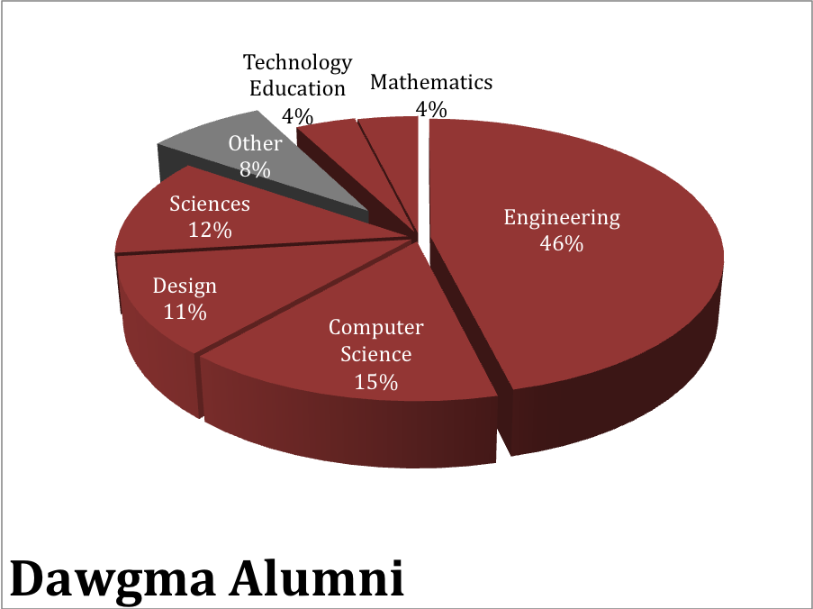

Cumulative FRC1712 Alumni Information

Name | LM Class | University/Location | Major/Status | Known STEM Outreach
Melani Butcher | 2009 | Cabrini College | Mathematics | Jr. FLL Vol.
Petra Hartman | 2009 | WPI | Robotics Engineering | Event Vol. in JrFLL, FLL, FTC, FRC  Organized/Delivered PI Workshops
Sylvia Herbert | 2009 | Drexel University | Mechanical Engineering | Event Vol. in JrFLL & FRC  Drexel Univ. COE Outreach
Ariel Morgenstern | 2009 | Drexel University | Mechanical Engineering | Event Vol. in JrFLL & FRC
David Morrison | 2009 | Cabrini College | Chemistry | JrFLL Vol.
Phil Ross | 2009 | University of Maryland | Landscape Architecture | FIRST/Americorps VISTA  Event Vol. in JrFLL, FLL, FTC, FRC  Eagle Scout Project:  Robotics with Special Needs Students
Jess Scolnic | 2009 | Tufts University | Mechanical Engineering | Tufts STOMP Outreach  Organized/Delivered JrFLL Expo  Published How-To Guide for JrFLL  VEX Robotics Student Advisory  TSA State Officer  PI Workshop Vol.
Ethan Wasserman | 2009 | Israel | Travel | Visits to/help with FRC2215 in Israel  JrFLL, FRC, and PI workshop volunteer
Frank Xu, | 2009 | University of Pittsburgh | Engineering | JrFLL Vol. & PI Workshop Vol.
Marita Araujo | 2008 | Arcadia University | Spanish & Internat’l Studies | JrFLL & PI Workshop Vol.
Taggart  Bowen-Gaddy | 2008 | Georgia Tech | Computer Science | PI Workshop Vol.
Matt Buczek | 2008 | DCCC | Web Design | Alumni Mentoring for FRC1712  FRC, JrFLL & PI workshop Vol.
Gregory Feldman | 2008 | Columbia University | Operations Research

Cumulative FRC1712 Alumni Information (continued)

Chuck Glick | 2008 | DCCC | Design | Mentoring for FRC321  Event Vol. in JrFLL, FLL, FTC, FRC  PI Workshop Vol.  Alumni Mentoring for FRC1712  VEX Robotics Student Advisory
Chris Julian | 2008 | Georgia Tech | Computer Science | JrFLL & PI Workshop Vol.
Ron Leibach | 2008 | Case Western University | Mech/Aerospace Eng | JrFLL & PI Workshop Vol.
Anton Pantev | 2008 | Georgia Tech | Computer Science
Bianca Szklaruk | 2008 | Syracuse University | Aerospace Engineering | JrFLL & PI Workshop Vol.
Dan Zollman | 2008 | RPI | Design, Innovation & Society | Phila. Region FIRST Website  Website/Inventor help for Teams  FLL, JrFLL & PI Workshop Vol.  Authored PATSA Inspiration Award  TSA State Officer
Noah Berson | 2007 | Vanderbilt University | Biomedical Engineering
Jacob Chamoun | 2007 | Cornell University | Engineering
Ira Goldberg | 2007 | University of Michigan | Mechanical Engineering | PI Workshop Vol.
Justin Rubin | 2007 | Johns Hopkins University | Physics
Ilya Zhitomirskiy | 2007 | New York University
Zac Cohen | 2006 | Millersville University | Technology Education | PI Workshop Vol.  Alumni Mentoring for FRC1712  Rookie Team Support @ Events  PublTechnical Paper for Teams
Alex Flaxenburg | 2006 | Penn State University | Computer Science | PI Workshop Vol.  Alumni Mentoring for FRC1712
Jon Gowa | 2006 | Tufts University | Mechanical Engineering | Tufts STOMP Outreach
Seth Leiblich | 2006 | Brandeis University | Biochemistry

Section 4. Club and Team Structure

4.1 Breakdown of Club and Team
Dawgma robotics team is a part of the Lower Merion High School’s Technology and Engineering Club. Dawgma consists of FRC team 1712 and VRC team 1712. The other half of the T&E club is Lower Merion High School’s TSA (technology student association) chapter. Although TSA and Dawgma compete at separate events and operate under different guidelines and rules, we are one club. Our collective leadership team meets to discuss and decide important matters with our mentors, while members of both teams participate in and help coordinate the club’s efforts in fundraising, spirit, outreach and more.
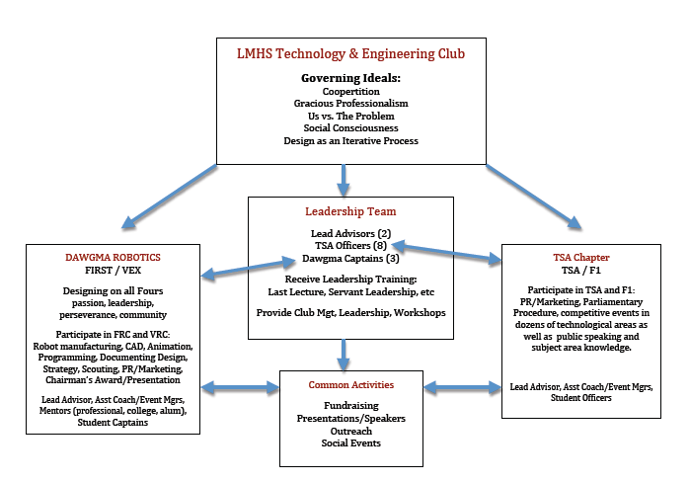
This chart shows the breakdown and function of each section of the Lower Merion High School Technology and Engineering Club.

4.2 Key Personnel and Backgrounds

Rich Kressly 2005- Present
Mr. Kressly is the founder and chief mentor of Dawgma. He has worked as a mentor of team 103 and a member of the FTC game design committee. He is a certified English and Technology Education teacher. He was the winner of a Woodie Flowers award at the 2009 DC Regional. His work with Dawgma focuses around logistics, personnel, community outreach, mechanical and electrical work.

Mark Piotrowski 2005-Present
Mark Piotrowski is the head of the Technology Education department at Lower Merion High School. He is the sponsor and head of the Lower Merion TSA chapter. He is essential to the T&E club’s fundraising, outreach and leadership.

Dr. Paul Gehman 2008-Present
Dr. Paul Gehman is a software engineer and Lockheed Martin employee. Dr. Gehman generously donates his time to Dawgma, making it possible for us to take our programming efforts to a highly improved level.

Bob Bellini 2008- Present
Bob Bellini is also a software engineer and Lockheed Martin employee. Like Dr. Gehman, Mr. Bellini also volunteers his time and expertise to Dawgma. His help made the transition to a new electronics system much smoother.

Kim Arleth 2008-Present
Kim Arleth is a chemistry teacher at Lower Merion High School. She joined dawgma in the 2008-2009 competition season. She generously donates her time to chaperone competitive events and field trips

Katie Cooper 2005-2007
Katie Cooper is a math and computer science teacher at Lower Merion High School. She implemented the use of VEX robotics in LMHS computer science classes. She was essential in the beginning years of Dawgma, providing the necessary expertise to begin training students in programming.

Dina Campagna 2008-2009
Dina Campagna is a TV studio teacher at Wissihickon High School. She is an active FIRST volunteer and also works with FRC team 357. She has provided great help with web site design, chairman’s entries and marketing/PR.
Gene Guay 2006-Present
Gene Guay is a physics teacher at Lower Merion High School. He mentors and manages Dawgma’s VRC team 1712.

Sean Lavery 2007-Present
Sean Lavery is a mechanical engineering major at Drexel University. He is an alumni of team 116 and has provided 1712 with his expertise in mechanical design, competitive strategy and coaching matches.

Jen Sand 2005-2007
Jen Sand is a biology teacher at Lower Merion High School. She contributed her enthusiasm and organization in the beginning years of 1712.

Kathleen Schroeck 2008
Kathleen Schroeck is at Lower Merion High School Biology Teacher. She has provided herself as a chaperone and as teacher support.

Mike Williams 2005-2008
Mike Williams was a Business and Finance major at St. Joseph’s University, he graduated in 2008. He is former member of FRC team 103 Cybersonics. His experience and knowledge were extremely helpful. He contributed to mechanical design and build and game strategy.

4.3 Communication

Dawgma 1712 uses a variety of communication tools to keep our team, local and global community aware of our daily and overall progress as a team.
The easiest form of communication used to daily contact with team members and mentors is email. Dawgma has set up multiple email groups to easily communicate with one or all parts of the team. In addition to email Dawgma uses a Twitter feed to keep members updated on announcements.
To communicate our local and global community we use both our website, http://dawgma.lmtechclub.org and our Youtube channel, www.youtube.com/dawgma1712. Our website includes picture galleries, detailed history of the team and information on present and past team members. Our Youtube channel currently has 0ver 25 videos including promotional videos, Chairmain’s video entries and matches from our past competitive year.
Dawgma places heavy importance on communicating with and helping the rest of the FIRST community. We reach this goal by posting on CheifDelphi forums. Our white papers there include tips on Inventor, running JrFLL expos, setting up a robotics curriculum for classrooms and much more. Collectively our papers have been downloaded 5,435 times.

Section5. Financial Information

5.1 Budget Finances
Budget finances for FRC1712 are planned, tended to and administered by a combination of adult and student leadership of the LMHS Technology & Engineering Club. This enables us to expose many more STEM students to FIRST while reaping the benefits of increased school district funding for one of the largest clubs in our school district. Students generally fund their own overnight travel (hotels, meals, airfare), and uniform costs. The team defrays up to 50% of this cost with additional sponsorship, fundraising, and grant writing as it can.
5.2 Breakdown of Budget
Annual expenses and funding for Dawgma portion of LMHS T&E Club

Funded by LMSD/LMHS
FRC Initial Registration and Event $6,000
FRC Second Event Registration (Regional or Championship) $5,000
FRC Offseason Events Entry Fee (two per year) $500
VRC Entry Fee and Event Registrations $300
Equipment/Tools/Supplies $5,000
Event Bus Transportation for Team (six events per year) $4,500
Funded by Additional Sponsorship/Fundraising/Grants/Students
JrFLL Expos/Outreach $1,600
Shirts/Uniforms $750
Promotional Items $500
Build Season Food $1000
Hotels/Lodging/Food $4,500
Airfare (only in years the team travels to the Championship) $3,000
Electronics and Controls $1,900
--------------
TOTAL $34,550

Section 6. Supporting Documents
Enclosed are the following vital team documents:
6.1 Origins of Team Name, Team Motto, & Robot Names page 19
6.2 In the Media – A Sampling of News Articles About Team 1712 page 20
6.3 2010 Chairman’s Award Entry page 26

How We Developed Our Name:

In the Spring of 2005, prior to our rookie year in FIRST, the team met to generate a name. Our school mascot is a Bulldog. That Name is frequently shortened to Dawgs and our student cheering section is affectionately called the Dawg Pound. Since the team wanted the name to reflect its beliefs, the term Dogma was selected to work with. Dogma is defined as “a set of principles laid down by an authority as incontrovertibly true.”

Putting the two together in Dawgma, we can be accurately described as “Dawgs with a strong set of principles.”

~~~~~~~~~~~~~~~~~~~~~~~~~~~~~~~~~

Team Motto: Designing On All Fours

Our Principles, The Four Legs Upon Which We Stand…

Passion:
Transforming curiosity into excitement
Leadership:
Developing socially responsible leaders for the 21st century
Perseverance:
Design is an iterative process; Culture change takes time
Community:
Strengthening team awareness and fostering connections
~~~~~~~~~~~~~~~~~~~~~~~~~~~~~~~~~
How Our FRC Robots Got Their Names
2006 – Dawgma I : The Team’s 1st ever competition robot – named accordingly
2007 – Deuce : Our Second FRC Robot, Designed to perform two tasks.
2008 – Galactus : Named for Marvel Comic character. Name means, “Devourer Of Worlds.” The robot grabs & lifts huge, “world-like” 40-inch ball.
2009 – Alice : Named after the late Dr. Randy Pausch’s culture-changing software. Pausch’s book, The Last Lecture, has had a strong influence on us.

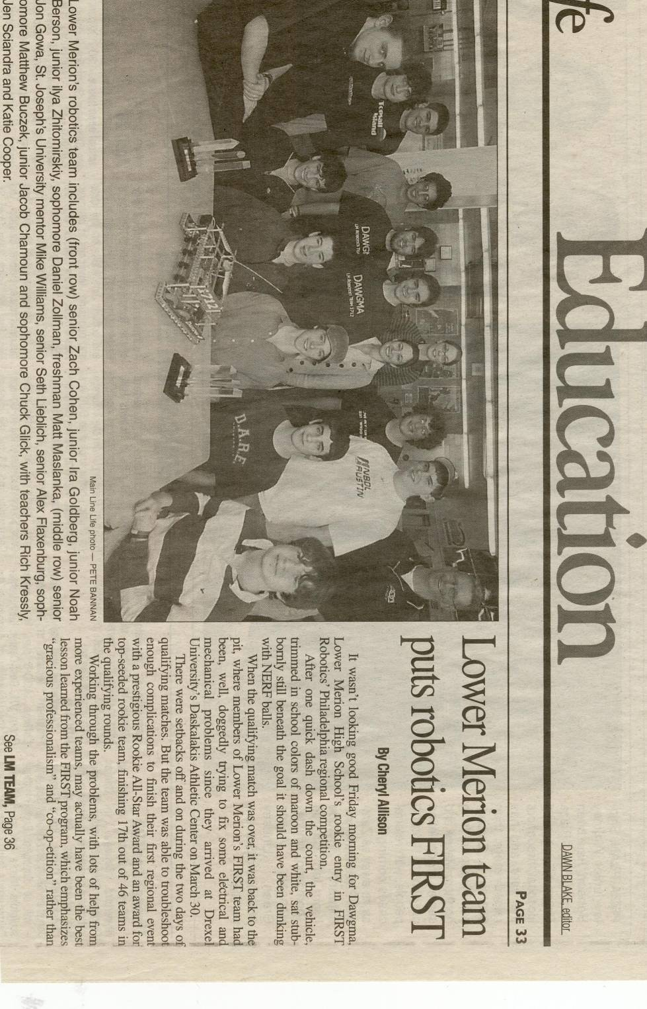

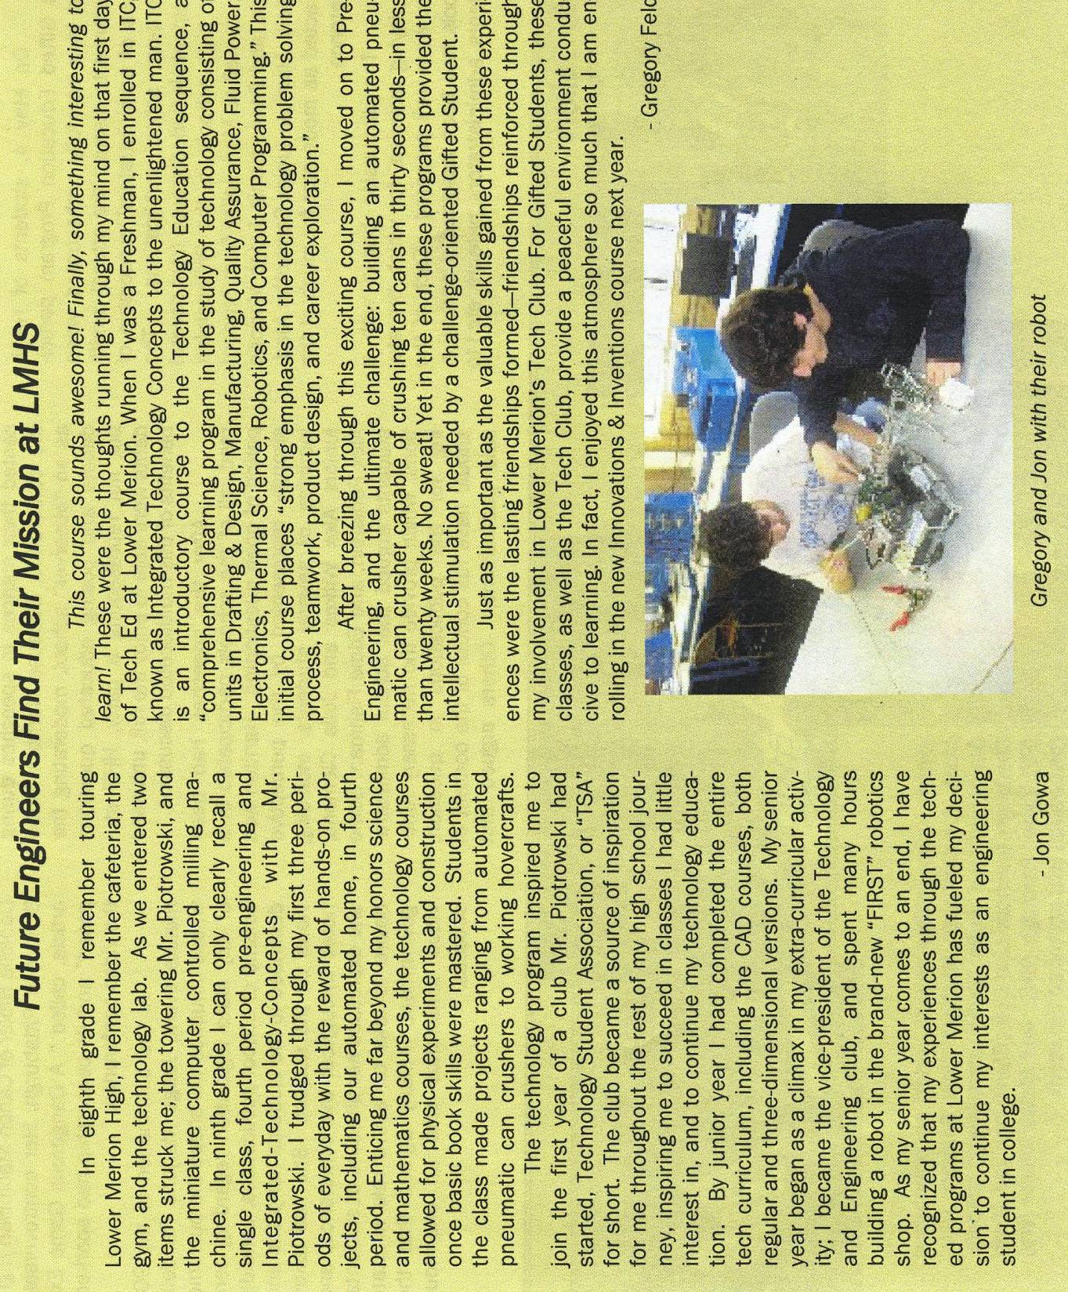

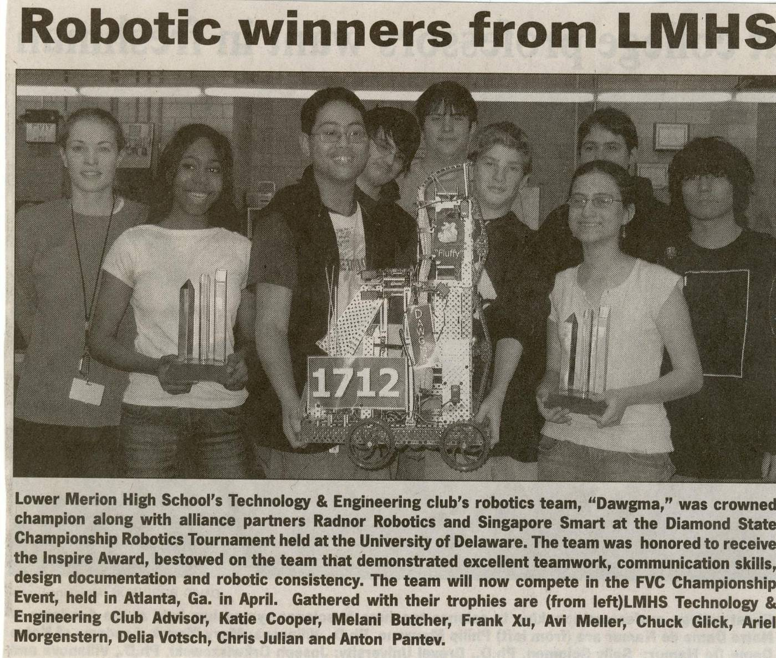

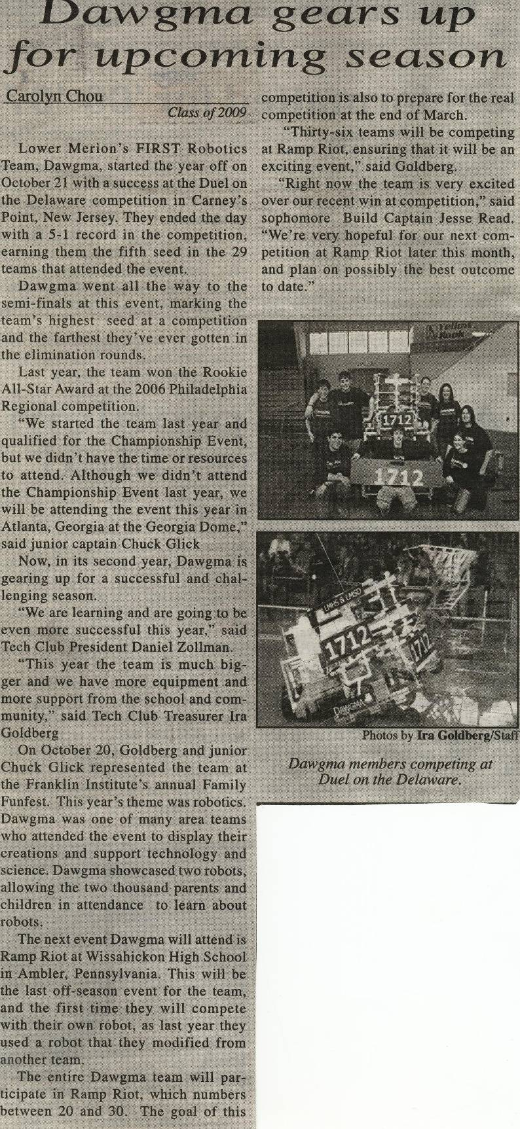
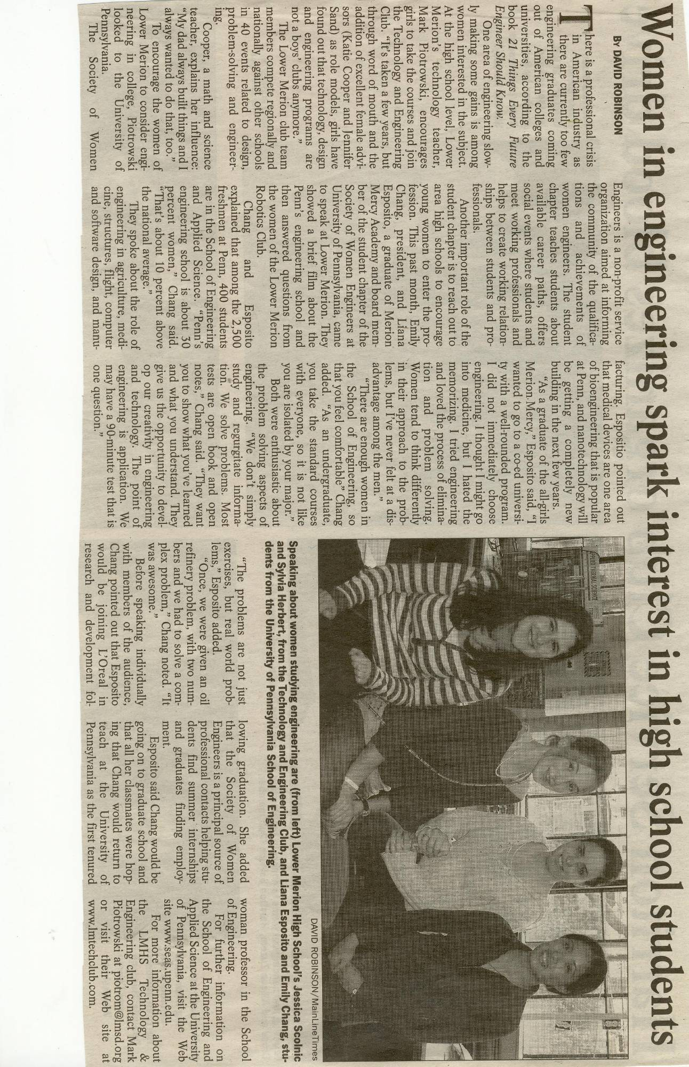

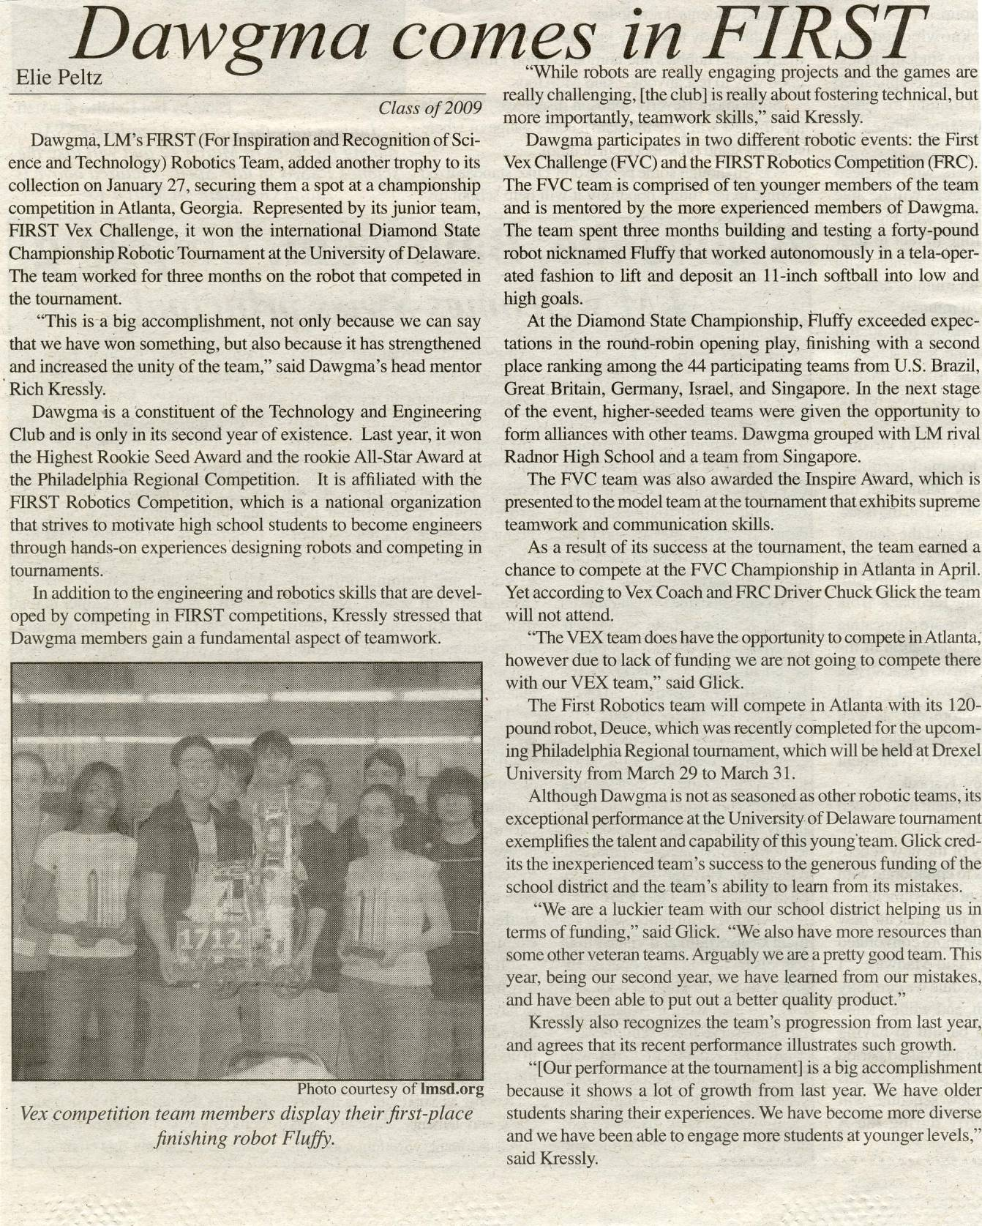

2010 Chairman’s Award Entry Essay

Dawgma was founded to feed the same social revolution that inspired the creation of FIRST. Since it’s inception, the team has been the impetus behind the co-curricular and curricular infusion of robotics and STEM outreach throughout Lower Merion school district and beyond. The purpose behind all of these efforts has been to inspire interest in science and technology but more importantly to create socially conscious leaders. In order to achieve this revolution, Dawgma has constantly focused on its evolution. Each year we evolve in order to adapt to the needs of our members, the community, and society.

Now in our fifth year, Dawgma has totaled eleven awards across three robotics programs, winning at least one award at every regional event we have attended. However, our most important statistics have nothing to do with robots. 92% of our graduates pursue STEM careers, most seek outreach and volunteer opportunities on their own, and our goal remains unchanged as our cumulative success drives us forward. Today, a VEX team serves as our feeder program for our FRC team and we’re all part of a larger Technology & Engineering Club that includes the school TSA Chapter.

Prior to kickoff, the 2009-10 school year was already filled with rich experiences. Dawgma visited FRC103 alum Tina Haskins at Rutgers University's Costal Ocean Observation Lab where she works with the world's most successful and inspirational underwater robotic glider team. Due to FIRST’s influence on Tina and our graduates, we traveled to Capitol Hill for a Robotics Caucus briefing to help ensure congressional support for programs like ours. As one of the thirteen exemplary programs invited to attend nationwide, we spread the word of STEM and FIRST to congress, other schools, representatives from NSF, the iRobot Corporation , and more. The fall was also the second year that team members and mentors organized and ran two Jr. FLL Expos at regional elementary schools. In two years 52 teams and nearly 200 students ages 6-9 have become inspired FIRST participants, at least one FLL team and one high school robotics club has grown from it, and our team members learn leadership skills while giving back to the community in the process.

This year also saw outreach efforts include our school’s TSA Chapter members when several members of Dawgma and TSA organized and ran a 3-day after school robotics build and competition with a science club of 36 participating 4th and 5th graders at a district elementary school. Two Dawgma members helped parents and teachers found the club in 2008 and the results of this partnership have excited students, parents, staff, and administrators. As our outreach efforts have grown so has our female student population. With a targeted effort female membership has quadrupled in two years, balancing our gender population.

This fall our team also participated in preseason FRC events, fund raise - including some for Engineers Without Borders, wrote a grant proposal, developed our first business plan, and attended weekly training sessions in CADD, manufacturing, and controls/programming,

Remembering how helpful others have been to us, Dawgma continues to share expertise via many avenues. Since our rookie year we have offered FIRST and STEM knowledge and assistance to fellow teams and others at workshops, events, through published articles and the ChiefDelphi message boards, where our papers authored by students, alum, engineers, and teachers have been collectively downloaded over 5400 times. Papers include running Jr. FLL Expos, CADD tips, robotics curriculum, design, outreach, award entries, grant tips, and more. We also share media, news and updates through our Twitter account, Youtube channel and newly revamped website. Articles have been published in the TEAP Journal, The Technology Teacher Magazine, FIRST’s Newsletter, TSA’s website, and iRobot’s SPARK website. We’ve given presentations at control system seminars, the TEAP Conference, and around the community. We’ve also spread the FIRST word through features on ABC6 and BotBeat, a web-based robotics show.

We have always remained focused on our main goal of producing socially conscious leaders for the future. Our alumni have gone on to study at top universities, where 92% pursue STEM and 46% study engineering. The majority also participate in community service through STEM outreach, by mentoring FRC teams, and by becoming FIRST event volunteers. One of our graduates, inspired by what he learned in FIRST, created, proposed, and had approved a PA TSA Inspiration Award that recognizes the state chapter that best engages its community. Another grad has even gone on to become the youngest VISTA every hired by FIRST.
Before we reached this high level of success there was still a passion for FIRST’s ideals. We began in 2005 when Rich Kressly brought FIRST to LMHS. His passion drove the team from

the start, inspiring a small number of students to take on new challenges. The local FIRST community, such as teams 341 and 357, fostered our development. 341 loaned us a robot to compete as pre-rookies while 357 came to our school to promote FIRST. In addition 1114 machined a key robot part for us as rookies and delivered it from Canada, while countless teams came to our rescue as rookies at our initial regional, including 103 and 365, helping us win two rookie awards. We’ve always remembered this support and we feel it’s extremely important to return this help to each years rookies. We’ve built and donated shipping crates, provided presentations and technical support, visited during build season, and even shipped spare parts to Tennessee overnight. At regional events in Philadelphia and Washington DC we’ve deployed engineers, team members, and alumni to aid with inspection, robot repair, programming, and more.

Spurred on by our rookie years’ success and ready to evolve, Dawgma refined its organization and procedures and set higher goals in design, programming, and outreach for 06-07. The introduction of a FTC/VEX team allowed us to meet the growing demand for membership and train younger members in a smaller, simpler environment. We made great efforts to begin spreading STEM in the community. Team mentors designed and implemented a curriculum based in VEX robotics. We introduced LEGO NXT to the gifted programs at both district middle schools. Starting in the fall of 2010, the school is adding robotics into its standard 7th and 8th grade Tech Ed curriculum, fostering student interest in robotics, FIRST, and STEM education.

2007-08 was our third year as a team. We focused our energies to follow and spread the word of FIRST by adopting our motto of “Designing on all Fours” and four principle “legs” of passion,

leadership, perseverance and community. Each one represents part of our core values. Specific training for new members was adopted in mechanical, electrical or software engineering, using a small robot built by an alumnus. As student interest developed, we were able to best draw on their positive energies to complete tasks at hand. Our VEX program attracted increased interest resulting in the creation of a second team. We also embraced our outside community in our third year, developing the core of our outreach program “Portable Inspiration”. In our work with autistic students at our school, to demos at FRC events, to collaborating with 365 to reach visiting students from Ireland, we used our third year as a team to really focus on outreach. These demonstrations and workshops fascinated countless students and adults. At one workshop two young girls even asked for an autograph from a female team member. We also took our VEX and FRC robots to present at the State Capitol. Along with fellow FRC teams, we spent the day in Harrisburg talking with legislators and their employees.

In 2008-09 Dawgma added new mentors from Lockheed Martin, Mr. Bob Bellini and Dr. Paul Gehman, whose knowledge and patience were fundamental to our elevated success in programming and controls. Thanks to a NASA grant, we were able to attend the first DC regional, we were the only team to successfully score in autonomous mode. We also spent the weekend, as always, focusing much of our time helping rookie teams. We spent an enormous effort helping out a particularly disadvantaged team make it through inspection. Seeing them win the Highest Rookie Seed Award and the gratitude they showed us was the highlight of our weekend. Due to our outreach efforts in the previous year, a few of the autistic students we did workshops with joined the team as full time members and were able to contribute. This was valuable learning experience for them as well as our non-autistic members, as both parties learned patience and how to communicate in difficult situations. We also continued to put on demos with PI at elementary schools and other places in the community. We collaborated with our school's service club to raise 2200 lbs of books for team 365's annual book drive. We partnered with the Philly Video Game Expo that resulted in a three-day FRC & VEX demo with teams 365, 357, and 341 exposing FRC to thousands of visitors. We had previously paired up with 365, and did so again for the daylong Ulster project; a summer teen program with the goal of improving relations between Irish Protestant and Catholic youth. Using VEX we spent a day providing 40 students with a taste of robotics and collaborative problem solving.

Looking at our history, the evolution of FRC 1712 has certainly fed the national STEM revolution and has helped spread FIRST’s ideals. From our hands-on workshops to our published articles, upwards of 200,000 people have been exposed to FIRST, outreach, and robotics. The momentum has produced a fantastic group graduates who pursue STEM and related careers with a social conscience rarely found in today’s youth. While much has been accomplished, we still look forward to what the future holds.

2010 Chairman’s Award Entry Executive Summary

Briefly describe the impact of the FIRST program on team participants with special emphasis on the 2009/2010 year and the preceding two years
Our alumni have gone on to study at top universities, where 92% stay with STEM and 46% pursue engineering. The majority also participate in community service through STEM outreach, by mentoring FRC teams, and by becoming FIRST event volunteers. One graduate took what he learned in FIRST and created, proposed, and had approved a PA TSA Inspiration Award that recognizes the chapter that best engages its community. Another grad has even gone on to become the youngest VISTA every hired by FIRST.

Examples of role model characteristics for other teams to emulate
Our team has been the impetus behind the co-curricular and curricular infusion of robotics and STEM outreach in our district and beyond. We’ve shared our outreach program Portable Inspiration with autistic and elementary school students, and with the local and national media. Team members have taken the initiative to create, organize and run a total of four JrFLL expos in two years.

Describe the impact of the FIRST program on your team and community with special emphasis on the 2009/2010 year and the preceding two years
Team members and mentors organized and ran two Jr. FLL Expos at regional elementary schools. In two years 52 teams and about 200 students ages 6-9 have become inspired FIRST participants, at least one FLL team has grown from it. Several members organized and ran a 3-day after school robotics build and competition with a science club of 36 participating 4th and 5th graders at a district elementary school, the results of this partnership have excited students, parents, staff, and administrators.

Team's innovative methods to spread the FIRST message
In addition to traveling to our nation’s and state’s capital to present to legislators, articles have been published in multiple national publications and websites. We have given presentations at control system seminars, the TEAP Conference, and throughout the community. Additionally, we’ve spread the FIRST word through our outreach program, Portable Inspiration. This has led to upwards of 200,000 people exposed to FIRST, STEM outreach, and robotics.

Describe the strength of your partnership with special emphasis on this year and the preceding two years
For the second year we’ve been excited with our partnership with mentors from Lockheed Martin, Mr. Bob Bellini and Dr. Paul Gehman, who’s knowledge and patience are fundamental to our elevated success in programming and controls. We’ve also been a part of numerous joint projects with other FRC teams, including book drives, demos and rookie assistance. Several community partnerships have developed through fund raising and demos.

Team's communication methods and results
Since our rookie year we have offered FIRST and STEM knowledge and assistance to fellow teams through the ChiefDelphi message boards, where our papers authored by students, alum, engineers, and teachers have been collectively downloaded over 5400 times. We also share media, news and updates through our Twitter account, Youtube channel and newly revamped website.

Other Matters of Interest to the FIRST judge, if any
Carolyn McKinney, a 6th grade teacher in our district’s gifted program, has incorporated NXT robotics into her class with our help. She summed up the essence of our entire experience when she wrote, “[We are] breeding a whole new generation of kids who are finding out they are interested and even talented in this area of study and considering careers in engineering and technology when they never thought they would have! It is really exciting!”

