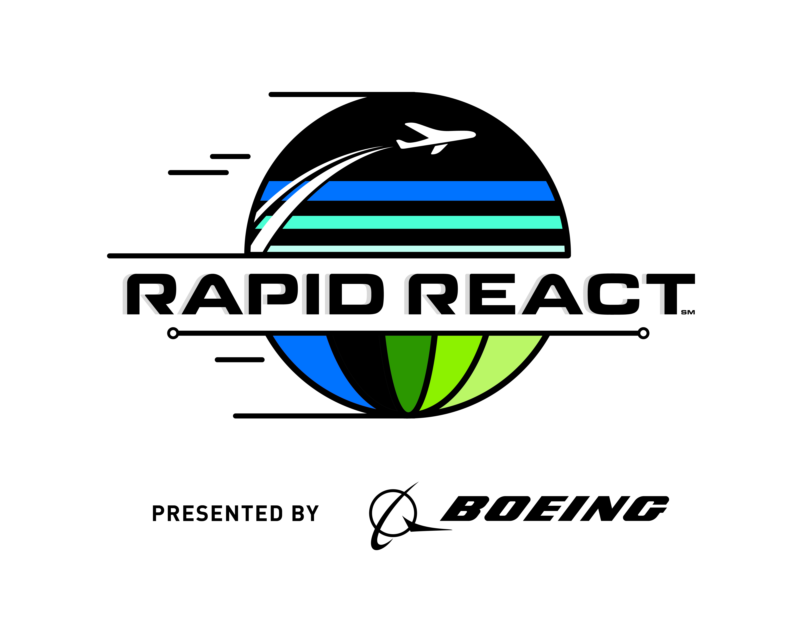How to Watch the 2022 FIRST Rapid React Robotics Game

By Gary Hedge, Mentor, Team 3476,   
Code Orange – 13 April 2022

This guide explains the basic flow of the FIRST “Rapid React Robotics Game” to a VIP, family member or visitor who is new to the game. It suggests what to watch on the field and tells why robots are doing what they are doing. Scoring is explained with examples and predictions.

It is best to read this while you watch a Match, either live or recorded. Live matches can be seen at <https://www.twitch.tv/firstinspires15> and <https://www.twitch.tv/firstinspires16> . (and similar higher numbers) Past matches can be watched at <https://www.thebluealliance.com/events> . (Pick a past event and choose the page for the “Results”. Click the little circle with a triangle arrow inside next to the Match you want to watch. Click the “Play” arrow in the middle of the video picture.) This year the game is fairly simple with the ability to lift the robot off the floor by hanging from one of four horizontal rungs at the end of the match being the final feature for victory. Defense will play a role to block balls being shot at the central goal and to push robots out of position to keep them from making accurate shots.

The story-line theme of the game is that the Game Field is an airport and the robots are airplanes that are processing Cargo and then racing to their Hangars.

For each Qualification Match, six robots are randomly assigned to either a “Red” temporary Alliance or a “Blue” temporary Alliance. Scoring is for the Alliance as a whole; scores are not tracked for each individual robot. Since each 3-Team Alliance is randomly assigned there can be a great deal of luck involved in having either strong or weak partners or opponents. Before each Match, a preview screen is displayed to the audience showing the Alliance colors, team numbers and names and their current Ranking position (#1 being best).

**3 … 2 … 1 … TAKE OFF!**

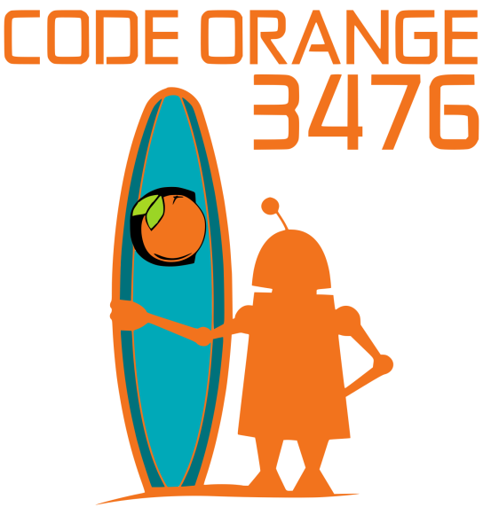The robots start out parked on the “Tarmac” around the central “Hub”. In the first 15 second Autonomous Period (Auto), the robots move independently, performing pre-programmed motions and tasks.

Each robot starts with 1 Cargo (ball) in its possession which it wants to launch into the central Hub. During the Auto period, scoring into the lower (easiest) Hub goal is worth 2 points for each Cargo ball and the upper goal is worth 4 points. At some point during the Auto period, each robot will want to Taxi completely out of its starting Tarmac area defined by the colored tape. That is worth an easy 2 points (Taxi points) for each robot. About 90% of the robots will do this. After shooting their starting Cargo, the better robots will then drive around to pick up additional Cargo balls to shoot into the Hub. 12 Cargo are positioned in precise, pre-determined locations. Many will be able to score 2 additional Cargo and the fastest will be able to get 5 additional Cargo (Rules limit each robot to carrying only 2 Cargo at a time.) and score them before the 15 second Auto Period expires. If an Alliance can score 5 balls during Auto it is called a “Quintet”. This will happen about 20% of the time.

**ACTION DURING THE MATCH**

At the end of the 15-second Autonomous Period, you will hear a buzzer and 3 bells and see the student-drivers step forward to the manual controls to begin the TeleOp period (When the robots are remotely driven by the students.).

Students will drive their robot around the field, collecting a maximum of 2 Cargo balls at a time and scoring them into the Hub. During the TeleOp period, the lower (easiest) Hub goal is only worth 1 point for each Cargo and the upper goal is worth 2 points.

If a robot is not good at shooting the Cargo balls, they will typically be assigned the duty of “playing defense” where they will try to inhibit the opponent robots from scoring. Robots are not allowed to damage other robots.

There is reflective tape on the top edge of the Hub that robots can “see”, if they have optical sensors and a bright green “limelight”, to line up and aim in the correct direction.

The very best robots will be able to “shoot on the fly” and score Cargo in the Upper Hub while in motion and while being bumped by opposing robots.

If you hear the sound of a foghorn, that means the Match has been stopped due a failure of the timing, scoring or control system on the field.

**END GAME**

The opposite corners of the field are filled with large structures known as “Hangars”.

When 30 seconds in the Match are left, you will hear a train whistle sound. Robots that have not yet gone to their Hangar to start an early climb, will head for their Hangar and try to progress up to hang on the highest of 4 rungs. The Rules impose a height restriction so each robot must progress up one rung at a time, “hand” over “hand”, often swinging wildly. At the end of the Match, robots hanging from the Low Rung earn 4 points, the Mid Rung earns 6 points, the High Rung earns 10 points and the highest “Traversal” Rung scores 15 points. Only about 25% of the time will an Alliance get one or more robots on the Traversal Rung.

The Match ends with a long Buzzer after 2 minutes and 30 seconds. Then you might see one ref waving his arm to count 5 seconds at which point they determine if a robot is hanging or has slipped down to the floor. Also, the height restriction is relaxed so robots can sag without penalty.

Three robots hanging on the Traversal Rung scores 45 points (A rare event.). In the Finals you might see both Alliances get this End Game maximum score. In which case the Match winner would probably be decided by the Cargo points and/or the Penalties.

Expect the average Match score to be about 50 to 60. Winning scores will typically be 70 to 80 points. High scores in the Finals will reach 170.

**THE LONELIEST SPOT ON THE FIELD**

In the other 2 corners, is the “Terminal”. Originally intended to help teams score who were not able to build a robot that could pick up Cargo from the floor and shoot it into the Hub, it allows a robot to push Cargo on the floor to a Human Player. Then the Human Player would pick up the cargo and roll it down an incline to the top of a robot where it could be more easily scored into the Lower Hub. But teams found this took too long or they were able to pick up Cargo from the floor so it is rarely used. But once the Human Player has a Cargo, they can try to throw it into the Upper Hub which is a difficult long shot. It adds to the excitement and the Audience erupts when the rare shot goes in.

**WHO IS WINNING?**

During the Match, you can follow the real-time scores on the Audience Display:

The number of the current Qualification Match is shown at the top left with the number of the final Match (like: “7 of 116”). The colored trapezoids (simplified Hubs) show the number of Cargo scored in the Upper and Lower Hubs for each Alliance. The 3 Team numbers in each Alliance are shown next to the scores. If yellow is displayed around a team number that means they have received a yellow card warning for breaking the rules. If they have another serious rule breaking Match, they will advance to a red card and not get any credit for points or RPs in that Match. The number of seconds left in the Match is shown in a progress bar above the scores. The color of the progress bar changes to indicate the 3 different periods of the Match.

At the far right and left are shown how many Cargo have been scored so far compared to the target of 20 (or 18 if the Alliance achieved a Quintet).

The real-time scoring shown during the Match is not official. It does not include the End Game Hangar points. Some penalties for fouls are not added into the displayed scores until after the Match is over. The display changes after the Match to show the official winners and list all the final points for each category and other details like their new Ranking.

**OVERALL GOAL**

The goal during the 2 days of 100-120 Qualifying Matches is to achieve top Ranking by earning Ranking Points (RP).These will be used to determine which Teams get to choose their 3 partners for an Elimination Tournament (Playoff). Winning a Match earns every Team on that Alliance 2 RPs. All 6 Teams get 1 RP in the unlikely case of a tie score. There are 2 additional RPs available to each Alliance. The first is called the Cargo Bonus. This is earned if the Alliance gets 20 Cargo balls scored in the Hub (both Upper and/or Lower). But if the Alliance got at least 5 Cargo scored in the Hub during the Auto period (the Quintet), this threshold is reduced to 18 Cargo balls. About 35% of the Alliances will earn this Ranking Point. You might see some robots only scoring in the Lower Hub to assure their Alliance earns the Cargo Bonus. This design might help them rank higher, but will not be that valuable in the Playoff Tournament since no Ranking Points are awarded then.

The other bonus RP is earned if the sum of the points scored by the 3 robots for the Hangar Climb in the End Game is 16 or more. Every Team on that Alliance earns an additional 1 RP regardless of which robots were hanging. This means there must be at least 2 robots earning Hangar points: A maximum of 15 points for one robot and a minimum of 4 for another.

About 50% to 60% of the Alliances will earn the Hangar RP.

In the Audience Display, the little yellow dots above the scores mean 1 or 2 additional RPs has been earned.

A team can be on the Winning Alliance and still go down in rank. This is because a win only earns a Team 2 RPs (Ranking Points) which are averaged into the existing total RPs a Team has earned in all its Matches so far. Teams that were previously ranked lower might have gotten 3 or 4 RPs in more Matches, giving them a higher average number of RPs.

Maybe 20% to 25% of all Matches will have an Alliance that earns the maximum of all 4 Ranking Points. Even the losing Alliance can earn 2 RPs for the Cargo Bonus and the Hangar Bonus.

**PENALTIES FOR BAD ROBOT BEHAVIOR**

A few General rules: A robot cannot extend more than 16 inches out from its bumpers and cannot reach into another robot. No robot is allowed to damage another robot. A robot can’t pin an opponent for more than 5 seconds. Referees will point to the offending robot and wave their other arm counting the 5 seconds and then either wave it off, if the pin is released, or wave their flag for a penalty. Each robot can only control 2 Cargo balls at a time. There is a “safe” zone at the end of the Hangar wall (the “Launch Area”) where robots can’t be hit. Breaking rules results in 4-point fouls being called by the referees who wave the red or blue ends of their flags. More serious fouls, called Technical, result in an 8-point penalty which Referees indicate by making an “X” by crossing their arms.

**ELIMINATION TOURNAMENT (PLAYOFFS)**

After all the randomly assigned Qualification Matches have been played, the 8 highest ranked Teams get priority to pick partners for the best 2-out-of-3 Matches Elimination Tournament (Playoffs). In case of a tie in Ranking between 2 or more Teams with the same average RPs, the Tiebreaker is the average Alliance Match Points not including penalties. If there is still a tie, then the next tiebreaker is the average Hangar points, then the average of the sum of Taxi and Auto Cargo points. If there still a tie, then the scoring system will randomly sort the teams.

The #1 Ranked Team gets to pick their 1st partner, then #2 picks a partner and so on down to #8. Then #8 gets to immediately pick a 2nd partner, then #7 and so on back up to #1. Then, at the Championships, #1 picks a 4th member of the Alliance, then #2 and so on down to #8. This is called the serpentine “Alliance Selection”. Note that #1 gets to pick both 1st and 16th. This serves to give all Teams a chance of winning. This results in 32 teams being in the Playoff Tournament. The only rule is that if a Team “declines” to be picked they cannot be picked by another Alliance Lead. But if they are one of the top 8 Alliance Leads, they can still pick other Teams as partners to form their own Alliance. When an Alliance Lead picks one of the other Alliance Leads, then the next lower-Ranked team moves up to become the #8 Alliance Lead. At one extreme if the first 7 Alliance Leads pick the other top 14 Ranked teams then the 15th Ranked team would become the #8 Alliance Lead. Or if the #9 Ranked team declines to be picked and none of the other top 8 teams is picked then no team can pick #9 and they will not move up to #8 and so will not be in the Playoff Tournament. If a top 8 team is picked, then they become the #8 Alliance Lead and can pick their own Alliance when it is their turn.