*FIRST Charged Up*

2611 Kickoff Strategy Worksheet

# Stage 1: Rules Analysis

## 1.1: Scoring

1. List all of the possible ways to score points and their associated point values. (Auto, teleop, end game)

|  |  |  |  |
| --- | --- | --- | --- |
| Way To Score | Auton Points | Teleop Points | Ranking Points |
|  |  |  |  |
|  |  |  |  |
|  |  |  |  |
|  |  |  |  |
|  |  |  |  |

1. For each type of scoring, what are the specific scoring criteria (i.e. completely over a line, not touching a robot, etc.).

|  |  |
| --- | --- |
| Way To Score | Criteria to Score |
|  |  |
|  |  |
|  |  |
|  |  |
|  |  |

1. Plot each way to score in the graph using point values on the X-Axis and difficulty on the Y-Axis.

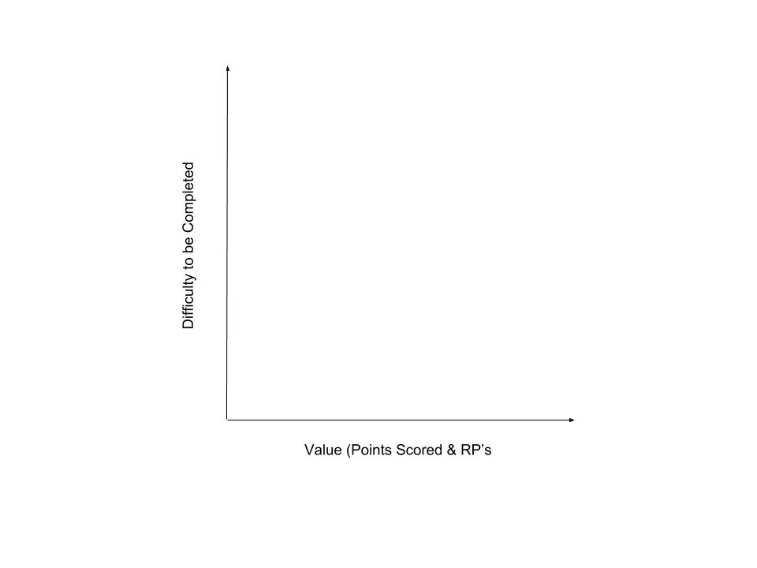

1. We need to consider the value in the task to the teammates to support ourselves and others. Please list tasks that would be valuable to teammates.

## 

## 

## 1.2 The Arena

1. To the best of your abilities, make a labelled sketch of the arena. Include the Red and Blue sides and Game Piece locations. Please draw it big, you will be labeling it as you go through this document.
2. Are there any potential visual obstacles for the drivers (i.e. 2017 airships, 2019 Cargo ship).
3. Are there any potential bottlenecks for robot flow through the field? Please describe here and add to your drawing (think places defense can be played)
4. Please add driving paths, to the drawing above, of the robot to the load of the game pieces and to the placement of the game pieces. (Should look like spaghetti!!)
5. Are there any beaching opportunities for the robot?

## 1.3 Match Logistics

1. How long are the periods of the match? Please include Autonomous, Teleop, and Endgame.
2. How many game pieces are there? Where do they start the match? How many in each location? Add those numbers to the drawing.
3. Are robots allowed to preload scoring objects? Are we able to score an alliance partner’s preload in autonomous if they don’t have an autonomous program?
4. Where do you obtain the Game Piece? Where do the Human Player (HP) interactions occur? Please add to the drawing above

## 1.4 Autonomous Rules

1. Where do robots start the match?
2. Are there any restrictions on where robots can go during autonomous? (add do not cross lines and label)
3. Are there any restrictions on drivers or human players during autonomous?
4. Are there any other important autonomous rules

## 1.5 General Game Rules

1. Are there any restrictions for interacting with or moving scoring objects? (i.e. possession limits, 2016 boulder movement rules, how many gamepieces you can posses)
2. Are there any restrictions for robot actions (i.e. protected zones, pinning) Please add to your drawing
3. Are game pieces that leave the field returned?
4. Are there any restrictions on drivers or human players?
5. Are there any special rules for the end of the match? (i.e. Climbing, or suckering people into a free climb - fouls / penalty)
6. When does scoring take place? (i.e. when all objects come to rest, as the final buzzer sounds...) (climb - one extra second after the end of the game, balls registering)

## 1.6 Robot Rules

1. What are the sizing restrictions for the robot to start the match?
2. What are the sizing restrictions for the robot during the match?
3. Any other sizing restrictions for other zones on the field? Please add to the drawing.

1. What is the robot’s weight limit?
2. Where are bumpers required? (i.e. what is the height of the bumper zone, does the whole robot need to be protected or just the corners?) Protip: draw a picture.
3. What is the withholding allowance? And timeframe on it?
4. Are there any limits on how many motors we can use?

1. Are there any other major differences in the robot rules from previous years? (for instance sandstorm)

## 1.7 Tournament Rules

1. What is the ranking system during qualifying matches? And what is the sort order (first order? Second order?)? Think Ranking Points
2. What are the tiebreakers during qualification matches?
3. What happens if an elimination match is tied?
4. Are there any other major differences in the tournament section of the manual?

Tear off and use this page for your drawing. If you need a second one, don’t be afraid to write on the back!!!!!

Thank you team for going through this. It is imperative that we all are on the same page for how the game is going to be played. In order for us to do this, we need to truly understand the game.